JANITORIAL SERVICES
U.S. BUREAU OF LAND MANAGEMENT – ARCATA FIELD OFFICE
RECREATION/MANAGEMENT SITES

Contents
PWS 1.0 Background on the Government’s Requirement 1
PWS 2.0 General Scope of Work 1
PWS 3.0 Overall Objective(s) 3
PWS 4.0 Specific Tasks 3
PWS 5.0 Delivery / Performance Schedule 5
PWS 7.0 Security and Administrative Matters 7
PWS 8.0 Technical Exhibits and Definitions 8
EXHIBIT 1: Performance Requirement Summary (PRS) 9
EXHIBIT 2: Delivery Schedule 13
EXHIBIT 3: Cleaning Schedule 14

PWS 1.0 Background on the Government’s Requirement
The U.S Bureau of Land Management (BLM) Arcata Field Office, of Humboldt County, California requires janitorial services at six (6) recreation/management sites. The sites are scattered throughout the management areas around Humboldt Bay and south of Ferndale. The table listed in Section 2.0 identifies the sites, location of each site, provides information on the number of restrooms, and trash receptacles within each area that require janitorial services due to high public use during the specified performance period.

PWS 2.0 General Scope of Work

The principal components of work to be performed by the contractor will consist of janitorial services. This includes emptying trash receptacles, picking up litter scattered throughout the recreation/management areas, cleaning vault toilets once (1) a week, and restocking restrooms in accordance with the specifications contained herein.

The contractor shall accomplish by providing all personnel, labor, materials, and supervision necessary to perform the janitorial and cleaning services as required by the Performance Work Statement (PWS).

Site Name | Vault Toilets | Trash Receptacles | Location | Latitude | Longitude
Headwaters Forest Reserve | 2 | 2 | Main Parking Lot | 40°41'31.34"N | 124° 8'26.82"W
 |  |  | HEC | 40°41'22.31"N | 124° 7'51.06"W
Waluphl Lighthouse Ranch | 1 | 1 |  | 40°41'45.00"N | 124°16'26.41"W
South Spit Mgmt Area | 2 | 2 | Table Bluff | 40°41'48.82"N | 124°16'32.49"W
 |  |  | South Jetty | 40°45'13.12"N | 124°14'0.21"W
Ma-le'l Dunes | 1 | 1 |  | 40°51'44.46"N | 124° 9'34.45"W
Lost Coast Headlands (Centerville) | 1 | 1 |  | 40°33'52.34"N | 124°20'57.29"W
Guthrie Creek Trailhead | 1 | 1 |  | 40°32'37.53"N | 124°21'28.08"W

Place of Performance:

Performance will occur at multiple government locations. The Table in Section 2.0 provides information on the places of performance for each site, which includes GPS coordinates. A map of all the sites to be provided under this contract has been included (Figure 1. Janitorial Recreation Site Map). Tasks must be completed at each of the sites identified in the Table.
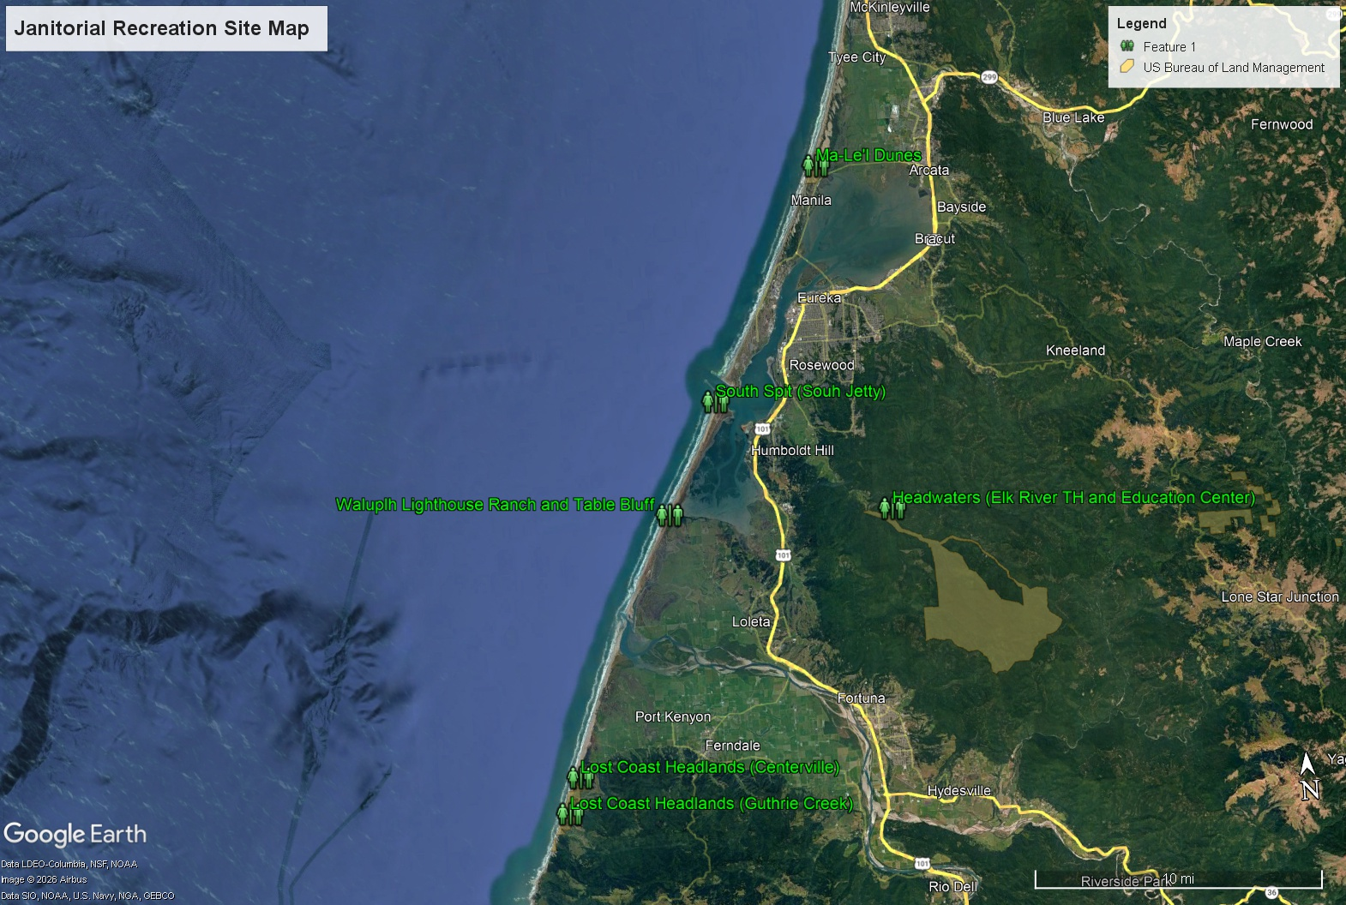
Figure 1. Janitorial Sanitation Site Map
Period of Performance:

The period of performance shall be for one (1) Base Year and four (4) Option Years. The Period of Performance reads as follows:

PWS 3.0 Overall Objective(s)

The contractor shall accomplish all cleaning tasks to meet the requirements of this Performance Work Statement. The minimum cleaning frequencies are established in Cleaning Schedule.

The objective of this work is to provide Janitorial Services for six (6) recreation & management sites located within the Arcata Field Office land management boundaries:

- Janitorial Services Schedule shall be performed one (1) time per week for each site under this contract.
- Basic restroom cleaning services shall include thorough cleaning and disinfecting of all surfaces with an appropriate cleaning agent, descale toilet bowls and sinks as per the Performance Work Statement.
- All trash, recycling and dog waste containers shall be emptied and returned to their original location and proper position, this includes trash receptacles located in the vault toilets and outside of the site entrances. Boxes, cans, papers and other material placed near a trash or recycling receptacle and marked “TRASH” or “RECYCLE” shall be removed. Any obviously soiled, torn or missing plastic trash and recycling receptacle liners shall be replaced. Trash and recycling receptacles shall be left clean, free of foreign matter, and free of odors.

PWS 4.0 Specific Tasks

Basic Services. The contractor shall provide services for janitorial work:

4.1 BASIC CLEANING SERVICES. The contractor shall accomplish all cleaning tasks to meet the requirements of this Performance Work Statement. The minimum cleaning frequencies are established in Technical Exhibit 3, Cleaning Schedule.

4.1.2. Clean Interior Bathroom Flooring/Sinks/Mirrors/Doors. All surfaces will be cleaned with a cleaning agent appropriate for each bathroom facility. Contractors shall remove all dust, dirt, marks, grease, smudges, scuffs, fingerprints, and other foreign matters to provide or maintain a clean, uniform appearance.

4.1.3 Remove Trash and Recycling. All trash, recycling and dog waste containers shall be emptied and returned to their original location and proper position, this includes trash receptacles located in the vault toilets and at trailheads or recreation site areas. Boxes, cans, papers and other material placed near a trash or recycling receptacle and marked “TRASH” or “RECYCLE” shall be removed. Any obviously soiled, torn or missing plastic trash and recycling receptacle liners shall be replaced with liners adequate in quality and size. Trash and recycling receptacles shall be left clean, free of foreign matter, and free of odors.

4.1.4 Clean Drinking Fountains. Drinking Fountains shall be sanitized and wiped out with appropriate cleaning agent and free of any foreign matter.

4.1.5 Clean Bathroom Sink and Surface Areas. Completely clean and disinfect all surfaces of sinks, plumbing fixtures, dispensers, stall doors and hardware, walls, and other such surfaces, using appropriate cleaning, disinfecting, and polishing agents.

4.1.6 General Spot Cleaning. Perform spot cleaning on a continual basis. Spot cleaning includes, but is not limited to removing, or cleaning smudges, fingerprints, marks, streaks, spills, etc., from washable surfaces of all walls, doors, door guards, door handles, push bars, kick plates, and fixtures. After spot cleaning, the surface shall have a clean, uniform appearance, free of streaks, spots, and other evidence of soil.

4.2. BASIC RESTROOMS CLEANING SERVICES. The contractor shall accomplish all cleaning tasks to meet the requirements of this Performance Work Statement.

4.2.1. Clean and Disinfect Surface Areas. Completely clean and disinfect all surfaces of sinks, toilet bowls, urinals, lavatories, dispensers, plumbing fixtures, partitions, dispensers, doors, walls, and other such surfaces, using a germicidal detergent. After cleaning, receptacles will be free of deposits, dirt, streaks, and odors. Disinfect all surfaces of partitions, stall doors, entry doors, (including handles, kick plates, ventilation grates, metal guards, etc.), and wall areas adjacent to wall mounted lavatories, urinals, and toilets.

4.2.2. Descale Toilet Bowls, and Sinks. Descaling shall be performed monthly, at a minimum, and, as often as needed, to keep areas free of scale, soap films, and other deposits. After descaling, surfaces shall be free from streaks, stains, scale, scum, urine deposits, and rust stains.

4.2.3. Stock Restroom and Vault Toilet Supplies. Contractors should ensure restrooms and vault toilet supplies are adequate in quality and shall be stocked sufficiently so that supplies including toilet tissue, paper towels, soap, and other materials do not run out between services. All supplies shall be stored in designated areas only. No overstocking shall be allowed. If supplies run out prior to the next service date, contractor shall refill within 24 hours of notification.

4.2.4. Vault Toilets Concrete Floors. Vault toilet concrete floors shall be swept and mopped using an appropriate cleaning and disinfecting agent. Toilet seats and covers shall be cleaned and disinfected, including the inside and outside of the vault toilet risers. A deodorizer and/or air freshener shall be applied inside the vault toilet room after each cleaning. The deodorizer or air freshener should last until the next cleaning service without being over-bearing, especially to visitors and others that may be sensitive to perfumes and other odors.

4.2.5 Dog Waste Bag Despensers. All dog Waste Bag Dispensers shall be restocked accordingly.

PWS 5.0 Delivery / Performance Schedule

PERFORMANCE WORK STATEMENT – Technical Exhibit

The contractor service requirements are summarized into performance objectives that relate directly to mission essential items. The performance threshold briefly describes the minimum acceptable levels of service required for each requirement. These thresholds are critical to mission success and are listed in EXHIBIT 1: Performance Requirement Summary (PRS).

The contractor shall adhere to the delivery schedule as listed in EXHIBIT 2: Delivery Schedule.

The contractor shall fill out and submit the Cleaning Schedule to the COR as listed in EXHIBIT 3: Cleaning Schedule.

PWS 6.0 Government-Furnished Property, Materials, Services

General:
The Contractor shall furnish all personnel, materials, equipment, supplies, facilities, transportation, tools, materials, supervision, and other items and non-personal services necessary to perform the work tasks defined in this Performance Work Statement, except for those items specified as government furnished.

Materials: The Government will not provide any materials

Equipment: The Government will not provide any equipment.

Services: The Government will provide quality assurance.

Facilities: The Government will provide an area for storage of limited supplies, such as for mops and bucket, extra paper products, cleaning agents, etc.

Utilities: The Government will provide utilities in the form of water and electricity to use in the performance of the tasks outlined in this Performance Work Statement.

The Contractor shall instruct employees in utilities conservation practices. The contractor shall be responsible for operating under conditions that preclude the waste of utilities, which include turning off the water faucets or valves after using the required amount to accomplish the work.

PWS 7.0 Security and Administrative Matters

The Contractor will be provided two (2) different keys to access the vault toilets and trash receptacles. This will be documented on a Department Property Issuance form and will be responsible for securing the personal property. Contractor shall notify the COR right away should the key be lost or stolen.

Regular Work Hours:

The performance period established for this contract is based upon all work being conducted during regular working hours between 8:00 am and 5:00 pm, Monday through Friday, excluding government holidays. If the Contractor desires to carry on work outside regular hours, including Saturdays, Sundays, and government holidays, a request must be submitted to the Contracting Officer in sufficient time to allow satisfactory arrangements to be made for access to the work site.

Communications:

“Time” for communications received after 3:00 pm, after 12:00 pm locally on Fridays, or after 12:00 pm locally prior to a holiday will not start until the next business day. All times are local Pacific Standard Time.

Federal Holidays:

The following Federal Legal Holidays are observed:

New Year’s Day Martin Luther King, Jr. Day
President’s Day Memorial Day
Juneteenth Independence Day
Labor Day Columbus Day
Veterans Day Thanksgiving Day
Christmas Day

Fire Danger Season:

If the Contracting Officer Representative (COR) allows the Contractor to continue work during periods of declared fire danger or season, the Contractor shall comply with all applicable state laws relating to fire prevention and with all special conditions of work as directed by the COR.

PWS 8.0 Technical Exhibits and Definitions

Standard Definitions:

Physical Condition
The Physical appearance of Federal equipment or facilities that considers cracks, chips, dents, abrasions, rust, corrosion, general cleanliness, and discoloration and other items as identified by the COR. Physical condition may be determined by visual as well as diagnostic means.

Contracting Officer (CO)
The Secretary of the Interior or designated authorized representative who is the only agent capable of signing a federal award or obligating funds.

Contracting Officer’s Representative (COR)
The Contracting Officer’s designated representative as indicated in a delegation of authority letter.

Quality Assurance (QA)
Surveillance of Contractor performance to determine performance requirements are met.

Performance Requirements Summary (PRS) (see Technical Exhibit below)
The PRS identifies the key performance indicators of the Contract that will be evaluated by the Government to assure Contract performance standards are met by the Contractor.

Quality Control
Those actions taken by the Contractor to control the production of goods or services so that they meet the requirements of the performance work statement.

EXHIBIT 1: Performance Requirement Summary (PRS)

STARTS ON NEXT PAGE

Performance Objective | Task # | Performance Standard | AQL / Performance Threshold | Surveillance Method | Incentive/ Remedy
Basic Cleaning Services | 4.1.2, 4.1.5, 4.1.6 | Bathroom floors, sinks, mirrors, doors, fixtures, and surfaces are cleaned and disinfected. Spot cleaning performed as required. Surfaces are free of dirt, dust, grease, smudges, fingerprints, stains, and visible debris. | 95% compliance. No more than two (2) deficiencies per month. | Contractor cleaning checklist; weekly Government review; monthly COR inspection. | Re-performance at no cost to Government. Repeated deficiencies may result in payment deductions and adverse past performance evaluation.
Trash, Recycling, and Dog Waste Removal | 4.1.3 | All trash, recycling, and dog waste receptacles emptied during each scheduled service. Receptacles are clean, properly lined, odor-free, and returned to original locations. | 100% of receptacles serviced during each visit. | Contractor cleaning checklist; weekly Government review; monthly COR inspection. | Re-performance at no cost to Government. Missed receptacles subject to payment deduction.
Drinking Fountain Cleaning | 4.1.4 | Drinking fountains are sanitized, operational, and free of dirt, stains, debris, and foreign matter. | 95% compliance. No visible contamination during inspection. | Visual inspection by Government representative and COR. | Re-performance at no cost to Government.

Restroom Sanitation | 4.2.1 | Restroom fixtures, partitions, doors, walls, urinals, and toilets are cleaned and disinfected. Surfaces are free of deposits, stains, streaks, odors, and visible contamination. | 95% compliance. No more than two (2) deficiencies per month. | Weekly Government review; monthly COR inspection. | Re-performance at no cost to Government.
Descaling Services | 4.2.2 | Toilet bowls and sinks descaled monthly, at minimum, and maintained free of scale, soap film, rust stains, and mineral deposits. | 100% completion of monthly descaling requirement. | COR monthly inspection and review of contractor service records. | Re-performance at no cost to Government.
Restroom and Vault Toilet Supply Stocking | 4.2.3 | Toilet tissue, paper towels, soap, and other required supplies are adequately stocked and available for public use. | Supplies available 100% of the time. Contractor responds within 24 hours of notification for depleted supplies. | Government notification log; COR inspection. | Failure to restock within 24 hours may result in payment deduction.
Vault Toilet Cleaning and Deodorizing | 4.2.4 | Vault toilet floors, seats, risers, walls, doors, and fixtures cleaned and disinfected. Appropriate deodorizer applied after each service. | 95% compliance. No offensive odors attributable to lack of cleaning or deodorizing. | Weekly Government review; monthly COR inspection. | Re-performance at no cost to Government.
Dog Waste Bag Dispenser Restocking | 4.2.5 | Dog waste bag dispensers remain stocked with bags adequate to last until the next scheduled service. | 100% of dispensers stocked after each service visit. | Visual inspection by Government representative. | Failure to stock may result in payment deduction for missed service.
Schedule Compliance | Technical Exhibit 3 | All services performed according to the approved Cleaning Schedule. | 95% of scheduled visits completed on time each month. | Review of contractor service logs and Government records. | Missed service visits subject to payment deduction.
Quality Control Plan | QCP | The contractor provided QCP based on the Performance Work Statement’s Task/Deliverables and Deliverables Schedule | 100% Compliance | COR receives QCP from contractor | Exceptional performance may result in Government exercising Option Year.  Non-compliance may result in delay of work and/or possible termination of contract for default. Negative past-performance evaluation on contract.

EXHIBIT 2: Delivery Schedule

DELIVERY SCHEDULE
DELIVERABLE | FREQUENCY | FORMAT | SUBMIT TO
Quality Control Plan | Once | Word or PDF | Contracting Officer  BLM  2800 Cottage Way  Sacramento, CA 95825
Basic Cleaning Services | Per Attachment 3 | N/A | COR  BLM, Arcata Field Office, 1695 Heindon Road, Arcata, CA 95521
Basic Restroom and Vault Toilet Cleaning Services | Per Attachment 3 | N/A | COR  BLM, Arcata Field Office, 1695 Heindon Road, Arcata, CA 95521  ATTN: COR

EXHIBIT 3: Cleaning Schedule

CLEANING SCHEDULE

CONTRACTOR TO FILL OUT PROPOSED WEEKLY SCHEDULE

General Administrative Areas
CATEGORY I - Minimum Frequency Standards

BASIC CLEANING & RESTROOM/TOILET CLEANING SERVICES

Janitorial Cleaning –  6 Recreation Sites/8 Vault Toilets | Su | M | Tu | W | Th | F | Sa | SERVICE ONCE PER WEEK
Mal-Le’l dunes
Waluphl Lighthouse Ranch
South Spit Management Area- Table Bluff
South Spit Management Area- South Jetty
Lost Coast Headlands- Centerville
Lost Coast Headlands- Guthrie Creek Trail Head
Headwaters Forest Reserve- Elk River Trail Head
Headwaters Forest Reserve- Educational Center

