SUBJECT* | Janitorial Services - Dayton VA Medical Center

GENERAL INFORMATION
CONTRACTING OFFICE’S ZIP CODE* | 45409-1337
SOLICITATION NUMBER* | 36C25026Q0740
RESPONSE DATE/TIME/ZONE | 08-07-2026 13:30 EASTERN TIME, NEW YORK, USA
ARCHIVE | 60 DAYS AFTER THE RESPONSE DATE
RECOVERY ACT FUNDS | N
SET-ASIDE | SDVOSBC
PRODUCT SERVICE CODE* | S201
NAICS CODE* | 561720
CONTRACTING OFFICE ADDRESS | Department of Veterans Affairs  Dayton VA Medical Center  3140 Governor’s Place Blvd. Suite 210  Kettering OH 45409-1337
POINT OF CONTACT* | Contracting Officer  Josh Kovar  Joshua.Kovar@VA.gov  937-268-6511  All questions shall be emailed to POC above

PLACE OF PERFORMANCE
ADDRESS | US Department of Veterans Affairs
 | Dayton VA Medical Center
 | EMS Department
 | 4100 West Third Street
 | Dayton Ohio
POSTAL CODE | 45428-9000
COUNTRY | USA

ADDITIONAL INFORMATION
AGENCY’S URL | https://www.va.gov/
URL DESCRIPTION | US Department of Veterans Affairs
AGENCY CONTACT’S EMAIL ADDRESS
EMAIL DESCRIPTION

DESCRIPTION
This is a solicitation for commercial items prepared in accordance with the format in Revolutionary FAR Overhaul (RFO) subpart 12.6, “Streamlined Procedures for Evaluation and Solicitation for Commercial Items,” as supplemented with additional information included in this notice. This solicitation is issued as an RFQ. The solicitation document and incorporated provisions and clauses are those in effect through Federal Acquisition Circular 2025-06.

- This solicitation is set aside for SDVOSB (Service-Disabled Veteran Owned Small Businesses)

The associated North American Industrial Classification System (NAICS) code for this procurement is 561720 – Janitorial Services, with a small business size standard of $ 47.0 Million. The FSC/PSC is S201 – Housekeeping – Custodial

Dayton VA Medical Center is requesting Janitorial Services to supplement current staffing.

- All vendors shall provide all requested information in Quote Preparation Instructions section.
- There is a question-and-answer period for this requirement, ending at 1:30 PM EST on 7/31/2026
- There is a non-mandatory Site Visit scheduled for 7/24/2026 1:00-3:00 PM EST

All interested companies shall provide quotations for the following:

PAGE 1 OF
1. REQUISITION NO.
2. CONTRACT NO.
3. AWARD/EFFECTIVE DATE
4. ORDER NO.
5. SOLICITATION NUMBER
6. SOLICITATION ISSUE DATE
a. NAME
b. TELEPHONE NO. (No Collect Calls)
8. OFFER DUE DATE/LOCAL
TIME
9. ISSUED BY
CODE
10. THIS ACQUISITION IS
UNRESTRICTED OR
SET ASIDE:
% FOR:
SMALL BUSINESS
HUBZONE SMALL
BUSINESS
SERVICE-DISABLED
VETERAN-OWNED
SMALL BUSINESS
WOMEN-OWNED SMALL BUSINESS
(WOSB) ELIGIBLE UNDER THE WOMEN-OWNED
SMALL BUSINESS PROGRAM
EDWOSB
8(A)
NAICS:
SIZE STANDARD:
11. DELIVERY FOR FOB DESTINA-
TION UNLESS BLOCK IS
MARKED
SEE SCHEDULE
12. DISCOUNT TERMS
13a. THIS CONTRACT IS A
RATED ORDER UNDER
DPAS (15 CFR 700)
13b. RATING
14. METHOD OF SOLICITATION
RFQ
IFB
RFP
15. DELIVER TO
CODE
16. ADMINISTERED BY
CODE
17a. CONTRACTOR/OFFEROR
CODE
FACILITY CODE
18a. PAYMENT WILL BE MADE BY
CODE
TELEPHONE NO.
UEI:
EFT:
PHONE:
FAX:
17b. CHECK IF REMITTANCE IS DIFFERENT AND PUT SUCH ADDRESS IN OFFER
18b. SUBMIT INVOICES TO ADDRESS SHOWN IN BLOCK 18a UNLESS BLOCK BELOW IS CHECKED
SEE ADDENDUM
19.
20.
21.
22.
23.
24.
ITEM NO.
SCHEDULE OF SUPPLIES/SERVICES
QUANTITY
UNIT
UNIT PRICE
AMOUNT
(Use Reverse and/or Attach Additional Sheets as Necessary)
25. ACCOUNTING AND APPROPRIATION DATA
26. TOTAL AWARD AMOUNT (For Govt. Use Only)
27a. SOLICITATION INCORPORATES BY REFERENCE FAR 52.212-1, 52.212-4. FAR 52.212-3 AND 52.212-5 ARE ATTACHED. ADDENDA
ARE
ARE NOT ATTACHED.
27b. CONTRACT/PURCHASE ORDER INCORPORATES BY REFERENCE FAR 52.212-4. FAR 52.212-5 IS ATTACHED. ADDENDA
ARE
ARE NOT ATTACHED
28. CONTRACTOR IS REQUIRED TO SIGN THIS DOCUMENT AND RETURN _______________
29. AWARD OF CONTRACT: REF. ___________________________________ OFFER
COPIES TO ISSUING OFFICE. CONTRACTOR AGREES TO FURNISH AND
DATED ________________________________. YOUR OFFER ON SOLICITATION
DELIVER ALL ITEMS SET FORTH OR OTHERWISE IDENTIFIED ABOVE AND ON ANY
(BLOCK 5), INCLUDING ANY ADDITIONS OR CHANGES WHICH ARE
ADDITIONAL SHEETS SUBJECT TO THE TERMS AND CONDITIONS SPECIFIED
SET FORTH HEREIN IS ACCEPTED AS TO ITEMS:
30a. SIGNATURE OF OFFEROR/CONTRACTOR
31a. UNITED STATES OF AMERICA (SIGNATURE OF CONTRACTING OFFICER)
30b. NAME AND TITLE OF SIGNER (TYPE OR PRINT)
30c. DATE SIGNED
31b. NAME OF CONTRACTING OFFICER (TYPE OR PRINT)
31c. DATE SIGNED
AUTHORIZED FOR LOCAL REPRODUCTION
(REV. NOV 2021)
PREVIOUS EDITION IS NOT USABLE
Prescribed by GSA - FAR (48 CFR) 53.212
7. FOR SOLICITATION
INFORMATION CALL:
STANDARD FORM 1449
SOLICITATION/CONTRACT/ORDER FOR COMMERCIAL PRODUCTS AND COMMERCIAL SERVICES
OFFEROR TO COMPLETE BLOCKS 12, 17, 23, 24, & 30
85

552-27-1-6104-0001

36C25026Q0740
07-16-2026
Josh Kovar - Joshua.Kovar@VA.gov

08-07-2026
13:30
EDT
36C250

Department of Veterans Affairs
Network Contracting Office (NCO 10)
3140 Governor’s Place Blvd. Suite 210
Kettering OH 45409-1337

X
100

X

561720
$22 Million

N/A
X

36C552
Department of Veterans Affairs
Dayton VA Medical Center
EMS Department
4100 West Third Street
Dayton OH 45428-9000
36C250

Department of Veterans Affairs
Network Contracting Office (NCO) 10
3140 Governors Place Blvd. Suite 210
Kettering OH 45409-1337

Department of Veterans Affairs
Financial Services Center
Invoices To Be Submitted Electronically
https://www.ob10.com/us/en/veterans-
affairs// Invoice Setup Info Phone
877 353 9791
512 460 5429

See CONTINUATION Page
This is a RFQ for Janitorial Services at Dayton VA Medical
Center.

Site Visit is available on 7/24/2026 (1:00 - 3:00 PM EST)
QA Period Closes at 1:30 PM EST on 7/31/2026
Solicitation Deadline is 1:30 PM EST on 8/7/2026

All questions and solicitation responses shall be emailed to
the Contracting officer - Phone calls are not entertained.

Please see *QUOTE PREPARATION INSTRUCTIONS* for a list of
items that must be returned in your response.

Failure to provide all requested items will result in your
response being excluded for award.

See CONTINUATION Page

x
X

x
1

Table of Contents
SECTION A 3
A.1 SF 1449 SOLICITATION/CONTRACT/ORDER FOR COMMERCIAL PRODUCTS AND COMMERCIAL SERVICES 3
SECTION B - CONTINUATION OF SF 1449 BLOCKS 6
B.1 CONTRACT ADMINISTRATION DATA 6
B.2 PERFORMANCE WORK STATEMENT 7
B.3 PRICE/COST SCHEDULE 25
ITEM INFORMATION 25
SECTION C - CONTRACT CLAUSES 26
C.1 52.212-4 CONTRACT TERMS AND CONDITIONS—COMMERCIAL PRODUCTS AND COMMERCIAL SERVICES (OCT 2025) (DEVIATION) 26
ADDENDUM to FAR 52.212-4 CONTRACT TERMS AND CONDITIONS—COMMERCIAL PRODUCTS AND COMMERCIAL SERVICES 29
C.2 52.252-2 CLAUSES INCORPORATED BY REFERENCE (FEB 1998) 29
C.3 FAR 52.203-14 DISPLAY OF HOTLINE POSTER(S) (NOV 2021) 31
C.4 52.217-8 OPTION TO EXTEND SERVICES (NOV 1999) 31
C.5 52.217-9 OPTION TO EXTEND THE TERM OF THE CONTRACT (MAR 2000) 32
52.222-42 STATEMENT OF EQUIVALENT RATES FOR FEDERAL HIRES (MAY 2014) 32
C.6 52.222-90 ADDRESSING DEI DISCRIMINATION BY FEDERAL CONTRACTORS (DEVIATION APR 2026) 32
C.7 52.223-23 SUSTAINABLE PRODUCTS (NOV 2025) (DEVIATION) 33
C.8 SUPPLEMENTAL INSURANCE REQUIREMENTS 33
C.9 52.240-91 SECURITY PROHIBITIONS AND EXCLUSIONS (NOV 2025) (DEVIATION) 34
C.10 VAAR 852.204-72 PERSONNEL VETTING AND CREDENTIALING (DEVIATION) (MAR 2026) 40
C.11 VAAR 852.211-76 LIQUIDATED DAMAGES - REIMBURSEMENT FOR DATA BREACH COSTS (FEB 2023) 42
C.12 VAAR 852.219-75 VA NOTICE OF LIMITATIONS ON SUBCONTRACTING—CERTIFICATE OF COMPLIANCE FOR SERVICES AND CONSTRUCTION (JAN 2023) (DEVIATION) 44
C.13 MANDATORY WRITTEN DISCLOSURES 46
SECTION D - CONTRACT DOCUMENTS, EXHIBITS, OR ATTACHMENTS 47
D.1 SITE VISIT INFORMATION 47
D.2 WAGE DETERMINATIONS 48
D.3 APPENDIX A: DETAILED SQUARE FOOTAGE BY AREA AND FLOOR TYPE 49
D.4 APPENDIX B: BUILDING 330 FLOORPLANS 52
D.5 APPENDIX C: VENDOR ACKNOWLEDGMENT AND CONCURRENCE TABLE 62
D.6 APPENDIX D: LIMITATIONS ON SUBCONTRACTING AND COMPLIANCE WORKSHEET 63
D.7 APPENDIX E: LIMITATIONS ON SUBCONTRACTING (LOS) REPORTING INSTRUCTIONS 67
D.8 APPENDIX F: INSTRUCTIONS FOR IDENTIFYING AND REPORTING SUBCONTRACTORS 69
SECTION E - SOLICITATION PROVISIONS 72
E.1 52.212-1 INSTRUCTIONS TO OFFERORS—COMMERCIAL PRODUCTS AND COMMERCIAL SERVICES (OCT 2025) (DEVIATION) 72
E.2 QUOTE PREPARATION INSTRUCTIONS 74
E.3 52.252-1 SOLICITATION PROVISIONS INCORPORATED BY REFERENCE (FEB 1998) 78
E.4 VAAR 852.252-70 SOLICITATION PROVISIONS OR CLAUSES INCORPORATED BY REFERENCE (JAN 2008) 78
E.5 52.209-7 INFORMATION REGARDING RESPONSIBILITY MATTERS (OCT 2018) 78
E.6 52.229-11 TAX ON CERTAIN FOREIGN PROCUREMENTS—NOTICE AND REPRESENTATION (JUN 2020) 79
52.233-2 SERVICE OF PROTEST (SEP 2006) (DEVIATION NOV 2025) 80
E.7 52.240-90 SECURITY PROHIBITIONS AND EXCLUSIONS REPRESENTATIONS AND CERTIFICATIONS (NOV 2025) (DEVIATION) 81
E.8 52.216-1 TYPE OF CONTRACT (NOV 2025) (DEVIATION) 83
E.9 52.212-2 EVALUATION—COMMERCIAL PRODUCTS AND COMMERCIAL SERVICES (OCT 2025) (DEVIATION) 83
E.10 EVALUATION APPROACH 84
E.11 BASIS FOR AWARD 86

SECTION B - CONTINUATION OF SF 1449 BLOCKS

B.1 CONTRACT ADMINISTRATION DATA
1. Contract Administration: All contract administration matters will be handled by the following individuals:
a. CONTRACTOR:

b. GOVERNMENT: Contracting Officer 36C250 Josh Kovar

Department of Veterans Affairs
Network Contracting Office (NCO 10)
3140 Governor’s Place Blvd. Suite 210
Kettering OH 45409-1337
2. CONTRACTOR REMITTANCE ADDRESS: All payments by the Government to the contractor will be made in accordance with:
[x] | 52.232-33, Payment by Electronic Funds Transfer—System For Award Management, or
[] | 52.232-36, Payment by Third Party
3. INVOICES: Invoices shall be submitted in arrears:
a. Quarterly []
b. Semi-Annually []
c. Other [x] Monthly in Arrears
4. GOVERNMENT INVOICE ADDRESS: All Invoices from the contractor shall be submitted electronically in accordance with VAAR Clause 852.232-72 Electronic Submission of Payment Requests.

https://www.tungsten-network.com/customer-campaigns/veteransaffairs/
ACKNOWLEDGMENT OF AMENDMENTS: The offeror acknowledges receipt of amendments to the Solicitation numbered and dated as follows:
AMENDMENT NO | DATE

B.2 PERFORMANCE WORK STATEMENT
Updated 7/13/2026

CONTRACT TITLE: Housekeeping Services – approximately 20 Buildings estimated 622,750 sq ft.
- BACKGROUND: This is a non-personal services contract to provide janitorial services for the Dayton VA Medical Center. The Government shall not exercise any supervision or control over the contract service providers performing the services herein. Such contract service providers shall be accountable solely to the Contractor who, in turn is responsible to the Government. Dayton VAMC has twenty buildings with administrative, common, and clinic areas that need housekeeping services to alleviate the burden of shortage of housekeeping staff.

1.1 SCOPE: The contractor shall provide all management, labor, and equipment necessary to ensure custodial services are performed at the Dayton Veterans Affairs Medical Center. The service will consist of housekeeping for buildings listed in the table below.
All services will be performed at Dayton VA Medical Center, 4100 W Third Street Dayton, Ohio 45428.

***NOTE***: The Government reserves the right to add or remove any additional Medical Centers, CBOC’s or other facilities to the contract as they become available. Furthermore, the Government reserves the right to add, increase, or decrease types of quantities of service to allow for fluctuations of client demand that are otherwise unknown at time of solicitation. The total contract value may increase up to 20% of the base award.

1.2 CONTRACT CHANGES: Additional cleaning required by changes in mission assignments must be documented by a written contract modification. If the contractor receives a request from VA personnel directing or requesting work that the contractor believes is not within the terms of the PWS or the contract, then the contractor must notify the Contracting Officer and the site POC of the request. The only person that has the authority to modify the terms of the contract or request work for which compensation will be provided is the Contracting Officer.

1.3 TYPE OF CONTRACT: The government will award a Firm Fixed Price contract, consisting of a period of one (1) Base Period and four (4) 12-month Option Periods exercisable at the Government’s discretion.

1.3.1 PERIOD OF PERFORMANCE:
- Base: 10/1/2026 – 09/30/2027
- OY1: 10/1/2027 – 09/30/2028
- OY2: 10/1/2028 – 09/30/2029
- OY3: 10/1/2029 – 09/30/2030
- OY4: 10/1/2030 – 09/30/2031
1.4 SPECIFIC TASKS: Contractor will perform cleaning services in administrative, after-hour clinics, and common areas. The Department of Labor wage determination must be followed. Cleaning information and frequency are in Section 5 below. All work performed by the contractor shall be performed in accordance with all applicable laws, regulations, HAF standards, instructions, and commercial practices.

1.5 WORK HOURS: The services covered by this contract shall be furnished by the contractor as defined herein. The contractor will be required to furnish such services five per below information. Dayton VA Medical Centers’ daily normal hours of operation are from 8:00am to 4:30pm.
1.5.1. Work Hours: Monday through Friday 2 shifts - 9am to 11pm. Project work can be completed on Saturday and/or Sunday (adjustments can be submitted to the COR for approval)
1.5.2 National Holidays: The eleven holidays observed by the Federal Government are: New Year’s Day, Martin Luther King’s Birthday, President’s Day, Memorial Day, Juneteenth, Independence Day, Labor Day, Columbus Day, Veteran’s Day, Thanksgiving Day and Christmas Day and any other day specifically declared by the President of the United States to be a national holiday.

1.6 Work Schedule: Prior to commencing performance under this contract, the Contractor shall provide proposed work schedules to the Site POC and Contracting Officer, CO describing how services will be accomplished. All work shall be coordinated with the Site POC or designated representative when accomplished during normal business hours to avoid disruptions or conflicts between the Government functions and the provision of service under this contract.

1.7 PERFORMANCE MONITORING: On-site monitoring shall be conducted by selected Contract Manager supervisor Monday through Friday with weekly QA inspections and document discrepancies and resolve.

2.0 DEFINITIONS & ACRONYMS
2.1 DEFINITIONS:
- Aseptic Cleaning. Techniques and procedures used under sterile conditions. Aseptic cleaning is the effort taken to clean the interior of building and keep people free from hospital micro-organisms. Contractor. A supplier or vendor awarded a contract to provide specific supplies or service to the government. The term used in this contract refers to the prime.
- Contracting Officer (CO). A person with the authority to enter, administers, and/or terminates contracts and makes related findings. The Contracting Officer is the only individual who has the authority to contractually bind the Government. The Contracting Officer may designate a government employee to act as his authorized technical representative.
- Contracting Officer’s Representative (COR) is the person appointed by the Contracting Officer to help monitor and oversee a contractor’s performance. The COR makes sure the contractor delivers what the contract requires, keeps records, and reports any issues to the Contracting Officer — but cannot change the contract or direct the contractor beyond its terms.
- Corrective Action. Action taken by the Contractor correct a deficiency and identify the cause(s) of the deficiency.
- Custodial Cleaning. Providing an array of cleaning functions that are vital to the daily operation of the facility to present a clean facility.
- Joint Commission (JC). A national organization dedicated to improving the care, safety, and treatment of patients in health care facilities, and publishers of the Joint Commission on Accreditation Manuals.
- Protection. This prevents damage to surfaces and equipment caused by normal use or improper cleaning procedures.
- Quiet Zone normally means a noise level of less than 72.B (A) at five feet from the source in patient- occupied areas.
- Soil. Dust, dirt, stains, grease, smudges, streaks, spots, lint, odors, organisms, vomits, or any agents that are injurious to health. Soil can be visible such as dust, or can be invisible such as organisms, and odors.
- Subcontractor. One that enters into a contract with a prime contractor. The Government does not have privity of contract with the subcontractor.
- Terminal Cleaning. Cleaning procedures implemented in the room or immediate physical environment after an individual has made an unexpected mess (vomit for example).
- Workday. The number of hours per day the Contractor provides services in accordance with the contract.

2.2 ACRONYMS:
- (CBI) Compliance and Business Integrity
- (CEH) Certified Executive Housekeeper
- (SITE POC) Contracting Officer Representative
- (EPA) Environmental Protection Agency
- (ID) Identification
- (IT) Information Technology
- (JC) Joint Commission
- (IHEA) International Executive Housekeeper Association
- (NEHA) National Executive Housekeeping Association
- (OSHA) Occupational Safety and Health Agency
- (PWS) Performance Work Statement
- (QASP) Quality Assurance Surveillance Plan
- (VA) Veterans Affairs

3.0 STANDARDS: The following standards apply to the contract.
- Aseptic areas apply to the kitchen, dining, and restrooms.
- Custodial standards apply to the common areas, excluding the dining area, and the exam rooms. There may be some cases where an exam room requires a “terminal cleaning” in the case of a sick patient or otherwise. Upon request from VA staff, the contractor shall perform a terminal cleaning to affected areas.

3.1 BASIC CLEANING SERVICES:
3.1.1 Non-Carpeted Floors (Hard Floors: Vinyl Tile, Ceramic Tile, Wood, Concrete, etc...): Hard floors shall be maintained free of grit, soil, dust, scuff and heel marks, stains, spills, debris, litter, and other foreign matters by effective routine cleaning. Cleaning shall be accomplished by the most appropriate method (vacuum, sweep, dust mop, damp mop, spot clean, etc.) and with cleaning solutions if applicable, for the specific floor type. After cleaning, floor surfaces to include grout shall have a uniform, clean appearance without streaks, swirl marks, detergent residue, or any evidence of soil, stain, film, or standing water. Baseboards, corners, and wall/floor edges shall also be clean. Chairs, trash receptacles, and other easily moveable items shall be moved to maintain floors underneath these items and returned to their original and proper position after cleaning.

3.1.2 Carpeted Floors: Carpets shall be maintained free of soil, dirt, debris, litter, and other foreign matter by effective routine vacuuming. Efficient vacuum cleaners shall offer high airflow, high efficiency filtration, and an adjustable rotating brush agitation for more effective soil removal. Any spots and/or spills shall be removed by the carpet manufacturer’s approved methods or other commercially accepted practices as soon as noticed. All tears, burns, and raveling shall be brought to the attention of the SITE POC. Area and throw rugs shall also receive this service. Chairs, trash receptacles, and other easily moveable items shall be moved to maintain floors underneath these items and returned to their original and proper position after cleaning.

3.1.3 Clean Floor (Walk-Off) Mats: Vacuum and/or clean interior and exterior floor mats. Mats shall befree of all visible lint, litter, debris, soil, and other foreign matter. Soil and moisture underneath mats
shall be removed, and mats returned to their normal location.

3.1.4 Trash Collection/Removal (Centralized Locations): All refuses, trash and garbage containers shall be emptied and returned to their initial location. Any obviously soiled or torn plastic trash receptacle liners shall be replaced. Trash receptacles shall be left clean, free of foreign matter, and free of odors. Trash receptacles shall not be moved except as needed to be cleaned. All buildings should have solid waste dumpsters in close proximity to them.

3.1.5 Handling of Infectious Medical Waste ("Red Bag" Waste and "Sharps") Containers: The Contract housekeeping employees are required to occasionally collect bio-hazardous waste and sealed "SHARPS “containers from the facility and deposit the bags and sealed containers in designated bio- hazardous waste containers in the locked bio-hazardous waste storage area. Frequency depends on the area/building/and scheduling. Full waste containers will be sealed for pick-up when full. The contractor shall maintain records on employee training on bio-waste handling.

3.1.6 Stock Hand Sanitizer: Monitor hand sanitizer dispensers and replace empty containers as required.

3.2.0 REST ROOMS/LOCKER ROOMS CLEANING SERVICES:
3.2.1 Clean and Disinfect: All surfaces of sinks, toilets, urinals, lavatories, showers, shower mats, dispensers, plumbing fixtures, partitions, dispensers, doors, walls, partitions, stalls, stall doors, entry doors (including handle, kick plates, ventilation grates, metal guards), walls, and other such surfaces shall be cleaned and disinfected using germicidal detergent. Restrooms shall have a clean scent or no odor at all. Toilets and urinals will be free of spots, water spots, scale buildup, soap scum, odors, and any other deposits. Mirrors shall be clean and have no streaks or other removable matter. Partitions shall be smudge, stain free. Vents (within 72 inches of the floor) shall be clean. Restroom sinks, countertops, and fixtures shall be free from water and scale deposits, soil, streaks, and other removable matter. Walls and grout shall be free of all film, spots, and detergent buildup.

3.2.2 Restroom Floor Care: All floor surfaces shall be maintained in accordance with industry standards by effective routine cleaning. Moveable items shall be tilted or moved to sweep and damp mop underneath. Grout on the wall and floor tiles shall be free of dirt, scum, mildew, and residue.

3.2.3 Stock Restroom Supplies: Contractor shall ensure restrooms are stocked sufficiently so any provided supplies including toilet tissue, paper towels, hand soap, and air freshener do not run out. Supplies shall be stored in designated areas. All supply orders will be handled by VA Medical center staff and placed into supply cabinet(s). If supplies are low then the contractor POC’s shall notify the COR for a resupply or restock.

3.2.4 Drinking Fountains: Contractor shall clean all facility drinking fountains, typically located near or in the vicinity of restrooms. All porcelain and polished metal surfaces, including the orifices and drain, as well as exterior surfaces of fountains shall be cleaned and disinfected. Drinking fountains shall be free of streaks, stains, spots, smudges, scale, and other obvious soil.

3.2.5 Restroom Trash Removal: All trash containers in restrooms and locker rooms shall be emptied, trash disposed, and containers returned to their original locations. The contractor shall provide and replace any obviously soiled, worn or torn plastic trash can liners. Trash receptacles shall be left clean, free of foreign matter and free of odors.

3.3.0 PERIODIC CLEANING SERVICES: (SERVICES PERFORMED ON A MONTHLY, SEMI-ANNUAL, ANNUAL BASIS)
3.3.1 Periodic Hard Floor Maintenance: Hard floors shall be cleaned, scrubbed, sealed, polished, and waxed as required for the appropriate surface to maintain, protect and ease normal routine floor cleanings. After periodic maintenance, floor surfaces to include grout shall have a uniform, clean appearance without streaks, swirl marks, detergent residue, or any evidence of soil, stain, film, or standing water. Waxed floors are to the stripped and re-waxed quarterly if required.

3.3.2 Periodic Carpet Restorative Cleaning: Carpets shall be deep cleaned semi-annually, if required, to remove embedded soil from carpet fibers. Deep cleaning shall employ an effective technique and/or method to address soil suspension, soil extraction and drying. After deep cleaning, the carpeted area shall show an improvement in visible appearance. All cleaning solutions shall be removed from baseboards, furniture, trash receptacles, chairs, and other similar items. Chairs, trash receptacles, and other items shall be moved to clean carpets underneath and returned to their original location after the carpet has dried.

3.3.3 APPROXIMATE FLOOR SQUARE FOOTAGE:
Please see tables in Appendix A and Floorplans in Appendix B:

3.4 SPECIAL REQUIREMENTS:
3.4.1 Equipment Cleaning: Wheelchairs, stretchers, and Hoyer lifts in storage for patient escort use shall all be cleaned with a germicidal once a month or as needed.

4.0 CONTRACTOR QUALIFICATIONS
- Contract Manager: The contractor shall provide a contract manager who shall be responsible for the performance of the contract. The contract manager shall have full authority to act on behalf of the contractor on all contract matters relating to the daily operation of this contract. The contract manager shall be able to read, write, speak, and understand English. The contract manager or alternate(s) shall be available during normal business hours and be able to meet, either in-person or telephonically, with VA personnel designated by the Contracting Officer within 24 hours to discuss deficiencies.
- Contractor Employees: Contractor personnel shall present a neat appearance and be easily recognized as contract employees. This may be accomplished by wearing distinctive clothing bearing the company name and/or by wearing appropriate badges that prominently display the contractor’s company name and the employee’s name. Jeans, shorts and sandals are not considered appropriate or safe attire for this setting.
- All Contractor Employees must display their government issued security (PIV) Badge at all times.
- The contractor shall not employ persons for work on this contract if such an employee is identified to the contractor by VA Police or Contracting Officer as a potential threat to the health, safety, security, general well-being, or mission of the medical center and the VA.
- The contractor shall not employ any person who is presently an employee of the U.S. Government when and if the employment of that person would create either a conflict of interest or the perception of such a conflict.
4.1. BUILDING SECURITY:
- Keys. The contractor shall be provided keys or allowed access to all areas and rooms requiring cleaning. Keys provided to the contractor shall not be duplicated. In the event a key is lost or duplicated, all locks and keys on that system shall be replaced by the Government. The contractor shall be responsible for the total cost involved in replacing keys and cores. The contractor shall be responsible for immediately reporting the occurrence of a lost key to the Contracting Officer Representative (COR) or his/her designee.
- Contractor employees shall not allow any unauthorized person the use of any key in their possession. They shall not open locked rooms or areas to permit entrance by persons other than contractor employees performing assigned duties. All rooms/areas required to be locked shall not be left unattended during the cleaning process and shall be relocked by contractor personnel after completing cleaning duties.
- Contractor personnel shall turn off all lights in unoccupied areas after cleaning is performed. Ensure areas are secured and windows are closed and locked, the Contracting Officer or designee shall be notified of any unlocked doors or windows during his/her duty hours.
4.3. SAFETY & HANDLING OF VA EQUIPMENT:
- The contractor shall display warning signs that have been approved by the COTR in all areas where housekeeping operations may cause traffic obstruction or personnel hazard.
- The cleaning of lobbies and corridors resulting in a temporary wet or slippery floor surface shall be accomplished so that it will not be necessary for personnel or patients to cross the wet surface to gain access to other areas (1/2 of the hallway or area at a time). The contractor must comply with all Life Safety Regulations.
- Handling/Cleaning of VA Furniture/Equipment: (make sure all functions performed at the location are included such as radiology, LAB etc.)
- Equipment that is plugged in for recharging shall not be unplugged.
- Podiatry tables and equipment (except console), and examination tables and all other furniture and equipment shall be cleaned in accordance with the government requirements. The contractor shall be responsible for moving and returning the furniture when cleaning it or behind it.
- All tasks accomplished by the contractor personnel shall be done so as to preclude damage or disfigurement of furniture and building structure. The contractor shall correct any damage caused by his employees to any part of the building or equipment or any area covered by this contract.
- Contractor personnel shall not use steel wool, abrasive metal cleaners, or any other cleaning materials or supplies which could cause damage to government property. At no time shall chairs, wastebaskets, brooms, mops, or any other items normally placed on the floor be placed on any surface of furniture or equipment.
- When not in use, equipment shall be stored in designated areas only. Trash containers shall be washed each day or as needed prior to storage.
- Supplies and equipment shall not be transported in trash barrels, mop buckets, etc. All materials not immediately used shall be properly stored. All equipment shall be cleaned with a disinfectant/detergent each day prior to storage.
- The disinfectant/detergent shall be currently Environmental Protection Agency (EPA) registered as a hospital grade germicidal (pseudomonicidal and staphylocidal), fungicidal and viricidal at the recommended use dilution. The manufacturer’s labeled instructions for use dilution should be followed. The disinfectant/detergent used shall be compatible in use with the microorganisms which may be prevalent in the local area. In the event of an outbreak of Methicillin Resistant Staphlococcus Aureus (MRSA), Clostridium Difficile (C-Diff) etc., COR will instruct contractor on proper cleaning procedures.
- Mop heads shall be laundered after each use.
- All vacuum equipment (i.e. tank, hose and bag) shall be cleaned daily with hospital disinfectants/detergents. Vacuum filters shall be cleaned weekly.
- All trash collection containers shall be thoroughly cleaned and disinfected daily.
- The double bucket mopping or microfiber system shall be used. Buckets shall be constructed of non-porous, acid resistant, seamless material.
- When routine facility’s defects (dripping faucet, loose door, loose window frames, etc.) are found, they shall be reported to the COR or his/her representative.
- All areas are to be pre-inspected by the contractor and shall receive cleaning, protection and beautification in keeping with the minimum standards established by the government.
- NOTE: Aerosol sprays shall not be used in patient treatment areas.
4.4. CONTRACTOR’S QUALITY CONTROL PLAN:
    - The Contractor shall establish and maintain a complete quality control program to ensure the requirements of the contract are met. One copy of the Contractor’s basic Quality Control Program shall be provided to the CO for evaluation of quote and will be approved by the government prior to award. An updated copy shall be provided to the SITE POC as changes occur. The quality control program shall include, but are not limited to the following:

  - An inspection system covering the required services. The plan shall specify the areas to be inspected on either a scheduled or unscheduled basis and how often inspections shall be accomplished.

  - The plan shall provide methods for identifying and preventing deficiencies and how the Contractor shall prevent the level of performance from becoming unacceptable.

  - On-site records of all inspections conducted by the Contractor and necessary corrective action taken.

  - A system to record all inspections conducted by the Contractor and record corrective action. These documents shall be made available to the SITE POC or designated representative during the term of the contract.

4.5 FIRE PREVENTION AND EMERGENCY PROCEDURES:
- The Contractor shall take such safety precautions as necessary to protect the lives and health of occupants of the buildings.
- Any hazardous incidents created by the Contractor shall be corrected immediately.
- The Contractor shall comply with applicable Federal, State, Local and facility safety and fire regulations and codes which are in effect at the beginning of the contract period. The Contractor shall keep abreast of and comply with changes in these regulations and codes applicable to the contract.
- The Contractor shall follow applicable facility policies concerning fire and/or disaster events.
- Posting Warning Signs: The Contractor shall display approved warning devices in all areas where operations may cause traffic obstruction or personnel hazard. The cleaning of lobbies and corridors, resulting in a temporary wet or slippery surface, shall be appropriately posted with signs and shall be accomplished so that it will not be necessary for personnel or patients to cross the wet surface to gain access to other areas.

4.6 INTERFERENCE TO NORMAL FUNCTION:
The Contractor shall delay or interrupt their work at any time to avoid interference with patient care procedures and the normal function of the facility, including utility services, fire protection systems, and passage of facility patients, personnel, equipment, and carts.

  - DAMAGE AND EQUIPMENT LOSS:
- The Contractor shall report damages or disfigurement of Government-owned furnishings, fixtures, equipment, and architectural or building structures to the CO, COR, or SITE POC immediately. The Contractor shall provide a written report of any damage or disfigurement to items to the CO, COR, SITE POC or designated representative within 24 hours. The Government will not be responsible for the Contractor’s equipment or belongings that are lost, stolen or damaged.

- The Contractor shall use reasonable care to avoid damaging existing buildings, equipment, and vegetation on the Government installation.
- The Contractor shall use reasonable care or be liable for the cost of repairs and/or replacement of damages to Government-owned equipment, fixtures, furnishings, grounds and architectural or building structures.

  - APPLICABLE REGULATIONS AND MANUALS:
- All work under this contract must be performed in accordance with (1) current Joint Commission Manual (JC); (2) Occupational Safety and Health Agency (OSHA); (3) Environmental Protection Agency (EPA) and Hazardous Materials requirements; (4) regulations cited in this Performance Work Statement (PWS) and (5) industry standards.

- Documents applicable to work described in this section are mandatory and are listed below. The Government will provide the Contractor with copies of all regulations, manuals and specifications such as those listed below. Supplements and amendments will be updated and will be in full force and effective immediately upon receipt by the Contractor. The policies and procedures of mandatory directives shall always be adhered to. The Contractor shall insure that all mandatory publications are posted and up to date.
  - Identification Badges
  - Facility policies concerning fire/disaster program.
  - Parking Requirements
  - Infection Control Manuals

4.9 INFORMATION SECURITY REQUIREMENTS: No contractor access to VA Information Systems Hardware or Software is performed under this contract. No contractor access to a VA Information System VA Protected Health Information (PHI), nor VA Personally Identifiable Information (PII) is allowed or performed on this contract. Contractors, contractor personnel, subcontractors, and subcontractor personnel shall be subject to the same Federal laws, regulations, standards and VA Directives and Handbooks as VA personnel regarding information and information system security. Dayton VA PIV Badge must be acquired prior to admittance to facility.

- The C&A requirements do apply, and a Security Accreditation Package is required. The vendor will be in contact or will have access to VA sensitive information. VA sensitive information procedures will be followed per VA Handbook 6500.6.

- Contractors, contractor personnel, subcontractors, and subcontractor personnel shall be subject to the same Federal laws, regulations, standards, and VA Directives and Handbooks as VA and VA personnel regarding information and information system security.

- Information Security and Privacy Training
  - All contractor employees and subcontractor employees requiring access to VA information and VA information systems shall complete the following before being granted access to VA information and its systems.

  - Sign and acknowledge (either manually or electronically) understanding of and responsibilities for compliance with the Contractor Rules of Behavior, VA Handbook 6500.6, Appendix E relating to access to VA information and information systems.

  - Successfully complete the VA Cyber Security Awareness and Rules of Behavior training and annually complete required security training.

  - Successfully complete the appropriate VA privacy training and annually complete required privacy training; and
e) Successfully complete any additional cyber security or privacy training, as required for VA personnel with equivalent information system access.
f) The contractor shall provide to the contracting officer and/or the CO, COR, or SITE POC a copy of the training certificates and certification of signing the Contractor Rules of Behavior for each applicable employee within 1 week of the initiation of the contract and annually thereafter, as required.
g) Failure to complete the mandatory annual training and sign the Rules of Behavior annually, within the timeframe required, is grounds for suspension or termination of all physical or electronic access privileges and removal from work on the contract until such time as the training and documents are complete.

- Contractor Personnel Security Requirements - Information Systems Access
  - All contractors, subcontractors, and third-party servicers and associates working with VA information are subject to the same investigative requirements as those of VA appointees or employees who have access to the same types of information. The level and process of background security investigations for contractors must be in accordance with VA Directive and Handbook 0710, Personnel Suitability and Security Program. The Office for Operations, Security, and Preparedness is responsible for these policies and procedures.

- Access to and Safeguard of VA Information/Computer Systems
  - The contractor/subcontractor shall request logical (technical) or physical access to VA information and VA information systems only to the extent necessary to perform the services specified in the contract, agreement, or task order.

  - The contractor or subcontractor must notify the Contracting Officer immediately when an employee working on a VA system or with access to VA information is reassigned or leaves the contractor or subcontractor’s employ. The Contracting Officer must also be notified immediately by the contractor or subcontractor prior to an unfriendly termination.

- VA Information Custodial Language: Information made available to the contractor or subcontractor by VA for the performance or administration of this contract or information developed by the contractor/subcontractor in performance or administration of the contract shall be used only for those purposes and shall not be used in any other way without the prior written agreement of the VA. This clause expressly limits the contractor/subcontractor's rights to use data as described in Rights in Data- General, FAR 52.227-14(d) (1).

- Security Incident Investigation: The term “security incident” means an event that has, or could have, resulted in unauthorized access to, loss or damage to VA assets, or sensitive information, or an action that breaches VA security procedures. The contractor/subcontractor shall immediately notify the CO, COR, or SITE POC and simultaneously, the designated ISO and Privacy Officer for the contract of any known or suspected security/privacy incidents, or any unauthorized disclosure of sensitive information, including that contained in system(s) to which the contractor/subcontractor has access.

Information Security and Privacy Training
  - All contractor employees and subcontractor employees requiring access to VA information and VA information systems shall complete the following before being granted access to VA information and its systems.

  - Sign and acknowledge (either manually or electronically) understanding of and responsibilities for compliance with the Contractor Rules of Behavior, VA Handbook 6500.6, Appendix E relating to access to VA information and information systems.

  - Successfully complete the VA Cyber Security Awareness and Rules of Behavior training and annually complete required security training.

  - Successfully complete the appropriate VA privacy training and annually complete required privacy training; and

e) Successfully complete any additional cyber security or privacy training, as required for VA personnel with equivalent information system access.

f) The contractor shall provide to the contracting officer and/or the SITE POC a copy of the training certificates and certification of signing the Contractor Rules of Behavior for each applicable employee within 1 week of the initiation of the contract and annually thereafter, as required.
g) Failure to complete the mandatory annual training and sign the Rules of Behavior annually, within the timeframe required, is grounds for suspension or termination of all physical or electronic access privileges and removal from work on the contract until such time as the training and documents are complete.
- Contractor Personnel Security Requirements - Information Systems Access
  - All contractors, subcontractors, and third-party servicers and associates working with VA information are subject to the same investigative requirements as those of VA appointees or employees who have access to the same types of information. The level and process of background security investigations for contractors must be in accordance with VA Directive and Handbook 0710, Personnel Suitability and Security Program. The Office for Operations, Security, and Preparedness is responsible for these policies and procedures.

- Access to and Safeguard of VA Information/Computer Systems
  - The contractor/subcontractor shall request logical (technical) or physical access to VA information and VA information systems only to the extent necessary to perform the services specified in the contract, agreement, or task order.

  - The contractor or subcontractor must notify the Contracting Officer immediately when an employee working on a VA system or with access to VA information is reassigned or leaves the contractor or subcontractor’s employ. The Contracting Officer must also be notified immediately by the contractor or subcontractor prior to an unfriendly termination.

- VA Information Custodial Language: Information made available to the contractor or subcontractor by VA for the performance or administration of this contract or information developed by the contractor/subcontractor in performance or administration of the contract shall be used only for those purposes and shall not be used in any other way without the prior written agreement of the VA. This clause expressly limits the contractor/subcontractor's rights to use data as described in Rights in Data- General, FAR 52.227-14(d) (1).

- Security Incident Investigation: The term “security incident” means an event that has, or could have, resulted in unauthorized access to, loss or damage to VA assets, or sensitive information, or an action that breaches VA security procedures. The contractor/subcontractor shall immediately notify the SITE POC and simultaneously, the designated ISO and Privacy Officer for the contract of any known or suspected security/privacy incidents, or any unauthorized disclosure of sensitive information, including that contained in system(s) to which the contractor/subcontractor has access.

5.0 CUSTODIAL TASK FREQUENCY SCHEDULE
Frequency of Services Required: (ensure all functions are included such as medical waste removal, common sharp containers, entrance ways, floor mats, outside areas)
5.1 DAILY CLEANING
- Exam Rooms/Lab - Dust desks, chairs, file cabinets and furniture. Empty all waste, clean and disinfect trash receptacles; inside and out. Wipe exam rooms footrests. Mop floors.
- Reception area - trash, dust chairs and counters, clean floors.
- Lobbies - vacuum floors, dust chairs. Clean, disinfect and polish water fountain, front doors glass, frame and thresholds. Spot clean walls and magazine racks.
- Restrooms - sanitization cleaning of lavatories, all fixtures, floors, toilet seat & bowl (inside and out), mirrors, soap dispensers, trash cans. Underside of sinks and pipes, faucets, paper towel holders, walls, doorknobs, ledges and light switches.
- NOTE: All restroom floors shall be damp mopped with hospital grade germicide solution; changed after each restroom.
- Hospital grade germicide will be used on sinks and toilets. Refill all dispensers.
- All areas - replace trash liners as required, not less than twice per week. Spot clean all doors, door frames, and areas around light switches. Thoroughly clean all glass.
- Floors - shall be dust mopped and wet mopped with disinfectant/detergent as stated in specifications.
- Break room – shall be dust mopped and wet mopped. All counters, sinks and tables to be cleaned using disinfectant/detergent.
- Stairwells and elevators shall be swept, mopped, cleaned, disinfected, and polished.
- Entryways and entry mats shall be kept clean and salt free during winter weather and floors shall be prepared for winter weather.
- Internal Walkway mats shall be cleaned and vacuumed
5.2 WEEKLY CLEANING (OR AS NEEDED)
- Buff floors - Fridays
- All medical waste receptacles need to be wiped down on Tuesdays. Thoroughly clean soiled walls, carpets and chairs.
- Light fixtures, damp wiping of handrails, door frames, fire extinguishers.
- All air vents shall be dusted.
- All window ledges and blinds shall be cleaned and dusted.
5.3 MONTHLY CLEANING (OR AS NEEDED)
- Windows - inside, window sills, window blinds.
- All light fixtures shall be wiped down.
5.4 QUARTERLY CLEANING (OR AS NEEDED)
- All N&FS areas
- All VCS areas
5.5 SEMI ANNUAL CLEANING (OR AS NEEDED)
- Hard-surface floor care (stripping and waxing).
- Carpet care (shampooing). No dust building-up in corners, edges or under or behind furniture. Spot/stains are to be promptly removed.
5.6 CLEANING FREQUENCY CHART
RESTROOMS | DAILY | WEEKLY | BI-MONTHLY | AS NEEDED
Vacuum, scrub/mop floors | X |  |  | X
Clean/disinfect sinks and sink surfaces | X |  |  | X
Clean mirrors | X |  |  | X
Clean/disinfect commodes | X
Spot-clean all walls (room and stalls) |  |  | X | X
Refill dispensers (toilet paper, paper towels, toilet seat covers) | X |  |  | X
Deep clean grout (walls and floors) |  |  |  | X
Trash container/cleaned & disinfected | X

ALL OTHER SPACE | DAILY | WEEKLY | BI-MONTHLY | AS NEEDED
Vacuum and mop tile floors | X |  |  | X
Clean cove base |  |  |  | X
Strip and refinish tile floors |  |  |  | X
Top scrub and recoat |  |  |  | X
Buff tile floors |  | X |  | X
High dust walls/wall art |  | X |  | X
Wash Walls/Cabinet/Fronts, etc. |  |  |  | X
Dust all flat surfaces (i.e. file and general cabinet tops, refrigerator tops, window sills, etc.) |  | X |  | X
Furniture/Furnishings |  |  | X | X
Light Fixtures and Vents (clean exterior, remove dead bugs and dust) |  |  | X | X
Equipment | x
Trash container/cleaned & disinfected | X

GLASS | DAILY | WEEKLY | BI-MONTHLY | AS NEEDED
Interior Window Glass (including doors) | X |  |  | X
Interior glass | X |  |  | X

6.0 GOVERNMENT FURNISHED EQUIPMENT/SUPPLIES
The government shall:
- provide the supplies necessary to perform all services required. Supplies shall meet the specifications below and comply with VA, federal or state Occupational Safety and Health Standards and fire regulations. Supplies will include paper towels, toilet paper, hand soap, hand sanitizer, detergent, disinfectant solution, sharp inserts and any other supplies needed to accomplish daily tasks;
- obtain Material Safety Data Sheets, Occupational Safety and Health Administration (OSHA) Form 20 for all chemical products used and must provide a copy to the COR. New supplies or changes in previously approved materials shall require product literature and may require samples;
- ensure containers of cleaning chemicals and similar products shall be conspicuously marked (preferably with a factory label), to identify contents. All other labels will be removed or defaced. Materials bearing a Department of Transportation (DOT) red label (flammable) shall not be used. No unlabeled chemicals are permitted for use anywhere within the facility;
- ensure all electrically operated equipment be equipped with hospital quiet-type motor, be third-wire grounded, and equipped with an appropriate length of UL approved three-conductor cord. Extension cords are prohibited;
- provide disposable mop heads made of non-woven fabric or a listless fabric consisting of textile fibers or a combination of fibers and yam and be clear or neutral in color. No oil-based treatments are allowable. The chemical treatment shall not have a “flashpoint” of less than 330º Fahrenheit and shall be free of specifiable matter. The compound shall not heat spontaneously under service conditions. Total treatment residue in mop heads shall contain no carbon residue;
- provide vacuum Cleaners to have hospital grade micro static impaction type filtration system which shall filter out all dust and bacteria particles larger than 0.3 micros;
- supply trash collection containers that are rigid, with a smooth interior finish, equipped with a snug fitting cover and hard rubber, non-marking, silent running casters. All trash containers shall meet local base fire regulations. Trash carts shall be of such size that will not block width or block passageways for building evacuation; and
- provide signs that contain easily understood directions and guidance in English and Spanish.

6.1 CONTRACTOR FURNISHED EQUIPMENT/SUPPLIES
The contractor shall be furnished all the supplies necessary to perform all services required. Equipment will be Contractor furnished and shall meet the requirements of the Medical Center. Supplies and equipment shall meet the specifications below and comply with VA, federal or state Occupational Safety and Health Standards and fire regulations. All items shall be approved by the facilities Infection Control Committee (ICC) and the COR prior to being used.
7.0 RISK CONTROL: N/A
8.0 PLACE OF PERFORMANCE: Dayton VA Medical Center.
9.0 DELIVERY SCHEDULE
9.1 POST AWARD DELIVERABLES:
Deliverable | Frequency | Quantity of Deliverables, Items or # of  Copies | Completion Method or Medium/Format | Deliver or submit to (as appropriate)
Tentative work schedule | Within 15 days of contract award, for government approval. | One (1) | One Adobe document, via email. | Willard Large (Site POC)
All training requirements  for employees | Within 30 days of notice of being selected for award and 10 days prior to future retraining requirements. | One (1) | One Adobe document per employee, via email. | Willard Large (Site POC)
Notice of employee changes | Within 5 days of decision and before a new employee starts work. | One (1) | One Adobe document per employee changes via email. | Willard Large (Site POC)
Limitations on Subcontracting (LOS) Compliance Report | Within 30 Days after the start of each option period, and upon request from Contracting Officer | One (1) | One Adobe PDF document via email containing the completed LOS compliance report | Josh Kovar (Contracting Officer)

10. INVOICING: All invoices from the contractor shall be submitted electronically in accordance with VAAR Clause 852.232-72 Electronic Submission of Payment Requests.
Payment shall be made monthly in arrears upon receipt of a properly prepared detailed invoice and validated by the Site POC. Invoices must be sent electronically through VA Tungsten Network Portal. https://www.tungsten-network.com/customer-campaigns/veteransaffairs/

A PROPERLY PREPARED INVOICE SHALL CONTAIN:
- Invoice Number and Date services were provided
- Contract Number
- Contractor’s Name and Address
- Accurate Purchase Order Number
- CLIN & Date of service/period of supply
- Description of Supply or Service provided Broken Down by service
- Total Amount Due
QUALITY CONTROL AND QUALITY ASSURANCE FOR CONTRACT SERVICE:

The contractor shall be responsible for effective implementation of their Quality Control Program and shall be responsive to the requirements of the Government’s Quality Assurance Plan conducted by the SITE POC.

Quality Control. The contractor shall have a Quality Control program to assure that the requirements of the contract are provided as specified. One copy of the Contractor’s basic Quality Control Program shall be submitted for approval by the SITE POC. Subsequent changes to the approved Quality Control Program must also be reviewed and approved by the SITE POC with final approval by the Contracting officer. The program shall include but not be limited to the following.

An inspection system covering the performance indicators given in the Quality Assurance/Performance Requirements table below.
A method for identifying deficiencies in the quality of services performed before the level of performance becomes unacceptable.
A file of all quality control inspections inspection results, and any Site POC corrective action required shall be maintained by the Contractor throughout the duration of this contract. This file shall be the property of the Government and shall be available to the SITE POC during normal working hours. The file shall be turned over to the Government within 14 days of completion of termination of the contract.
QASP: A (Quality Assurance Surveillance Plan (QASP) has been developed for in-house operations or to implement a service contract. It is designed to aid the Government in providing effective and systematic surveillance of all aspects of document and media destruction. This plan provides for monitoring all contract requirements through a combination of methods. These are:
- Checking in at all locations using hospital tracking systems were applicable.
- Furnishing reports including pickup and delivery data (if applicable).
- Random observation
- Client/Customer Complaints
- Surveillance Activity Checklist

The contractor is required to conduct a check-in process upon arrival at all designated locations. This procedure shall be executed using the hospital tracking system, where applicable. QR Codes, accessible at entry points and front desks or can be provided by point of contact (POC). This must be utilized by the contractor to gain access to the app. The App will capture and record details such as time, date, and location upon check-in. Additionally, the contractor is obligated to input details regarding the services provided into the available slots within the app.

The contractor shall be responsible for furnishing schedules, and logged reports of cleaned areas in the form of monthly reports. This information will be delivered via email to identified Government officials in the role of Site POC, and the Contracting Officer. This data is required to be submitted simultaneously with the invoice for the preceding month.

The QASP is a “living document” and the Government may review and revise it on a regular basis. However, the Government shall coordinate changes with the contractor. Updates shall ensure that the QASP remains a valid, useful, and enforceable document. Copies of the original QASP and revisions shall be provided to the contractor and Government officials implementing surveillance activities.
The objective of this surveillance plan is to evaluate how the Government or contractor is performing in key areas. We are primarily interested in the final product or service being provided and not the details of the accomplishment.

QUALITY ASSURANCE / PERFORMANCE REQUIREMENTS STANDARDS
Performance Objective | Standard | Performance Threshold | Method of Surveillance | Incentive / Disincentive
PRS # 1.  The contractor shall maintain all areas as  stated in the PWS. | The Performance Work Statement  (Section 5 & Appendix  6.1 A). | No more than three certified complaints a month. | Certified customer complaints and random sampling. | incentive: favorable performance review and use option years; disincentive: A Contract Discrepancy Report (CDR) will be issued on the first instance of failure to provide the acceptable level of service and lead to possible termination of contract
PRS#2  The Contractor shall Adherence to government approved  schedule. | The Performance Work Statement (Section 5 & Appendix 6.1 A). | No more than a 3% deviation. | Certified customer complaints and random sampling. | incentive: favorable performance review and use option years; disincentive: A Contract Discrepancy Report (CDR) will be issued on the first instance of failure to provide the acceptable level of service and lead to possible termination of contract
PRS#3  The Contractor shall maintain training requirements. (if required) | The Performance Work Statement (Section 5.5.3  & 5.5.11). | No more than 10 days late after the required date for submittal. | SITE POC notification to the co. | incentive: favorable performance review and use option years; disincentive: A Contract Discrepancy Report (CDR) will be issued on the first instance of failure to provide the acceptable level of service and lead to possible termination of contract
PRS#4  The contractor shall maintain all professional appearance  requirements. | The Performance Work Statement (Section 5.5.2). | No more than 5 complaints per year. | Certified customer complaints and random sampling. | incentive: favorable performance review and use option years; disincentive: A Contract Discrepancy Report (CDR) will be issued on the first instance of failure to provide the acceptable level of service and lead to possible termination of contract
PRS 5  Performance Requirement | Department of Labor - Wage Determination Compliance | Vendor shall submit confirmation of compliance with the current Department of Labor Wage Determination (WD) hourly rate if requested by the CO in writing within four (4) hours of request which may include an itemized list of the hourly rate being paid for employees performing services under this contract | The Contracting Officer (CO) will conduct random compliance checks with the contractor as necessary. | Satisfactory or better CPARS / Past Performance rating & Option Period Renewal
PRS 6: Limitations on Subcontracting Reporting | Compliance with FAR 52.219-14 and 15 U.S.C. § 657s Limitations on Subcontracting | The contractor shall send reports validating their Limitations on Subcontracting worksheet within 30 days after the start of each option period and at the request of the contracting officer. | 100% | Contracting Officer will validate the previous period of performance against the initial Limitations on Subcontracting plan. Any substantial deviations will result in corrective action, issuance of a cure notice, or other remedies as determined appropriate by the Contracting Officer.  Please see note 6.1 below
Note 6.1: IAW 13 CFR § 125.6(g), Whoever violates the requirements set forth in paragraph (a) of this section shall be subject to the penalties prescribed in 15 U.S.C. 645(d), except that the fine shall be treated as the greater of $500,000 or the dollar amount spent, in excess of permitted levels, by the entity on subcontractors. A party's failure to comply with the spirit and intent of a subcontract with a similarly situated entity may be considered a basis for debarment on the grounds, including but not limited to, that the parties have violated the terms of a government contract or subcontract pursuant to far 9.406-2(b)(1)(i) (48 CFR 9.406-2(b)(1)(i)).

PERFORMANCE MONITORING:
The government will periodically evaluate the contractor's performance by appointing representative(s) from serviced facilities to monitor performance to ensure services are received.
- The government representative will evaluate the contractor's performance through intermittent observation and on-site inspections of the contractor's quality control program and receipt of complaints from facility personnel.
- Routine collections and container movements will be observed by a government representative at random intervals no less than once per month.
- The government representative will perform on-site inspections of the contractor's facility(s) if applicable, no less than once annually. The government may increase the number of quality control inspections if deemed appropriate because of repeated failures discovered during quality control inspections or because of repeated customer complaints. The government will also receive and investigate complaints from various customers located on the installation.
The contractor shall be responsible for initially validating customer complaints. However, the government representative shall make final determination of the validity of customer complaint(s) in cases of disagreement with customer(s).
ACCEPTABLE Performance
The Government shall document positive performance. Any report may become a part of the supporting documentation for any contractual action.
UNACCEPTABLE performance
When unacceptable performance occurs, the SITE POC shall inform the contractor. This will normally be in writing unless circumstances necessitate verbal communication. In any case the SITE POC shall document the discussion and place it in the SITE POC file.
- When the Site POC determines formal written communication is required, the Site POC shall prepare a Contract Discrepancy Report (CDR) and present it to the contractor's program manager.

- The contractor shall acknowledge receipt of the CDR in writing. The CDR will specify if the contractor is required to prepare a corrective action plan to document how the contractor shall correct the unacceptable performance and avoid a recurrence. The CDR will also state how long after receipt the contractor has to present this corrective action plan to the Site POC. The Government shall review the contractor's corrective action plan to determine acceptability.

- Any CDRs may become a part of the supporting documentation for any contractual action deemed necessary by the CO.

The Contractor shall appoint a point of contact that will have the responsibility to respond to customer needs in accordance with this contract. He/she will ensure emergent needs are appropriately addressed within 24 hours and non-emergent needs addressed within the normal delivery period specified by the contract. Facility POC’s are listed above.

SPECIAL CONTRACT REQUIREMENTS:
PER REVIEW OF VA HANDBOOK 6500.6, CONTRACT SECURITY, APPENDIX A- INFORMATION SECURITY AND PRIVACY CHECKLIST:
- “The C&A requirements do not apply, and a Security Accreditation Package is not required.”
- Acquisition of this service does not involve storage, generating, transmitting, or exchanging of VA sensitive information to the vendor
- There may exist exposure to VA sensitive information, to sensitive personal information (SPI) while implementing contractual services
MINIMUM STATUTORY REQUIREMENTS:
Prohibition on unauthorized disclosure: Information made available to the contractor or subcontractor by VA for the performance or administration of this contract or information developed by the contractor/subcontractor in performance or administration of the contract shall be used only for those purposes and shall not be used in any other way without the prior written agreement of the VA. This clause expressly limits the contractor/subcontractor's rights to use data as described in Rights in Data - General, FAR 52.227-14(d) (1). See VA Handbook 6500.6, Appendix C, paragraph 3.a.

Requirement for data breach notification: Upon discovery of any known or suspected security/privacy incidents, or any unauthorized disclosure of sensitive information, including that contained in system(s) to which the contractor/subcontractor has access, the contractor/subcontractor shall immediately and simultaneously notify the SITE POC, the designated ISO, and Privacy Officer for the contract. The term ‘security incident’ means an event that has, or could have, resulted in unauthorized access to, loss or damage to VA assets, or sensitive information, or an action that breaches VA security procedures. See VA Handbook 6500.6, Appendix C, paragraph 6.a

Requirement to pay liquidated damages in the event of a data breach: Consistent with the requirements of 38 U.S.C. §5725, a contract may require access to sensitive personal information. If so, the contractor is liable to VA for liquidated damages in the event of a data breach or privacy incident involving any SPI the contractor/subcontractor processes or maintains under this contract.

The contractor/subcontractor shall provide notice to VA of a “security incident” as set forth in the Security Incident Investigation section above. Upon such notification, VA must secure from a non-Department entity or the VA Office of Inspector General an independent risk analysis of the data breach to determine the level of risk associated with the data breach for the potential misuse of any sensitive personal information involved in the data breach. The term 'data breach' means the loss, theft, or other unauthorized access, or any access other than that incidental to the scope of employment, to data containing sensitive personal information, in electronic or printed form, that results in the potential compromise of the confidentiality or integrity of the data. The contractor shall fully cooperate with the entity performing the risk analysis.

Failure to cooperate may be deemed a material breach and grounds for contract termination.

Each risk analysis shall address all relevant information concerning the data breach, including the following:
(1) Nature of the event (loss, theft, unauthorized access);
(2) Description of the event, including:
(a) date of occurrence;
(b) data elements involved, including any PII, such as full name, social security number, date of birth, home address, account number, disability code.
(3) Number of individuals affected or potentially affected;
(4) Names of individuals or groups affected or potentially affected.
(5) Ease of logical data access to the lost, stolen or improperly accessed data in light of the degree of protection for the data, e.g., unencrypted, plain text.
(6) Amount of time the data has been out of VA control.
(7) The likelihood that the sensitive personal information will or has been compromised (made accessible to and usable by unauthorized persons).
(8) Known misuses of data containing sensitive personal information, if any.
(9) Assessment of the potential harm to the affected individuals.
(10) Data breach analysis as outlined in 6500.2 Handbook, Management of Security and Privacy Incidents, as appropriate: and
(11) Whether credit protection services may assist record subjects in avoiding or mitigating the results of identity theft based on the sensitive personal information that may have been compromised.

Based on the determinations of the independent risk analysis, the contractor shall be responsible for paying to the VA liquidated damages in the amount of $37.50 per affected individual to cover the cost of providing credit protection services to affected individuals consisting of the following:
(1) Notification.
(2) One year of credit monitoring services consisting of automatic daily monitoring of at least 3 relevant credit bureau reports.
(3) Data breach analysis.
(4) Fraud resolution services, including writing dispute letters, initiating fraud alerts and credit freezes, to assist affected individuals to bring matters to resolution.
(5) One year of identity theft insurance with $20,000.00 coverage at $0 deductible; and
(6) Necessary legal expenses the subjects may incur to repair falsified or damaged credit records, histories, or financial affairs (see VA handbook 6500.6, appendix c, paragraph 7.a, 7.d

B.3 PRICE/COST SCHEDULE

ITEM INFORMATION
ITEM NUMBER | DESCRIPTION OF SUPPLIES/SERVICES | QUANTITY | UNIT | UNIT PRICE | AMOUNT
0001 |  | 12.00 | MO | __________________ | __________________
Janitorial Services - Dayton VA Medical Center
Contract Period: Base
POP Begin: 10-01-2026
POP End: 09-30-2027
PRINCIPAL NAICS CODE: 561720 - Janitorial Services
PRODUCT/SERVICE CODE: S201 - Housekeeping - Custodial Janitorial
1001 |  | 12.00 | MO | __________________ | __________________
Janitorial Services - Dayton VA Medical Center
Contract Period: Option 1
POP Begin: 10-01-2027
POP End: 09-30-2028
PRINCIPAL NAICS CODE: 561720 - Janitorial Services
PRODUCT/SERVICE CODE: S201 - Housekeeping - Custodial Janitorial
2001 |  | 12.00 | MO | __________________ | __________________
Janitorial Services - Dayton VA Medical Center
Contract Period: Option 2
POP Begin: 10-01-2028
POP End: 09-30-2029
PRINCIPAL NAICS CODE: 561720 - Janitorial Services
PRODUCT/SERVICE CODE: S201 - Housekeeping - Custodial Janitorial
3001 |  | 12.00 | MO | __________________ | __________________
Janitorial Services - Dayton VA Medical Center
Contract Period: Option 3
POP Begin: 10-01-2029
POP End: 09-30-2030
PRINCIPAL NAICS CODE: 561720 - Janitorial Services
PRODUCT/SERVICE CODE: S201 - Housekeeping - Custodial Janitorial
4001 |  | 12.00 | MO | __________________ | __________________
Janitorial Services - Dayton VA Medical Center
Contract Period: Option 4
POP Begin: 10-01-2030
POP End: 09-30-2031
PRINCIPAL NAICS CODE: 561720 - Janitorial Services
PRODUCT/SERVICE CODE: S201 - Housekeeping - Custodial Janitorial
 |  |  |  | GRAND TOTAL | __________________

SECTION C - CONTRACT CLAUSES

C.1 52.212-4 CONTRACT TERMS AND CONDITIONS—COMMERCIAL PRODUCTS AND COMMERCIAL SERVICES (OCT 2025) (DEVIATION)
(a) Definitions. The clause at Federal Acquisition Regulation (FAR) 52.202-1, Definitions, is incorporated by reference.
(b) Inspection/Acceptance. The Contractor shall only tender for acceptance those items that conform to the requirements of this contract. The Government reserves the right to inspect or test any supplies or services that have been tendered for acceptance. The Government may require repair or replacement of nonconforming supplies or reperformance of nonconforming services at no increase in contract price. If repair/replacement or reperformance will not correct the defects or is not possible, the Government may seek an equitable price reduction or adequate consideration for acceptance of nonconforming supplies or services. The Government must exercise its post acceptance rights—
(1) Within a reasonable time after the defect was discovered or should have been discovered; and
(2) Before any substantial change occurs in the condition of the item, unless the change is due to the defect in the item.
(c) Assignment. The Contractor or its assignee may assign its rights to receive payment due as a result of performance of this contract to a bank, trust company, or other financing institution, including any Federal lending agency in accordance with the Assignment of Claims Act (31 U.S.C. 3727). However, when a third party makes payment (e.g., use of the Governmentwide commercial purchase card), the Contractor may not assign its rights to receive payment under this contract.
(d) Changes. Changes in the terms and conditions of this contract may be made only by written agreement of the parties.
(e) Disputes. This contract is subject to 41 U.S.C. chapter 71, Contract Disputes. Failure of the parties to this contract to reach agreement on any request for equitable adjustment, claim, appeal or action arising under or relating to this contract shall be a dispute to be resolved in accordance with the clause FAR 52.233-1, Disputes, which is incorporated in this contract by reference. The Contractor shall proceed diligently with performance of this contract, pending final resolution of any dispute arising under the contract.
(f) Excusable delays. The Contractor shall be liable for default unless nonperformance is caused by an occurrence beyond the reasonable control of the Contractor and without its fault or negligence. Examples of occurrences include acts of God or the public enemy, acts of the Government in either its sovereign or contractual capacity, fires, floods, epidemics, quarantine restrictions, strikes, unusually severe weather, and delays of common carriers. When an excusable delay occurs, the Contractor shall—
(1) Notify the Contracting Officer in writing as soon as possible;
(2) Remedy the delay as quickly as possible; and
(3) Notify the Contracting Officer when the occurrence is over.
(g) Invoice. The Government will handle invoices according to the Prompt Payment Act (31 U.S.C. 3903) and 5 CFR part 1315. The Contractor shall submit invoices to the address designated in the contract to receive invoices. An invoice must include the information required by 5 CFR part 1315.9(b).
(h) Patent indemnity. The Contractor shall indemnify the Government and its officers, employees, and agents against liability, including costs, for actual or alleged direct or contributory infringement of, or inducement to infringe, any United States or foreign patent, trademark, or copyright, arising out of the performance of this contract, provided the Contractor is reasonably notified of such claims and proceedings.
(i) Payment—
(1) Items accepted. Payment shall be made for items accepted by the Government that have been delivered to the delivery destinations set forth in this contract.
(2) Prompt payment. The Government will make payment in accordance with the Prompt Payment Act (31 U.S.C. 3903) and prompt payment regulations at 5 CFR part 1315.
(3) Discount. In connection with any discount offered for early payment, time shall be computed from the date of the invoice. For the purpose of computing the discount earned, payment shall be considered to have been made on the date that appears on the payment check or the specified payment date if an electronic funds transfer payment is made.
(4) Overpayments. If the Contractor becomes aware of a duplicate contract financing or invoice payment or that the Government has otherwise overpaid on a contract financing or invoice payment, the Contractor shall—
(i) Remit the overpayment amount to the payment office cited in the contract along with a description of the overpayment including the—
(A) Circumstances of the overpayment (e.g., duplicate payment, erroneous payment, liquidation errors, date(s) of overpayment);
(B) Affected contract number and delivery order number, if applicable;
(C) Affected line item or subline item, if applicable;
(D) Contractor point of contact; and
(ii) Provide a copy of the remittance and supporting documentation to the Contracting Officer.
(5) Interest.
(i) All amounts that become payable by the Contractor to the Government under this contract shall bear simple interest from the date due until paid unless paid within 30 days of becoming due. The interest rate shall be the interest rate established by the Secretary of the Treasury as provided in 41 U.S.C. 7109, which is applicable to the period in which the amount becomes due, as provided in (i)(6)(v) of this clause, and then at the rate applicable for each six-month period as fixed by the Secretary until the amount is paid.
(ii) The Government may issue a demand for payment to the Contractor upon finding a debt is due under the contract.
(iii) Final decisions. The Contracting Officer will issue a final decision as required by FAR part 33 if—
(A) The Contracting Officer and the Contractor are unable to reach agreement on the existence or amount of a debt within 30 days;
(B) The Contractor fails to liquidate a debt previously demanded by the Contracting Officer within the timeline specified in the demand for payment unless the amounts were not repaid because the Contractor has requested an installment payment agreement; or
(C) The Contractor requests a deferment of collection on a debt previously demanded by the Contracting Officer (see FAR part 32).
(iv) If a demand for payment was previously issued for the debt, the demand for payment included in the final decision shall identify the same due date as the original demand for payment.
(v) Amounts shall be due at the earliest of the following dates:
(A) The date fixed under this contract.
(B) The date of the first written demand for payment, including any demand for payment resulting from a termination for cause.
(vi) The interest charge shall be computed for the actual number of calendar days involved beginning on the due date and ending on-
(A) The date on which the designated office receives payment from the Contractor;
(B) The date of issuance of a Government check to the Contractor from which an amount otherwise payable has been withheld as a credit against the contract debt; or
(C) The date on which an amount withheld and applied to the contract debt would otherwise have become payable to the Contractor.
(vii) The interest charge made under this clause may be reduced under the procedures for interest credits prescribed in FAR part 32 in effect on the date of this contract.
(j) Risk of loss. Unless the contract specifically provides otherwise, risk of loss or damage to the supplies provided under this contract shall remain with the Contractor until, and shall pass to the Government upon—
(1) Delivery of the supplies to a carrier, if transportation is f.o.b. origin; or
(2) Delivery of the supplies to the Government at the destination specified in the contract, if transportation is f.o.b. destination.
(k) Taxes. The contract price includes all applicable Federal, State, and local taxes and duties.
(l) Termination for the Government's convenience. The Government reserves the right to terminate this contract, or any part hereof, for its sole convenience. In the event of such termination, the Contractor shall immediately stop all work and shall immediately cause any and all of its suppliers and subcontractors to cease work. Subject to the terms of this contract, the Contractor shall be paid a percentage of the contract price reflecting the percentage of the work performed prior to the notice of termination, plus reasonable charges the Contractor can demonstrate to the satisfaction of the Government using its standard record keeping system, have resulted from the termination. The Contractor shall not be required to comply with the cost accounting standards or contract cost principles for this purpose. This paragraph does not give the Government any right to audit the Contractor's records. The Contractor shall not be paid for any work performed or costs incurred which reasonably could have been avoided.
(m) Termination for cause. The Government may terminate this contract, or any part hereof, for cause in the event of any default by the Contractor, or if the Contractor fails to comply with any contract terms and conditions, or fails to provide the Government, upon request, with adequate assurances of future performance. The Government will send a cure notice to the Contractor, unless the reason for the termination is late delivery. In the event of termination for cause, the Government shall not be liable to the Contractor for any amount for supplies or services not accepted, and the Contractor shall be liable to the Government for any and all rights and remedies provided by law. If it is determined that the Government improperly terminated this contract for default, such termination shall be deemed a termination for convenience.
(n) Title. Unless specified elsewhere in this contract, title to items furnished under this contract shall pass to the Government upon acceptance, regardless of when or where the Government takes physical possession.
(o) Warranty. The Contractor warrants and implies that the items delivered under this contract are merchantable and fit for use for the particular purpose described in this contract.
(p) Limitation of liability. Except as otherwise provided by an express warranty, the Contractor will not be liable to the Government for consequential damages resulting from any defect or deficiencies in accepted items.
(q) Compliance with laws unique to Government contracts. The Contractor agrees to comply with 31 U.S.C. 1352 relating to limitations on the use of appropriated funds to influence certain Federal contracts; 40 U.S.C. chapter 37, Contract Work Hours and Safety Standards; 41 U.S.C. chapter 87, Kickbacks; 49 U.S.C. 40118, Government-financed air transportation; and 41 U.S.C. chapter 21 relating to procurement integrity.
(r) Order of precedence. Any inconsistencies in this solicitation or contract shall be resolved by giving precedence in the following order:
(1) The schedule of supplies/services.
(2) The Disputes, Payments, Invoice, Compliance with Laws Unique to Government Contracts, and Unauthorized Obligations paragraphs of this clause;
(3) Other contract clauses incorporated in the solicitation or contract;
(4) Addenda to this solicitation or contract,
(5) Solicitation provisions incorporated in the solicitation.
(6) Other paragraphs of this clause.
(7) Other documents, exhibits, and attachments; and
(8) The specification.
(s) Unauthorized obligations.
(1) Except as stated in paragraph (s)(2) of this clause, when any supply or service acquired under this contract is subject to any End User License Agreement (EULA), Terms of Service (TOS), or similar legal instrument or agreement, that includes any clause requiring the Government to indemnify the Contractor or any person or entity for damages, costs, fees, or any other loss or liability that would create an Anti-Deficiency Act violation (31 U.S.C. 1341), the following shall govern:
(i) Any such clause is unenforceable against the Government.
(ii) Neither the Government nor any Government-authorized end user shall be deemed to have agreed to such clause by virtue of it appearing in the EULA, TOS, or similar legal instrument or agreement. If the EULA, TOS, or similar legal instrument or agreement is invoked through an “I agree” click box or other comparable mechanism (e.g., “click-wrap” or “browse-wrap” agreements), execution does not bind the Government or any Government authorized end user to such clause.
(iii) Any such clause is deemed to be stricken from the EULA, TOS, or similar legal instrument or agreement.
(2) Paragraph (s)(1) of this clause does not apply to indemnification by the Government that is expressly authorized by statute and specifically authorized under applicable agency regulations and procedures.
(t) Comptroller General examination of record. This paragraph applies if this contract was awarded using other than sealed bid procedures and is in excess of the simplified acquisition threshold on the date of award of this contract.
(1) The Comptroller General of the United States, or an authorized representative of the Comptroller General, shall have access to and right to examine any of the Contractor’s directly pertinent records involving transactions related to this contract.
(2) The Contractor shall make available at its offices, at all reasonable times, the records, materials, and other evidence for examination, audit, or reproduction, until 3 years after final payment under this contract or for any shorter period specified in FAR part 4, longer period required by statute, or periods specified in other clauses of this contract. If this contract is completely or partially terminated, the records relating to the work terminated shall be made available for 3 years after any resulting final termination settlement. Records relating to appeals under the disputes clause or to litigation or the settlement of claims arising under or relating to this contract shall be made available until such appeals, litigation, or claims are finally resolved.
(3) As used in this clause, records include books, documents, accounting procedures and practices, and other data, regardless of type and regardless of form. This clause does not require the Contractor to create or maintain any record that the Contractor does not maintain in the ordinary course of business or pursuant to a provision of law.
(u) Incorporation by reference. The Contractor’s representations and certifications, including those completed electronically via the System for Award Management (SAM), are incorporated by reference into the contract.
(End of Clause)

ADDENDUM to FAR 52.212-4 CONTRACT TERMS AND CONDITIONS—COMMERCIAL PRODUCTS AND COMMERCIAL SERVICES
Clauses that are incorporated by reference (by Citation Number, Title, and Date), have the same force and effect as if they were given in full text. Upon request, the Contracting Officer will make their full text available.
The following clauses are incorporated into 52.212-4 as an addendum to this contract:

C.2 52.252-2 CLAUSES INCORPORATED BY REFERENCE (FEB 1998)
This contract incorporates one or more clauses by reference, with the same force and effect as if they were given in full text. Upon request, the Contracting Officer will make their full text available. Also, the full text of a clause may be accessed electronically at this/these address(es):
https://www.acquisition.gov/far-overhaul
https://www.va.gov/oal/library/vaar/

(End of Clause)
FAR Number | Title | Date
52.203-6 | RESTRICTIONS ON SUBCONTRACTOR SALES TO THE GOVERNMENT ALTERNATE I (NOV 2021) | JUN 2020
52.203-13 | CONTRACTOR CODE OF BUSINESS ETHICS AND CONDUCT | NOV 2021
52.203-17 | CONTRACTOR EMPLOYEE WHISTLEBLOWER RIGHTS | NOV 2023
52.203-19 | PROHIBITION ON REQUIRING CERTAIN INTERNAL CONFIDENTIALITY AGREEMENTS OR STATEMENTS | JAN 2017
52.204-9 | PERSONAL IDENTITY VERIFICATION OF CONTRACTOR PERSONNEL | JAN 2011
52.204-13 | SYSTEM FOR AWARD MANAGEMENT—MAINTENANCE (DEVIATION) | NOV 2025
52.209-6 | PROTECTING THE GOVERNMENT'S INTEREST WHEN SUBCONTRACTING WITH CONTRACTORS DEBARRED, SUSPENDED, PROPOSED FOR DEBARMENT, OR VOLUNTARILY EXCLUDED | JAN 2025
52.209-9 | UPDATES OF PUBLICLY AVAILABLE INFORMATION REGARDING RESPONSIBILITY MATTERS | OCT 2018
52.209-10 | PROHIBITION ON CONTRACTING WITH INVERTED DOMESTIC CORPORATIONS | NOV 2015
52.219-6 | NOTICE OF TOTAL SMALL BUSINESS SET-ASIDE (DEVIATION) | NOV 2025
52.219-8 | UTILIZATION OF SMALL BUSINESS CONCERNS (DEVIATION) | NOV 2025
52.219-14 | LIMITATIONS ON SUBCONTRACTING (DEVIATION) | NOV 2025
52.219-28 | POSTAWARD SMALL BUSINESS PROGRAM REREPRESENTATION (DEVIATION) | NOV 2025
52.222-3 | CONVICT LABOR (DEVIATION) | NOV 2025
52.222-35 | EQUAL OPPORTUNITY FOR VETERANS (DEVIATION) | NOV 2025
52.222-36 | EQUAL OPPORTUNITY FOR WORKERS WITH DISABILITIES (DEVIATION) | NOV 2025
52.222-37 | EMPLOYMENT REPORTS ON VETERANS (DEVIATION) | NOV 2025
52.222-40 | NOTIFICATION OF EMPLOYEE RIGHTS UNDER THE NATIONAL LABOR RELATIONS ACT (DEVIATION) | NOV 2025
52.222-41 | SERVICE CONTRACT LABOR STANDARDS (DEVIATION) | NOV 2025
52.222-43 | FAIR LABOR STANDARDS ACT AND SERVICE CONTRACT LABOR STANDARDS-PRICE ADJUSTMENT (MULTIPLE YEAR AND OPTION CONTRACTS) (DEVIATION) | NOV 2025
52.222-50 | COMBATING TRAFFICKING IN PERSONS (DEVIATION) | NOV 2025
52.222-54 | EMPLOYMENT ELIGIBILITY VERIFICATION (DEVIATION) | NOV 2025
52.222-62 | PAID SICK LEAVE UNDER EXECUTIVE ORDER 13706 (DEVIATION) | NOV 2025
52.226-8 | ENCOURAGING CONTRACTOR POLICIES TO BAN TEXT MESSAGING WHILE DRIVING | MAY 2024
52.228-5 | INSURANCE—WORK ON A GOVERNMENT INSTALLATION | JAN 1997
52.229-12 | TAX ON CERTAIN FOREIGN PROCUREMENTS | FEB 2021
52.232-18 | AVAILABILITY OF FUNDS | APR 1984
52.232-33 | PAYMENT BY ELECTRONIC FUNDS TRANSFER—SYSTEM FOR AWARD MANAGEMENT | OCT 2018
52.232-40 | PROVIDING ACCELERATED PAYMENTS TO SMALL BUSINESS SUBCONTRACTORS | MAR 2023
52.233-3 | PROTEST AFTER AWARD | AUG 1996
52.233-4 | APPLICABLE LAW FOR BREACH OF CONTRACT CLAIM | OCT 2004
52.237-2 | PROTECTION OF GOVERNMENT BUILDINGS, EQUIPMENT, AND VEGETATION | APR 1984
52.237-3 | CONTINUITY OF SERVICES | JAN 1991
852.201-70 | CONTRACTING OFFICER'S REPRESENTATIVE | DEC 2022
852.203-70 | COMMERCIAL ADVERTISING | MAY 2018
852.204-70 | PERSONAL IDENTITY VERIFICATION OF CONTRACTOR PERSONNEL (DEVIATION) | MAR 2026
852.219-73 | VA NOTICE OF TOTAL SET-ASIDE FOR CERTIFIED SERVICE-DISABLED VETERAN-OWNED SMALL BUSINESSES (DEVIATION) | JAN 2023
852.222-71 | COMPLIANCE WITH EXECUTIVE ORDER 13899 (DEVIATION) (APR 2025) | APR 2025
852.232-72 | ELECTRONIC SUBMISSION OF PAYMENT REQUESTS | NOV 2018
852.242-71 | ADMINISTRATIVE CONTRACTING OFFICER | OCT 2020

C.3 FAR 52.203-14 DISPLAY OF HOTLINE POSTER(S) (NOV 2021)
(a) Definition.
United States, as used in this clause, means the 50 States, the District of Columbia, and outlying areas.
(b) Display of fraud hotline poster(s). Except as provided in paragraph (c)—
(1) During contract performance in the United States, the Contractor shall prominently display in common work areas within business segments performing work under this contract and at contract work sites-
(i) Any agency fraud hotline poster or Department of Homeland Security (DHS) fraud hotline poster identified in paragraph (b)(3) of this clause; and
(ii) Any DHS fraud hotline poster subsequently identified by the Contracting Officer.
(2) Additionally, if the Contractor maintains a company website as a method of providing information to employees, the Contractor shall display an electronic version of the poster(s) at the website.
(3) Any required posters may be obtained as follows:
Poster(s) | Obtain from
VA Fraud Hotline Poster | https://www.vaoig.gov/hotline/online-forms
(Contracting Officer shall insert—
(i) Appropriate agency name(s) and/or title of applicable Department of Homeland Security fraud hotline poster; and
(ii) The website(s) or other contact information for obtaining the poster(s).)
(c) If the Contractor has implemented a business ethics and conduct awareness program, including a reporting mechanism, such as a hotline poster, then the Contractor need not display any agency fraud hotline posters as required in paragraph (b) of this clause, other than any required DHS posters.
(d) Subcontracts. The Contractor shall include the substance of this clause, including this paragraph (d), in all subcontracts that exceed the threshold specified in Federal Acquisition Regulation 3.1004(b)(1) on the date of subcontract award, except when the subcontract—
(1) Is for the acquisition of a commercial product or commercial service; or
(2) Is performed entirely outside the United States.

C.4 52.217-8 OPTION TO EXTEND SERVICES (NOV 1999)
The Government may require continued performance of any services within the limits and at the rates specified in the contract. These rates may be adjusted only as a result of revisions to prevailing labor rates provided by the Secretary of Labor. The option provision may be exercised more than once, but the total extension of performance hereunder shall not exceed 6 months. The Contracting Officer may exercise the option by written notice to the Contractor within 30 days before expiration.
(End of Clause)

C.5 52.217-9 OPTION TO EXTEND THE TERM OF THE CONTRACT (MAR 2000)
(a) The Government may extend the term of this contract by written notice to the Contractor within 30 days before expiration; provided that the Government gives the Contractor a preliminary written notice of its intent to extend at least 30 days before the contract expires. The preliminary notice does not commit the Government to an extension.
(b) If the Government exercises this option, the extended contract shall be considered to include this option clause.
(c) The total duration of this contract, including the exercise of any options under this clause, shall not exceed one (1) year.
(End of Clause)

52.222-42 STATEMENT OF EQUIVALENT RATES FOR FEDERAL HIRES (MAY 2014)
In compliance with the Service Contract Labor Standards statute and the regulations of the Secretary of Labor (29 CFR Part 4), this clause identifies the classes of service employees expected to be employed under the contract and states the wages and fringe benefits payable to each if they were employed by the contracting agency subject to the provisions of 5 U.S.C.5341 or 5332.
This Statement is for Information Only:
It is not a Wage Determination
Employee Class | Monetary Wage-Fringe Benefits
WG-2

This is for Instruction Only. The Contractor is responsible for the correct title classification of workers and compliance with all DOL applicable wage and hour laws and assume all related risks. The VA is not responsible for wage determinations and classifications.

If you’ll be using the occupational titles from the wage determinations for the classification of workers their WG/GS-equivalent rates can be found at this link:
https://www.dol.gov/whd/regs/compliance/wage/SCADirV5/Vers5ContentsTable.pdf

the WG/GS equivalent rates step-2 hourly rates can be found at this link: Benefits, Wage, NAF (osd.mil)
the GS equivalent rates step-1 hourly rates can be found at this link: General Schedule (opm.gov)

C.6 52.222-90 ADDRESSING DEI DISCRIMINATION BY FEDERAL CONTRACTORS (DEVIATION APR 2026)
(a)Definitions. As used in this clause—
Program participation means membership or participation in, or access or admission to: training, mentoring, or leadership development programs; educational opportunities; clubs; associations; or similar opportunities that are sponsored or established by the contractor or subcontractor.
Racially discriminatory diversity, equity, and inclusion (DEI) activities means disparate treatment based on race or ethnicity in the recruitment, employment (e.g., hiring, promotions), contracting (e.g., vendor agreements), program participation, or allocation or deployment of an entity's resources.
(b) In connection with the performance of work under this contract, the Contractor agrees as follows:
(1) The Contractor will not engage in any racially discriminatory DEI activities;
(2) The Contractor will furnish all information and reports, including providing access to books, records, and accounts, as required by the Contracting Officer, for purposes of ascertaining compliance with this clause;
(3) In the event of the Contractor's or a subcontractor's noncompliance with this clause, this contract may be canceled, terminated, or suspended in whole or in part, and the Contractor or subcontractor may be declared ineligible for further Government contracts;
(4) The Contractor will report any subcontractor's known or reasonably knowable conduct that may violate this clause to the Contracting Officer and take any appropriate remedial actions directed by the Contracting Officer; and
(5) The Contractor will inform the Contracting Officer if a subcontractor sues the Contractor and the suit puts at issue, in any way, the validity of this clause.
(6) The Contractor recognizes that compliance with the requirements of this clause are material to the Government's payment decisions for purposes of 31 U.S.C. 3729(b)(4).
(c) The Contractor must include the substance of this clause, including this paragraph (c), in subcontracts at any tier, including those for commercial products and commercial services, except those where the place of delivery or performance is outside the United States.
(End of Clause)

C.7 52.223-23 SUSTAINABLE PRODUCTS (NOV 2025) (DEVIATION)
(a) Definitions. As used in this clause—
Sustainable products means—
(1) A product that contains recovered material designated by the EPA under the Comprehensive Procurement Guidelines (42 U.S.C. 6962) (40 CFR part 247) (https://www.epa.gov/smm/comprehensive-procurement-guideline-cpg-program#products).
(2) An energy-efficient product or low standby power device (42 U.S.C. 8259b) (10 CFR part 436, subpart C) (https://www.energy.gov/femp/search-energy-efficient-products, https://www.energystar.gov/products?s=mega, and https://www.energy.gov/femp/low-standby-power-product-list).
(3) A biobased product that meets the content requirements of the USDA under the BioPreferred® program (7 U.S.C. 8102) (7 CFR Part 4270) (https://www.biopreferred.gov/)
(4) A substance identified in the EPA’s Significant New Alternatives Policy (SNAP) program as a safe alternative to an ozone-depleting substance (42 U.S.C. 7671l) (40 CFR part 82, subpart G) (https://www.epa.gov/snap/unacceptable-and-acceptable-substitutes-tables).
(b) Requirements. The Government has identified in the statement of work or elsewhere in the contract the sustainable products that are required during the performance of this contract. The Contractor shall ensure that it provides sustainable products as required by this contract, when the products are—
(1) Delivered to the Government;
(2)Furnished for use by the Government;
(3) Incorporated into the construction of a public building or public work; or
(c) Furnished for use in performing services under this contract, where the cost of the products is a direct cost to this contract.
(End of Clause)

C.8 SUPPLEMENTAL INSURANCE REQUIREMENTS
In accordance with FAR 28.307-2 and FAR 52.228-5, the following minimum coverage shall apply to this contract:
(a) Workers' compensation and employers liability: Contractors are required to comply with applicable Federal and State workers' compensation and occupational disease statutes. If occupational diseases are not compensable under those statutes, they shall be covered under the employer's liability section of the insurance policy, except when contract operations are so commingled with a Contractor's commercial operations that it would not be practical to require this coverage. Employer's liability coverage of at least $100,000 is required, except in States with exclusive or monopolistic funds that do not permit workers' compensation to be written by private carriers.
(b) General Liability: $500,000.00 per occurrences.
(c) Automobile liability: $200,000.00 per person; $500,000.00 per occurrence and $20,000.00 property damage.
(d) The successful bidder must present to the Contracting Officer, prior to award, evidence of general liability insurance without any exclusionary clauses for asbestos that would void the general liability coverage.
(End of Clause)

C.9 52.240-91 SECURITY PROHIBITIONS AND EXCLUSIONS (NOV 2025) (DEVIATION)
(a) Definitions. As used in this clause—
American Security Drone Act-covered foreign entity means an entity included on a list that the Federal Acquisition Security Council (FASC) develops and maintains and publishes in the System for Award Management (SAM) at https://www.sam.gov (section 1822 of Pub. L. 118-31, 41 U.S.C. 3901 note prec.).
Backhaul means intermediate links between the core network, or backbone network, and the small subnetworks at the edge of the network (e.g., connecting cell phones/towers to the core telephone network). Backhaul can be wireless (e.g., microwave) or wired (e.g., fiber optic, coaxial cable, Ethernet).
Covered application means the social networking service TikTok or any successor application or service developed or provided by ByteDance Limited or an entity owned by ByteDance Limited.
Covered article, as defined in 41 U.S.C. 4713(k), means:
(1) Information technology, as defined in 40 U.S.C. 11101, including cloud computing services of all types;
(2) Telecommunications equipment or telecommunications service, as those terms are defined in section 3 of the Communications Act of 1934 (47 U.S.C. 153);
(3) The processing of information on a Federal or non-Federal information system, subject to the requirements of the Controlled Unclassified Information program (see 32 CFR part 2002); or
(4) Hardware, systems, devices, software, or services that include embedded or incidental information technology.
Covered foreign country means The People’s Republic of China.
Covered telecommunications equipment or services means—
(1) Telecommunications equipment produced by Huawei Technologies Company or ZTE Corporation (or any subsidiary or affiliate of such entities);
(2) For the purpose of public safety, security of Government facilities, physical security surveillance of critical infrastructure, and other national security purposes, video surveillance and telecommunications equipment produced by Hytera Communications Corporation, Hangzhou Hikvision Digital Technology Company, or Dahua Technology Company (or any subsidiary or affiliate of such entities);
(3) Telecommunications or video surveillance services provided by such entities or using such equipment; or
(4) Telecommunications or video surveillance equipment or services produced or provided by an entity that the Secretary of Defense, in consultation with the Director of National Intelligence or the Director of the Federal Bureau of Investigation, reasonably believes to be an entity owned or controlled by, or otherwise connected to, the government of a covered foreign country.
Critical technology means—
(1) Defense articles or defense services included on the United States Munitions List set forth in the International Traffic in Arms Regulations under subchapter M of chapter I of title 22, Code of Federal Regulations;
(2) Items included on the Commerce Control List set forth in Supplement No. 1 to part 774 of the Export Administration Regulations under subchapter C of chapter VII of title 15, Code of Federal Regulations, and controlled—
(i) Pursuant to multilateral regimes, including for reasons relating to national security, chemical and biological weapons proliferation, nuclear nonproliferation, or missile technology; or
(ii) For reasons relating to regional stability or surreptitious listening;
(3) Specially designed and prepared nuclear equipment, parts and components, materials, software, and technology covered by part 810 of title 10, Code of Federal Regulations (relating to assistance to foreign atomic energy activities);
(4) Nuclear facilities, equipment, and material covered by part 110 of title 10, Code of Federal Regulations (relating to export and import of nuclear equipment and material);
(5) Select agents and toxins covered by part 331 of title 7, Code of Federal Regulations, part 121 of title 9 of such Code, or part 73 of title 42 of such Code; or
(6) Emerging and foundational technologies controlled pursuant to section 1758 of the Export Control Reform Act of 2018 (50 U.S.C. 4817).
FASC-prohibited unmanned aircraft system means an unmanned aircraft system manufactured or assembled by an American Security Drone Act—covered foreign entity.
FASCSA order means any of the following orders issued under the Federal Acquisition Supply Chain Security Act (FASCSA) requiring removing covered articles from executive agency information systems or excluding one or more named sources or named covered articles from executive agency procurement actions, as described in 41 CFR 201-1.303(d) and (e):
(1) The Secretary of Homeland Security may issue FASCSA orders that apply to civilian agencies, to the extent not covered by paragraph (2) or (3) of this definition. This type of FASCSA order may be referred to as a Department of Homeland Security (DHS) FASCSA order.
(2) The Secretary of Defense may issue FASCSA orders that apply to the Department of Defense (DoD) and national security systems other than sensitive compartmented information systems. This type of FASCSA order may be referred to as a DoD FASCSA order.
(3) The Director of National Intelligence (DNI) may issue FASCSA orders that apply to the intelligence community and sensitive compartmented information systems, to the extent not covered by paragraph (2) of this definition. This type of FASCSA order may be referred to as a DNI FASCSA order.
Information technology, as defined in 40 U.S.C. 11101(6)—
(1) Means any equipment or interconnected system or subsystem of equipment, used in the automatic acquisition, storage, analysis, evaluation, manipulation, management, movement, control, display, switching, interchange, transmission, or reception of data or information by the executive agency, if the equipment is used by the executive agency directly or is used by a contractor under a contract with the executive agency that requires the use—
(i) Of that equipment; or
(ii) Of that equipment to a significant extent in the performance of a service or the furnishing of a product;
(2) Includes computers, ancillary equipment (including imaging peripherals, input, output, and storage devices necessary for security and surveillance), peripheral equipment designed to be controlled by the central processing unit of a computer, software, firmware and similar procedures, services (including support services), and related resources; but
(3) Does not include any equipment acquired by a Federal contractor incidental to a Federal contract.
Intelligence community, as defined by 50 U.S.C. 3003(4), means the following—
(1) The Office of the Director of National Intelligence;
(2) The Central Intelligence Agency;
(3) The National Security Agency;
(4) The Defense Intelligence Agency;
(5) The National Geospatial-Intelligence Agency;
(6) The National Reconnaissance Office;
(7) Other offices within the Department of Defense for the collection of specialized national intelligence through reconnaissance programs;
(8) The intelligence elements of the Army, the Navy, the Air Force, the Marine Corps, the Coast Guard, the Federal Bureau of Investigation, the Drug Enforcement Administration, and the Department of Energy;
(9) The Bureau of Intelligence and Research of the Department of State;
(10) The Office of Intelligence and Analysis of the Department of the Treasury;
(11) The Office of Intelligence and Analysis of the Department of Homeland Security; or
(12) Such other elements of any department or agency as may be designated by the President, or designated jointly by the Director of National Intelligence and the head of the department or agency concerned, as an element of the intelligence community.
Interconnection arrangement means arrangements governing the physical connection of two or more networks to allow the use of another’s network to hand off traffic where it is ultimately delivered (e.g., connecting a customer of telephone provider A to a customer of telephone company B) or sharing data and other information resources.
Kaspersky Lab-covered article means any hardware, software, or service that—
(1) Is developed or provided by a Kaspersky Lab-covered entity;
(2) Includes any hardware, software, or service developed or provided in whole or in part by a Kaspersky Lab-covered entity; or
(3) Contains components using any hardware or software developed in whole or in part by a Kaspersky Lab-covered entity.
Kaspersky Lab-covered entity means—
(1) Kaspersky Lab;
(2) Any successor entity to Kaspersky Lab, including any change in name, e.g., “Kaspersky”;
(3) Any entity that controls, is controlled by, or is under common control with Kaspersky Lab; or
(4) Any entity of which Kaspersky Lab has a majority ownership.
National security system, as defined in 44 U.S.C. 3552, means any information system (including any telecommunications system) used or operated by an agency or by a contractor of an agency, or other organization on behalf of an agency—
(1) The function, operation, or use of which involves intelligence activities; involves cryptologic activities related to national security; involves command and control of military forces; involves equipment that is an integral part of a weapon or weapons system; or is critical to the direct fulfillment of military or intelligence missions, but does not include a system that is to be used for routine administrative and business applications (including payroll, finance, logistics, and personnel management applications); or
(2) Is protected at all times by procedures established for information that have been specifically authorized under criteria established by an Executive order or an Act of Congress to be kept classified in the interest of national defense or foreign policy.
Roaming means cellular communications services (e.g., voice, video, data) received from a visited network when unable to connect to the facilities of the home network either because signal coverage is too weak or because traffic is too high.
Sensitive compartmented information means classified information concerning or derived from intelligence sources, methods, or analytical processes, which is required to be handled within formal access control systems established by the Director of National Intelligence.
Sensitive compartmented information system means a national security system authorized to process or store sensitive compartmented information.
Source means a non-Federal supplier, or potential supplier, of products or services, at any tier.
Subsidiary means an entity in which more than 50 percent of the entity is owned directly by a parent corporation or through another subsidiary of a parent corporation.
Substantial or essential component means any component necessary for the proper function or performance of a piece of equipment, system, or service.
Unmanned aircraft means an aircraft that is operated without the possibility of direct human intervention from within or on the aircraft (49 U.S.C. 44801(11)).
Unmanned aircraft system means an unmanned aircraft and associated elements (including communication links and the components that control the unmanned aircraft) that are required for the operator to operate safely and efficiently in the national airspace system (49 U.S.C. 44801(12)).
(b) Prohibitions on providing or using specific products or services in performance of contract. Unless a waiver or exception applies, the Contractor is prohibited from providing any products or services to the Government or using in the performance of the contract any of the following:
(1) A covered application on any information technology owned or managed by the Government, or on any information technology used or provided by the Contractor under this contract, including equipment provided by the Contractor’s employees (section 102 of Division R of the Consolidated Appropriations Act, 2023 (Pub. L. 117-328));
(2) A Kaspersky Lab-covered article (Section 1634 of Division A of the National Defense Authorization Act for Fiscal Year 2018 (Pub. L. 115-91));
(3) Covered telecommunications equipment or services used as a substantial or essential component of any system, or as critical technology as part of any system (paragraphs (a)(1)(A) of section 889 of the John S. McCain National Defense Authorization Act for Fiscal Year 2019 (Pub. L. 115-232)). This does not prohibit contractors from providing—
(i) A service that connects to the facilities of a third-party, such as backhaul, roaming, or interconnection arrangements; or
(ii) Telecommunications equipment that cannot route or redirect user data traffic or cannot permit visibility into any user data or packets that such equipment transmits or otherwise handles.
(c) Prohibition on unmanned aircraft systems manufactured or assembled by American Security Drone Act—covered foreign entities.
(1) Prohibition. The Contractor is prohibited from—
(i) Delivering any FASC-prohibited unmanned aircraft system, which includes unmanned aircraft (i.e., drones) and associated elements (sections 1823 and 1826 of American Security Drone Act of 2023, within the National Defense Authorization Act for Fiscal Year 2024, Pub. L. 118-31, Div. A, Title XVIII, Subtitle B, 41 U.S.C. 3901 note prec.);
(ii) On or after December 22, 2025, operating a FASC-prohibited unmanned aircraft system in the performance of the contract (section 1824 of Pub. L. 118-31); and
(iii) On or after December 22, 2025, using Federal funds to procure or operate a FASC-prohibited unmanned aircraft system (section 1825 of Pub. L. 118-31).
(2) Procedures. The Contractor shall search SAM for the FASC-maintained list of American Security Drone Act—covered foreign entities before proposing, or using in performance of the contract, any unmanned aircraft system. Also, the Contractor shall ensure any effort or expenditure associated with a FASC-prohibited unmanned aircraft system is consistent with a corresponding exemption, exception, or waiver determination expressly stated in the contract.
(3) Exemptions, exceptions, and waivers. The prohibitions in paragraph (c) of this clause do not apply where the agency has determined an exemption, exception, or waiver applies, and the contract indicates that such a determination has been made. See sections 1823 through 1825 and 1832 of Public Law 118-31 for statutory requirements pertaining to exemptions, exceptions, and waivers.
(d) Prohibition on using or providing specific products or services or conducting certain transactions regardless of connection to contract.
(1) Certain telecommunications and video surveillance equipment, systems, or services.
(i) Unless an applicable waiver has been issued by the Government, the Contractor cannot use any equipment, systems, or services that uses covered telecommunications equipment or services as a substantial or essential component of any system, or as critical technology as part of any system (paragraph (a)(1)(B) of section 889 of the John S. McCain National Defense Authorization Act for Fiscal Year 2019 (Pub. L. 115-232)).
(ii) This prohibition applies to using covered telecommunications equipment or services, regardless of whether that use is in performance of work under a Federal contract. This does not prohibit the contractor from using—
(A) A service that connects to the facilities of a third party, such as backhaul, roaming, or interconnection arrangements; or
(B) Telecommunications equipment that cannot route or redirect user data traffic or cannot permit visibility into any user data or packets that such equipment transmits or otherwise handles.
(2) Office of Foreign Assets Control Restrictions.
(i) Except as authorized by the Office of Foreign Assets Control (OFAC) in the Department of the Treasury, the Contractor shall not acquire, for use in the performance of this contract, any supplies or services if any proclamation, Executive order, or statute administered by OFAC, or if OFAC’s implementing regulations at 31 CFR chapter V, would prohibit such a transaction by a person subject to the jurisdiction of the United States.
(ii) Except as authorized by OFAC, most transactions involving Cuba, Iran, and Sudan are prohibited, as are most imports from Burma or North Korea, into the United States or its outlying areas.
(A) For lists of entities and individuals subject to economic sanctions, see OFAC’s List of Specially Designated Nationals and Blocked Persons at https://home.treasury.gov/policy-issues/financial-sanctions/specially-designated-nationals-and-blocked-persons-list-sdn-human-readable-lists.
(B) For more information about these restrictions, as well as updates, see OFAC’s regulations at 31 CFR chapter V and at https://home.treasury.gov/policy-issues/office-of-foreign-assets-control-sanctions-programs-and-information.
(C) To conduct electronic screens of potential parties to regulated transactions, see the consolidated screening list at https://www.trade.gov/consolidated-screening-list, which consolidates multiple export screening lists of the Departments of Commerce, State, and the Treasury.
(3) Sudan prohibition. The Contractor is prohibited from conducting any restricted business operations in Sudan in accordance with Accountability and Divestment Act of 2007 (Pub. L. 110-174).
(4) Iran prohibitions.
(i) Unless an exception applies according to paragraph (d)(4)(iii) or the Government grants a waiver, the contractor shall not engage in certain activities or transactions relating to Iran (section 6(b)(1)(A) of Iran Sanctions Act (50 U.S.C. 1701 note).
(ii) Unless an exception applies according to paragraph (d)(4)(iii) or the Government grants a waiver, contractor shall not export certain sensitive technology to Iran, as determined by the President, and has an active exclusion in SAM (22 U.S.C. 8515).
(iii) The prohibition in paragraphs (d)(4)(i) and (d)(4)(ii) do not apply if the acquisition is subject to trade agreements and the offeror certifies that all the offered products are designated country end products or designated country construction material (see part 25).
(iv) Unless an exception applies or the Government grants a waiver, contractors are prohibited from knowingly engaging in any significant transaction (i.e., over $15,000) with Iran’s Revolutionary Guard Corps or any of its officials, agents, or affiliates, the property and interests in property of which are blocked according to the International Emergency Economic Powers Act (section 6(b)(1)(B) of Iran Sanctions Act (50 U.S.C. 1701 note)).
(e) Governmentwide exclusion and removal orders.
(1) Unless the Government has issued an applicable waiver, contractors shall not provide or use as part of the performance of the contract any covered article, or any products or services produced or provided by a source, if the covered article or the source is prohibited by an applicable FASCSA order as follows:
(i) For solicitations and contracts awarded by a Department of Defense contracting office, DoD FASCSA orders apply.
(ii) For all other solicitations and contracts, DHS FASCSA orders apply.
(2) The Contractor shall search for the phrase “FASCSA order” in the System for Award Management (SAM) at https://www.sam.gov to locate applicable FASCSA orders.
(3) The Government may identify in the solicitation other FASCSA orders that are not in SAM, which are effective and apply to the solicitation and resulting contract.
(4) A FASCSA order issued after the date of solicitation applies to this contract only if added by an amendment to the solicitation or modification to the contract (see FAR 40.204-1(c)).
(f)Reasonable inquiry. The contractor shall conduct a reasonable inquiry to determine if there are any prohibited products or services. The inquiry will look at any information in the entity’s possession but does not need to include an internal or third-party audit.
(g) Removal of prohibited products and services. For Federal Supply Schedules, Governmentwide acquisition contracts, multi-agency contracts or any other procurement instrument intended for use by multiple agencies, upon notification from the Contracting Officer, during the performance of the contract, the Contractor shall promptly make any necessary changes or modifications to remove any product or service produced or provided by a source that this clause prohibits.
(h) General report.
(1) If the Contractor identifies or is notified by any source, (including a subcontractor at any tier), that any product or service provided or used (or to be provided or used) during contract performance does not comply with any prohibition in this clause, then the Contractor shall report the following information, or as much information is known, in writing to the contracting office as identified in paragraph (h)(2) within 72 hours:
(i) Contract number and order number, if applicable;
(ii) The specific prohibition the product or service is not complying with;
(iii) A description of the products or services that the Contractor identifies or has reason to suspect is prohibited (include brand; model number, such as the original equipment manufacturer (OEM) number, manufacturer part number, or wholesaler number; and item description, as applicable);
(iv) The entity that produced the product or service (include entity name, unique entity identifier, Contractor and Government Entity (CAGE) code, facilities responsible for design, fabrication, assembly, packaging, and test of the product, and whether the entity was the OEM or a distributor (provide manufacturer codes and distributor codes used for the product));
(v) Description of the functionality of the product or service and how that functionality impacts the risk to the product or service;
(vi) An explanation of any factors relevant to determining if the product or service should be permitted by an applicable exception, exemption, or waiver (if the contractor would like the Government to consider a waiver, and asks for such a waiver);
(vii) Whether alternative products or services are available that would comply with the prohibition;
(viii) If the product or service is related to item maintenance, include the following information on the item being maintained:
(A) Brand;
(B) Model number, OEM number, manufacturer part number, or wholesaler number; and
(C) Item description, as applicable.
(ix) Any readily available information about mitigation actions implemented or recommended.
(2) If a report must be submitted to a contracting office, the Contractor shall submit the report as follows:
(i) If a Department of Defense contracting office, the Contractor shall report to the website at https://dibnet.dod.mil.
(ii) For all other contracting offices, the Contractor shall report to the Contracting Officer.
(iii) For indefinite delivery contracts, the Contractor shall report to both the contracting office for the indefinite delivery contract and the contracting office for any affected order.
(3) If the report provided does not contain any of the information required by paragraph (h)(1) of this clause, and the contractor later discovers new information that is required by paragraph (h)(1) of this clause, then the contractor shall submit a subsequent report within 72 hours of discovering the new information.
(4) The contractor shall also report the information in paragraph (h)(1) if the contractor wishes to ask for a waiver of the requirements of a new FASCSA order being applied through modification.
(i) New FASCSA orders report.
(1) During contract performance, the Contractor shall review SAM at least once every three months, or as advised by the Contracting Officer, to check for covered articles subject to FASCSA order(s), or for products or services produced by a source subject to FASCSA order(s) not currently identified under paragraph (e) of this clause.
(2) If the Contractor identifies a new FASCSA order(s) that could impact their supply chain, then the Contractor shall conduct a reasonable inquiry to identify whether a covered article or product or service produced or provided by a source subject to the FASCSA order(s) was provided to the Government or used during contract performance. The inquiry will look at any information in the entity’s possession but does not need to include an internal or third-party audit.
(3) The Contractor shall submit a report to the contracting office identified in paragraph (h)(2) of this clause if the Contractor identifies, including through any notification by a subcontractor at any tier, that a covered article or product or service produced or provided by a source was provided to the Government or used during contract performance and is subject to a FASCSA order(s). For indefinite delivery contracts, the Contractor shall report to both the contracting office for the indefinite delivery contract and the contracting office for any affected order. The Contractor shall report the following information within 72 hours for each covered article or each product or service produced or provided by a source, where the covered article or source is subject to a FASCSA order:
(i) Contract number and order number, if applicable;
(ii) Name of the covered article or source subject to a FASCSA order;
(iii) The specific FASCSA order the product or service does not comply with;
(iv) The elements of (h)(1)(iii) through (ix) of this clause.
(j) Subcontracts. The Contractor shall insert the substance of this clause, including this paragraph (j) but excluding subparagraphs (d)(1) and (i)(1), in all subcontracts and other contractual instruments, including subcontracts for acquiring commercial products or commercial services.
(End of Provision)

C.10 VAAR 852.204-72 PERSONNEL VETTING AND CREDENTIALING (DEVIATION) (MAR 2026)
(a) Definitions. As used in this clause –
VA Information system is the same as information system and means, pursuant to 38 U.S.C. 5727, a discrete set of information resources organized for the collection, processing, maintenance, use, sharing, dissemination, or disposition of information whether automated or manual.
VA sensitive information means all VA data, on any storage media or in any form or format, which requires protection due to the risk of harm that could result from inadvertent or deliberate disclosure, alteration, or destruction of the information and includes sensitive personal information. The term includes information where improper use or disclosure could adversely affect the ability of VA to accomplish its mission, proprietary information, records about individuals requiring protection under various confidentiality provisions such as the Privacy Act and the HIPAA Privacy Rule, and information that can be withheld under the Freedom of Information Act. Examples of VA sensitive information include the following: individually-identifiable medical, benefits, and personnel information; financial, budgetary, research, quality assurance, confidential commercial, critical infrastructure, investigatory, and law enforcement information; information that is confidential and privileged in litigation such as information protected by the deliberative process privilege, attorney work-product privilege, and the attorney client privilege; and other information which, if released, could result in violation of law or harm or unfairness to any individual or group, or could adversely affect the national interest or the conduct of Federal programs.
(b) General. Contractor personnel assigned to work for or on behalf of VA must undergo a background investigation commensurate with the risk and sensitivity level designation associated with the work to be performed at the level indicated in the contract. The Contractor and subcontractors shall comply with VA Directive/Handbook 0710, Personnel Security and Suitability Program, which can be accessed at: https://vaww.va.gov/vapubs/index.cfm.
(c) Risk and Sensitivity Levels. The following table identifies the risk and sensitivity levels that apply to any personnel providing services under this contract. *VA Administrations, organizations and staff offices will use the OPM Position Designation Tool.

Positions/Tasks Designated as Non-Sensitive Positions – Tier 1/Low Risk
Janitorial Staff
Supervisor(s) to Janitorial Staff
Positions/Tasks Designated as Non-Sensitive Positions – Tier 2/Mod Risk
Positions/Tasks Designated as Non-Sensitive Positions – Tier 4/High Risk
Security clearances are granted to individuals with a specific requirement for access to classified material (for example, Confidential, Secret and Top Secret). Contractor personnel that are required to obtain a security clearance will be subject to a Tier 3 or Tier 5 investigation. The following sensitivity designations have been assigned for the identified Tier 3 and Tier 5 required by this contract:
Tier 3:
Tier 5:
(d) Fitness. The results from a background investigation are used to determine if an individual’s fitness is sufficient for that individual to perform work for or on behalf of VA in the position identified in this contract. Contractor fitness determinations are made in accordance with 5 CFR Part 731.202.
Fitness requirements for employment are separate and distinct from job qualifications. If a Contractor or subcontractor employee is found to be unsuitable or unfit to provide services under this contract, the Contractor shall immediately remove the employee from working on this contract and take those necessary steps that restrict the employee’s logical access to VA data, information, VA sensitive information, or information technology or VA information systems containing such data or information.
The Contractor shall advise the employee that they are not permitted to access any VA controlled building or real property in relation to this contract. The removal of an unfit Contractor or subcontractor employee does not alleviate the Contractor from satisfying the requirements of this contract. The Government will not reimburse the Contractor for any costs associated with the recruitment/replacement of an employee or subcontractor employee who is found to be unfit.
(e) Identification Cards. The Government will provide a Personal Identification Verification (PIV) card or other identification card, as necessary, to fit Contractor personnel who require physical access to VA facilities and/or logical access to VA data, information, VA sensitive information, or information technology or VA information systems containing such data or information. Contractor and subcontractor personnel shall prominently display their PIV/identification card on their persons while working at a VA facility and shall present their PIV/identification card for inspection upon request by a VA official. The Contractor must surrender the employee or subcontractor employee’s PIV/identification card in accordance with the requirements set forth in Directive/Handbook 0735 when any of the following events occur:
1. When no longer needed for contract performance.
2. Upon completion of the Contractor/subcontractor employee’s employment.
3. Upon contract completion or termination.
(f) Lost/stolen. Immediately upon detection, the Contractor shall report a lost or stolen PIV/identification card to the Government authorities as identified in Directive/Handbook 0735. Within 48 hours of reporting the lost/stolen PIV/identification card, the Contractor shall submit to the Program Manager an incident report that describes the relevant facts and circumstances regarding the loss/theft. If the loss/theft was reported by the Contractor to the local police, the Contractor shall further submit a copy of the final police report to the Program Manager within 48 hours of the report being made available by the local police department. The Government will not reimburse the Contractor for any costs that result from lost/stolen PIV/identification card(s).
(g) Regular Reporting. The Contractor shall submit a status report to PIV Sponsor within 5 working days after the end of each calendar quarter and as requested by the Government in order to initiate contract closeout procedures. The report must provide the status of each contractor/subcontractor employee who is required to have a PIV/identification card during the performance of the contract. The report shall identify the Contractor and the contract number, and list the following status for each contractor/subcontractor employee who holds a PIV/identification card under this contract:
1. Contractor/subcontractor employee name.
2. Name of VA facility where Contractor/subcontractor employee works, if applicable.
3. Date background check submitted for Contractor/subcontractor employee.
4. Date PIV/identification card issued to Contractor/subcontractor employee.
5. Contractor/subcontractor employee’s PIV/identification card number, as applicable.
6. Date Contractor/subcontractor employee no longer has need for PIV/identification card.
7. Date Contractor notified VA that PIV/identification card is no longer required.
8. Date Contractor returned PIV/identification card was returned to VA.
(h) Flow down of clause. The Contractor shall include the substance of this clause in subcontracts, third-party agreements, and BAA’s, in which subcontractors, third-party servicers/employees, and business associates will perform functions where they will have physical access to a VA facility or logical access to VA data, information, VA sensitive information, or information technology or VA information system containing such data or information.
(End of Clause)

C.11 VAAR 852.211-76 LIQUIDATED DAMAGES - REIMBURSEMENT FOR DATA BREACH COSTS (FEB 2023)
(a) Definition. As used in this clause, ‘‘contract’’ means any contract, agreement, order or other instrument and encompasses the definition set forth in FAR 2.101.
(b) Non-disclosure requirements. As a condition of performance under a contract, order, agreement, or other instrument that requires access to sensitive personal information as defined in VAAR 802.101, the following is expressly required—
(1) The Contractor, subcontractor, their employees or business associates shall not, directly or through an affiliate or employee of the Contractor, subcontractor, or business associate, disclose sensitive personal information to any other person unless the disclosure is lawful and is expressly permitted under the contract; and
(2) The Contractor, subcontractor, their employees or business associates shall immediately notify the Contracting Officer and the Contracting Officer’s Representative (COR) of any security incident that occurs involving sensitive personal information.
(c) Liquidated damages. If the Contractor or any of its agents fails to protect VA sensitive personal information or otherwise engages in conduct which results in a data breach, the Contractor shall, in place of actual damages, pay to the Government liquidated damages of [$37.50] per affected individual in order to cover costs related to the notification, data breach analysis and credit monitoring. In the event the Contractor provides payment of actual damages in an amount determined to be adequate by the Contracting Officer, the Contracting Officer may forgo collection of liquidated damages.
(d) Purpose of liquidated damages. Based on the results from VA’s determination that there was a data breach caused by Contractor’s or any of its agents’ failure to protect or otherwise engaging in conduct to cause a data breach of VA sensitive personal information, and as directed by the Contracting Officer, the Contractor shall be responsible for paying to the VA liquidated damages in the amount of [$37.50] per affected individual to cover the cost of the following:
(1) Notification related costs.
(2) Credit monitoring reports.
(3) Data breach analysis and impact.
(4) Fraud alerts.
(5) Identity theft insurance.
(e) Relationship to termination clause, if applicable. If the Government terminates this contract, purchase order, or agreement, in whole or in part under clause 52.249–8, Default—Fixed-Price Supply and Service, or any other related FAR or VAAR clause included in the contract, in addition to the required liquidated damages for data breach related expenses specified in paragraph (c) above, the Contractor is liable for excess costs for those supplies and services for repurchase as may be required under the Termination clause.
(End of Clause)

C.12 VAAR 852.219-75 VA NOTICE OF LIMITATIONS ON SUBCONTRACTING—CERTIFICATE OF COMPLIANCE FOR SERVICES AND CONSTRUCTION (JAN 2023) (DEVIATION)
(a) Pursuant to 38 U.S.C. 8127(l)(2), the offeror certifies that—
(1) If awarded a contract (see FAR 2.101 definition), it will comply with the limitations on subcontracting requirement as provided in the solicitation and the resultant contract, as follows:
(i)] Services. In the case of a contract for services (except construction), the contractor will not pay more than 50% of the amount paid by the government to it to firms that are not certified SDVOSBs listed in the SBA certification database as set forth in 852.219–73 or certified VOSBs listed in the SBA certification database as set forth in 852.219–74. Any work that a similarly situated certified SDVOSB/VOSB subcontractor further subcontracts will count towards the 50% subcontract amount that cannot be exceeded. Other direct costs may be excluded to the extent they are not the principal purpose of the acquisition and small business concerns do not provide the service as set forth in 13 CFR 125.6.
(ii) [] General construction. In the case of a contract for general construction, the contractor will not pay more than 85% of the amount paid by the government to it to firms that are not certified SDVOSBs listed in the SBA certification database as set forth in 852.219–73 or certified VOSBs listed in the SBA certification database as set forth in 852.219–74. Any work that a similarly situated certified SDVOSB/VOSB subcontractor further subcontracts will count towards the 85% subcontract amount that cannot be exceeded. Cost of materials are excluded and not considered to be subcontracted.
(iii) [] Special trade construction contractors. In the case of a contract for special trade contractors, the contractor will not pay more than 75% of the amount paid by the government to it to firms that are not certified SDVOSBs listed in the SBA certification database as set forth in 852.219–73 or certified VOSBs listed in the SBA certification database as set forth in 852.219–74. Any work that a similarly situated certified SDVOSB/VOSB subcontractor further subcontracts will count towards the 75% subcontract amount that cannot be exceeded. Cost of materials are excluded and not considered to be subcontracted.
(2) The offeror acknowledges that this certification concerns a matter within the jurisdiction of an Agency of the United States. The offeror further acknowledges that this certification is subject to Title 18, United States Code, Section 1001, and, as such, a false, fictitious, or fraudulent certification may render the offeror subject to criminal, civil, or administrative penalties, including prosecution.
(3) If VA determines that an SDVOSB/ VOSB awarded a contract pursuant to 38 U.S.C. 8127 did not act in good faith, such SDVOSB/VOSB shall be subject to any or all of the following:
(i) Referral to the VA Suspension and Debarment Committee;
(ii) A fine under section 16(g)(1) of the Small Business Act (15 U.S.C. 645(g)(1)); and
(iii) Prosecution for violating 18 U.S.C. 1001.
(b) The offeror represents and understands that by submission of its offer and award of a contract it may be required to provide copies of documents or records to VA that VA may review to determine whether the offeror complied with the limitations on subcontracting requirement specified in the contract. Contracting officers may, at their discretion, require the contractor to demonstrate its compliance with the limitations on subcontracting at any time during performance and upon completion of a contract if the information regarding such compliance is not already available to the contracting officer. Evidence of compliance includes, but is not limited to, invoices, copies of subcontracts, or a list of the value of tasks performed.
(c) The offeror further agrees to cooperate fully and make available any documents or records as may be required to enable VA to determine compliance with the limitations on subcontracting requirement. The offeror understands that failure to provide documents as requested by VA may result in remedial action as the Government deems appropriate.
(d) Offeror completed certification/fill-in required. The formal certification must be completed, signed and returned with the offeror’s bid, quotation, or proposal. The Government will not consider offers for award from offerors that do not provide the certification, and all such responses will be deemed ineligible for evaluation and award.
Certification
I hereby certify that if awarded the contract, [insert name of offeror] will comply with the limitations on subcontracting specified in this clause and in the resultant contract. I further certify that I am authorized to execute this certification on behalf of [insert name of offeror].
Printed Name of Signee: _______________________________________
Printed Title of Signee: ________________________________________
Signature: ___________________________________________________
Date: _______________________________________________________
Company Name and Address: ________________________________

C.13 MANDATORY WRITTEN DISCLOSURES
Mandatory written disclosures required by FAR clause 52.203-13 to the Department of Veterans Affairs, Office of Inspector General (OIG) must be made electronically through the VA OIG Hotline at https://www.vaoig.gov/hotline/online-forms and clicking on "FAR clause 52.203-13 Reporting." If you experience difficulty accessing the website, call the Hotline at 1-800-488-8244 for further instructions.
(End of Addendum to 52.212-4)

SECTION D - CONTRACT DOCUMENTS, EXHIBITS, OR ATTACHMENTS

D.1 SITE VISIT INFORMATION
It is strongly suggested and expected that the offeror inspects the campuses to be serviced to fully understand the nature of the work and the conditions under which the work is to be performed. In no case shall failure to inspect the campus constitute grounds for a claim after contract award. A site visit is not a requirement to offer a quote. The Government has allocated the following Date/Times for site visits. All prospective quoters shall check in with Police Services to obtain a visitor’s badge. All prospective quoters shall follow Covid Protocols as directed by VA / CDC guidance. All times below are EST.
Dayton VA Medical Center | 7/24/2026 | 1:00 PM – 3:00 PM
  - West Third Street, Dayton, OH 45428-9000

- All Visitors Must check in with Police Services – Building 128
    - After Checked in With Police Services please go to Building 128, Room 108 to meet with Site POC, Will Large. All companies shall sign in for this site visit upon reaching Building 128.
    - All participants shall arrive by 1:00 PM EST and the tour will commence at 1:05 PM EST. Any participants that arrive after the tour has started may not be accepted.

D.2 WAGE DETERMINATIONS
Service Contract Labor Standards are applicable to this contract. Please reference SAM.gov for all the locations below.
All applicable Wage Determinations can be found at www.SAM.gov.

Updated: 7/13/2026
Station Name | City | State | County | Wage Determination Number | Revision | Date of Last Revision
Dayton VAMC | Dayton | Ohio | Montgomery | 2015-4731 | 29 | 5/13/2026

VIRTUAL REQUIREMENTS:
- Any requirements that are performed remotely (Web, Telephonic) shall utilize Wage Determinations based upon where the vendor’s employee is performing the work.

D.3 APPENDIX A: DETAILED SQUARE FOOTAGE BY AREA AND FLOOR TYPE
Building 330 | Area | Cleanable SQFT | Hard Non-finish SQFT | Hard finish SQFT (VCT) | Ceramic tile SQFT | Carpet SQFT | Rubber SQFT | Concrete SQFT
Basement | Center Core | 4966 | 0 | 4729 | 101 | 0 | 136 | 0
Basement | Dietary | 2015 | 100 | 501 | 1289 | 125 | 0 | 0
Basement | BioMed | 2702 | 0 | 2129 | 294 | 279 | 0 | 0
Basement | Logistics | 11528 | 341 | 9652 | 1086 | 0 | 90 | 359
Basement | Electronics | 2193 | 0 | 1989 | 0 | 94 | 110 | 0
Basement | Canteen | 1919 | 0 | 306 | 1476 | 0 | 0 | 137
Basement | Medical Media | 2868 | 2151 | 0 | 0 | 717 | 0 | 0
1st floor | Center Core | 3701 | 0 | 336 | 3088 | 163 | 114 | 0
1st floor | Lobby | 5189 | 0 | 115 | 4936 | 138 | 0 | 0
1st floor | Cafeteria | 5752 | 203 | 34 | 5339 | 176 | 0 | 0
1st floor | Patriot Store | 1462 | 1462 | 0 | 0 | 0 | 0 | 0
1st floor | Patriot Brew | 677 | 677 | 0 | 0 | 0 | 0 | 0
1st floor | Dispatch | 456 | 0 | 215 | 56 | 185 | 0 | 0
1st floor | Vet Service Officers | 1294 | 0 | 0 | 0 | 1294 | 0 | 0
1st floor | Social Work | 2023 | 0 | 0 | 0 | 2023 | 0 | 0
1st floor | Office Suite | 6983 | 1404 | 255 | 602 | 4608 | 114 | 0
1st floor | Chapel | 398 | 0 | 0 | 0 | 398 | 0 | 0
2nd floor | Center Core | 6035 | 0 | 5199 | 199 | 525 | 112 | 0
2nd floor | North Dental | 8805 | 3694 | 3386 | 203 | 1410 | 112 | 0
2nd floor | On Call Quarters | 2033 | 0 | 131 | 338 | 1564 | 0 | 0
2nd floor | North Neuro | 3216 | 0 | 1842 | 73 | 1301 | 0 | 0
2nd floor | PT/OT/KT | 14122 | 3562 | 7745 | 388 | 2312 | 115 | 0
2nd floor | South Prosthetics | 9299 | 6514 | 978 | 228 | 1464 | 115 | 0
2nd floor | South Intg Med | 2606 | 1907 | 0 | 149 | 550 | 0 | 0
2nd floor | South ENT | 5670 | 629 | 295 | 0 | 4746 | 0 | 0
3rd floor | Center Core | 5673 | 1491 | 3298 | 503 | 381 | 0 | 0
4th floor | Center Core | 8277 | 2521 | 3745 | 252 | 1631 | 128 | 0
5th floor | Center Core | 7257 | 3842 | 1987 | 161 | 1145 | 122 | 0
6th floor | Center Core | 6520 | 489 | 4529 | 204 | 1176 | 122 | 0
6th floor | North | 14391 | 815 | 10688 | 1738 | 1028 | 122 | 0
6th floor | South | 13612 | 0 | 8916 | 1578 | 2994 | 124 | 0
7th floor | Center Core | 4498 | 52 | 3613 | 203 | 505 | 125 | 0
8th floor | Center Core | 7875 | 0 | 4321 | 202 | 3230 | 122 | 0
8th floor | North | 13591 | 758 | 8420 | 1277 | 3013 | 123 | 0
8th floor | South | 13262 | 0 | 6700 | 1492 | 4947 | 123 | 0
9th floor | Center Core | 7846 | 55 | 4780 | 206 | 2675 | 130 | 0
9th floor | North | 14048 | 8899 | 501 | 1466 | 3058 | 124 | 0
9th floor | South | 11938 | 0 | 312 | 225 | 11279 | 122 | 0
 | Building 330 Total | 236700 | 41566 | 101647 | 29352 | 61134 | 2505 | 496
 | Total Cleanable SQFT | 236700 | The Totals in the area directly above this box are totals for the individual Flooring Type. They are Captured in Total Cleanable SQ Ft (Column C) Sum (D2:I2) = C2. They are not in addition to Column C.
Total Area: All Out Buildings
Building | Cleanable SQFT | Hard Non-finish SQFT | Hard finish SQFT (VCT) | Ceramic tile SQFT | Carpet SQFT | Rubber SQFT | Concrete SQFT | Wood SQFT | Quarry Stone SQFT
115 | 17737 | 0 | 8256 | 320 | 7867 | 0 | 1294 | 0 | 0
118 | 4935 | 1427 | 0 | 188 | 3049 | 0 | 181 | 90 | 0
126 | 27860 | 0 | 676 | 643 | 8389 | 310 | 17842 | 0 | 0
127 | 7418 | 396 | 2658 | 675 | 3689 | 0 | 0 | 0 | 0
128 | 8486 | 387 | 1252 | 267 | 5244 | 0 | 1336 | 0 | 0
135 | 1238 | 378 | 449 | 0 | 148 | 0 | 263 | 0 | 0
143 | 1540 | 0 | 322 | 0 | 0 | 0 | 1218 | 0 | 0
302 | 47734 | 16969 | 3795 | 2157 | 23694 | 0 | 0 | 0 | 1119
305 | 37121 | 1345 | 16856 | 472 | 9126 | 0 | 0 | 9322 | 0
310 | 22484 | 0 | 18026 | 525 | 1691 | 624 | 1618 | 0 | 0
315 | 34322 | 6951 | 9402 | 1759 | 13390 | 0 | 2820 | 0 | 0
320 | 8540 | 522 | 3428 | 3437 | 308 | 0 | 845 | 0 | 0
340 | 23012 | 1065 | 15844 | 883 | 5220 | 0 | 0 | 0 | 0
341 | 15689 | 4158 | 5908 | 1513 | 4110 | 0 | 0 | 0 | 0
401 | 21500 | 0 | 1075 | 0 | 20425 | 0 | 0 | 0 | 0
408 | 27767 | 107 | 1011 | 859 | 24275 | 1515 | 0 | 0 | 0
409 | 12851 | 0 | 2187 | 8650 | 231 | 1552 | 231 | 0 | 0
410 | 45677 | 32962 | 1441 | 5343 | 4872 | 0 | 1059 | 0 | 0
411 | 20131 | 4784 | 1410 | 6968 | 2881 | 0 | 4088 | 0 | 0
Total Area | 386042 | 71451 | 93996 | 34659 | 138609 | 4001 | 32795 | 9412 | 1119
 |  | Note: ‘Total Area SQ FT’ (Column B) = SUM(C:J). These totals already include the flooring types listed in Columns C through J

Total Area: All Buildings (330 and All Outbuildings).
Building | Cleanable SQFT | Hard Non-finish SQFT | Hard finish SQFT (VCT) | Ceramic tile SQFT | Carpet SQFT | Rubber SQFT | Concrete SQFT | Wood SQFT | Quarry Stone SQFT
115 | 17737 | 0 | 8256 | 320 | 7867 | 0 | 1294 | 0 | 0
118 | 4935 | 1427 | 0 | 188 | 3049 | 0 | 181 | 90 | 0
126 | 27860 | 0 | 676 | 643 | 8389 | 310 | 17842 | 0 | 0
127 | 7418 | 396 | 2658 | 675 | 3689 | 0 | 0 | 0 | 0
128 | 8486 | 387 | 1252 | 267 | 5244 | 0 | 1336 | 0 | 0
135 | 1238 | 378 | 449 | 0 | 148 | 0 | 263 | 0 | 0
143 | 1540 | 0 | 322 | 0 | 0 | 0 | 1218 | 0 | 0
302 | 47734 | 16969 | 3795 | 2157 | 23694 | 0 | 0 | 0 | 1119
305 | 37121 | 1345 | 16856 | 472 | 9126 | 0 | 0 | 9322 | 0
310 | 22484 | 0 | 18026 | 525 | 1691 | 624 | 1618 | 0 | 0
315 | 34322 | 6951 | 9402 | 1759 | 13390 | 0 | 2820 | 0 | 0
320 | 8540 | 522 | 3428 | 3437 | 308 | 0 | 845 | 0 | 0
330 | 236700 | 41566 | 101647 | 29352 | 61134 | 2505 | 496 | 0 | 0
340 | 23012 | 1065 | 15844 | 883 | 5220 | 0 | 0 | 0 | 0
341 | 15689 | 4158 | 5908 | 1513 | 4110 | 0 | 0 | 0 | 0
401 | 21500 | 0 | 1075 | 0 | 20425 | 0 | 0 | 0 | 0
408 | 27767 | 107 | 1011 | 859 | 24275 | 1515 | 0 | 0 | 0
409 | 12851 | 0 | 2187 | 8650 | 231 | 1552 | 231 | 0 | 0
410 | 45677 | 32962 | 1441 | 5343 | 4872 | 0 | 1059 | 0 | 0
411 | 20131 | 4784 | 1410 | 6968 | 2881 | 0 | 4088 | 0 | 0
Total Area By Building | 622742 | 113017 | 195643 | 64011 | 199743 | 6506 | 33291 | 9412 | 1119
Note: ‘Total Area SQ FT’ (Column B) = SUM(C:J). These totals already include the flooring types
listed in Columns C through J

D.4 APPENDIX B: BUILDING 330 FLOORPLANS

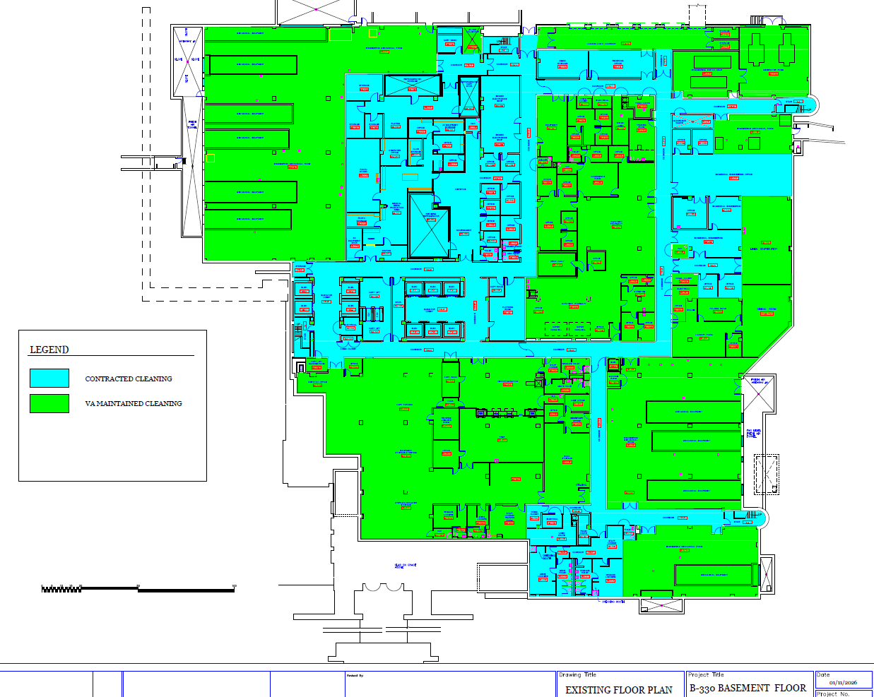

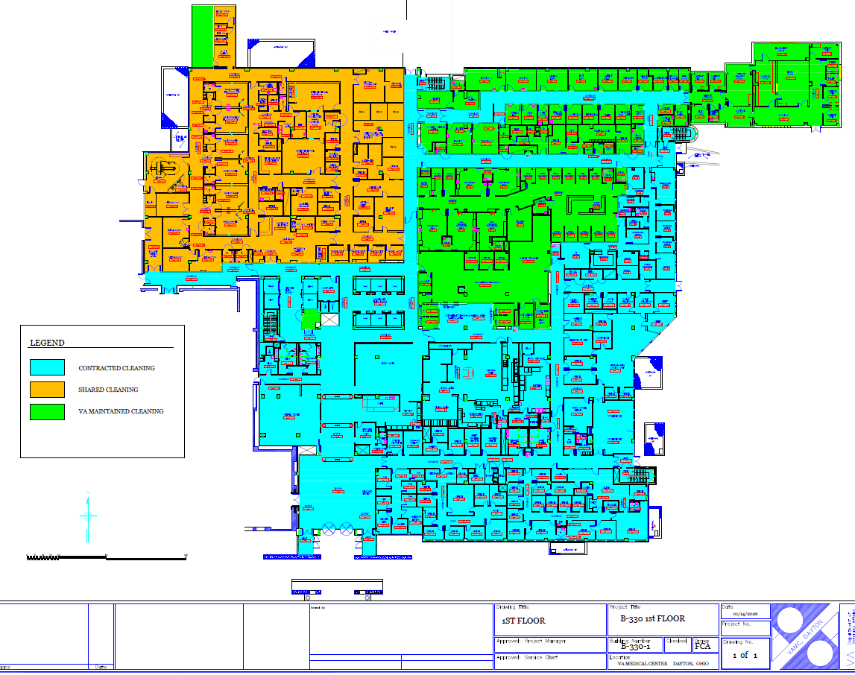

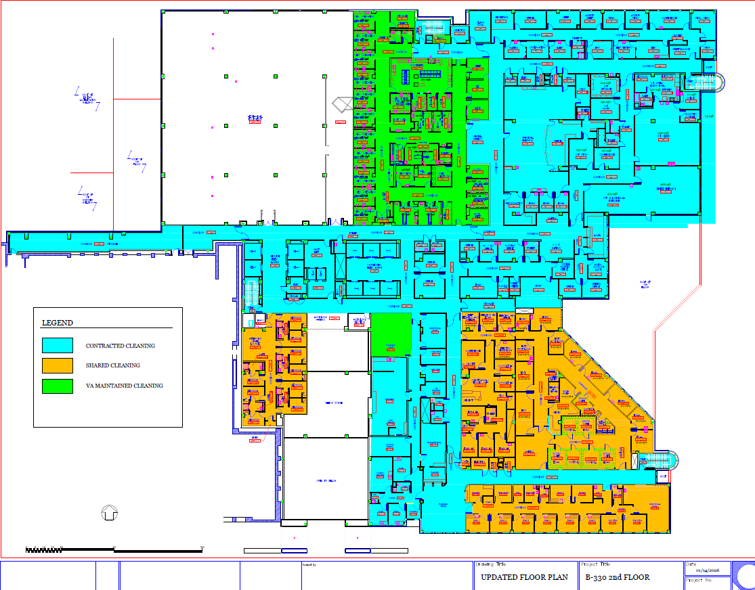

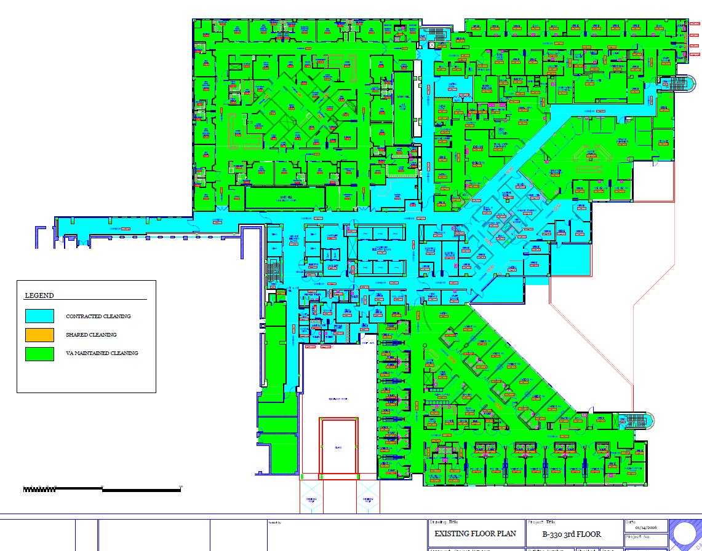

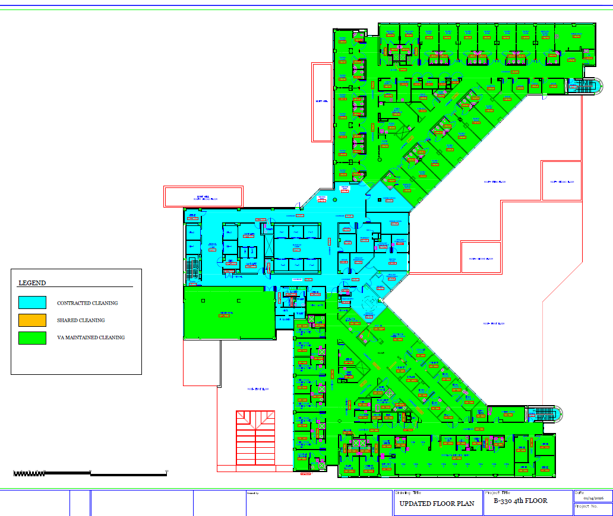
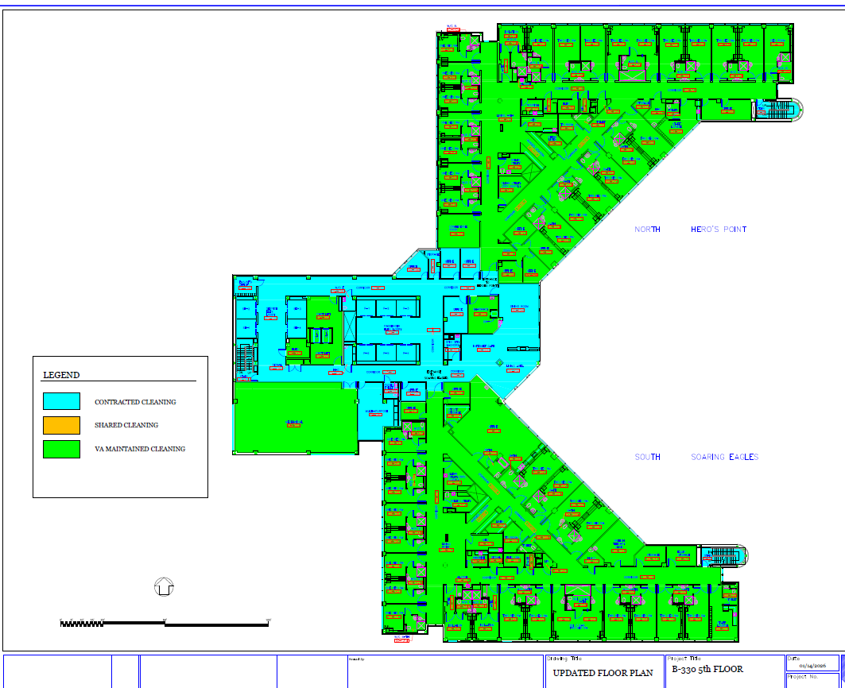
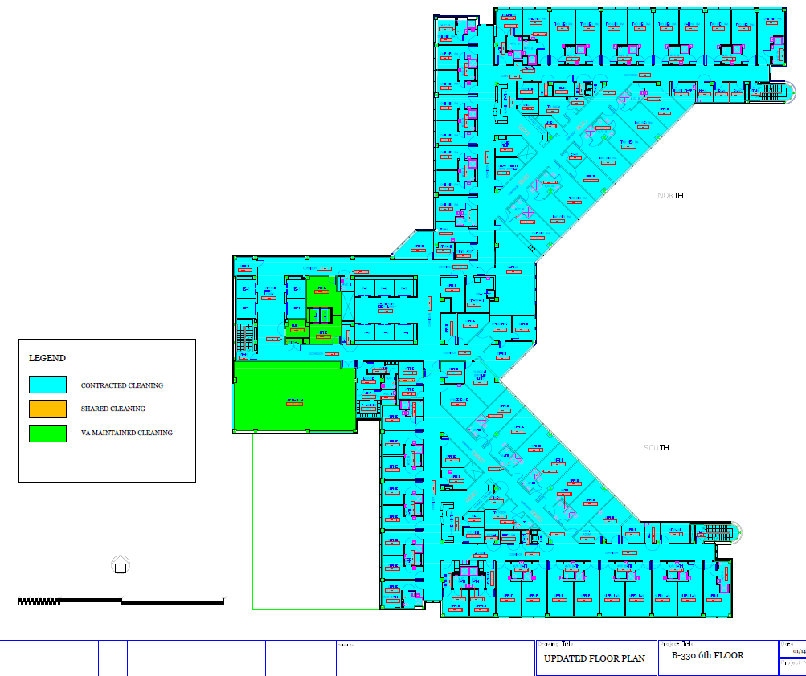
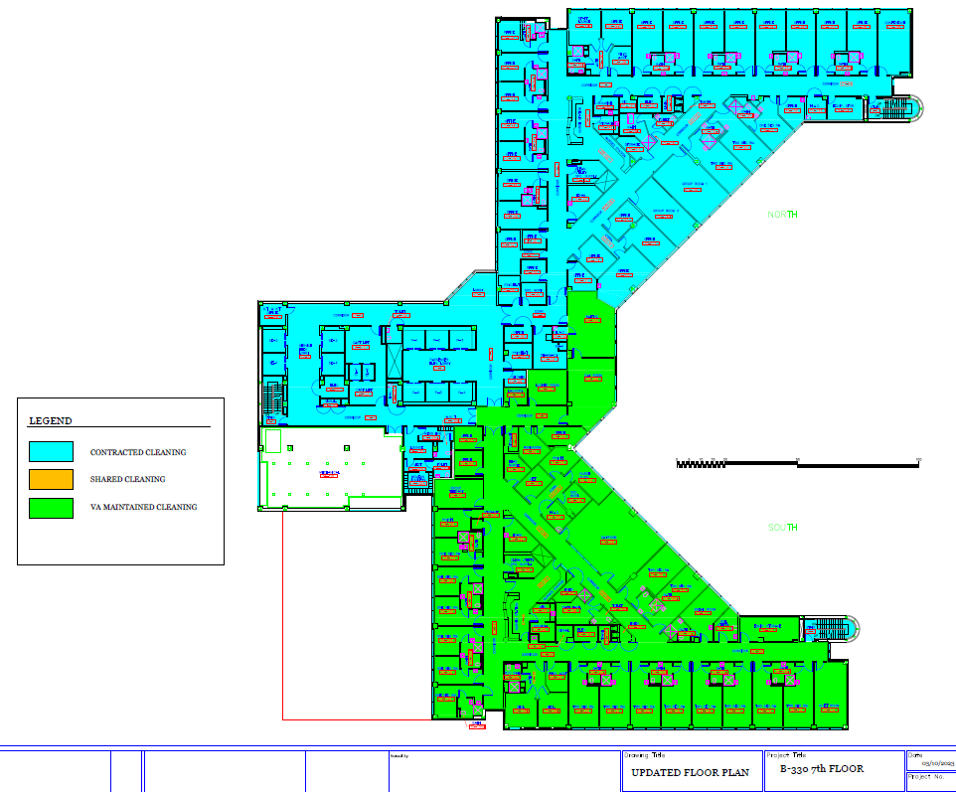
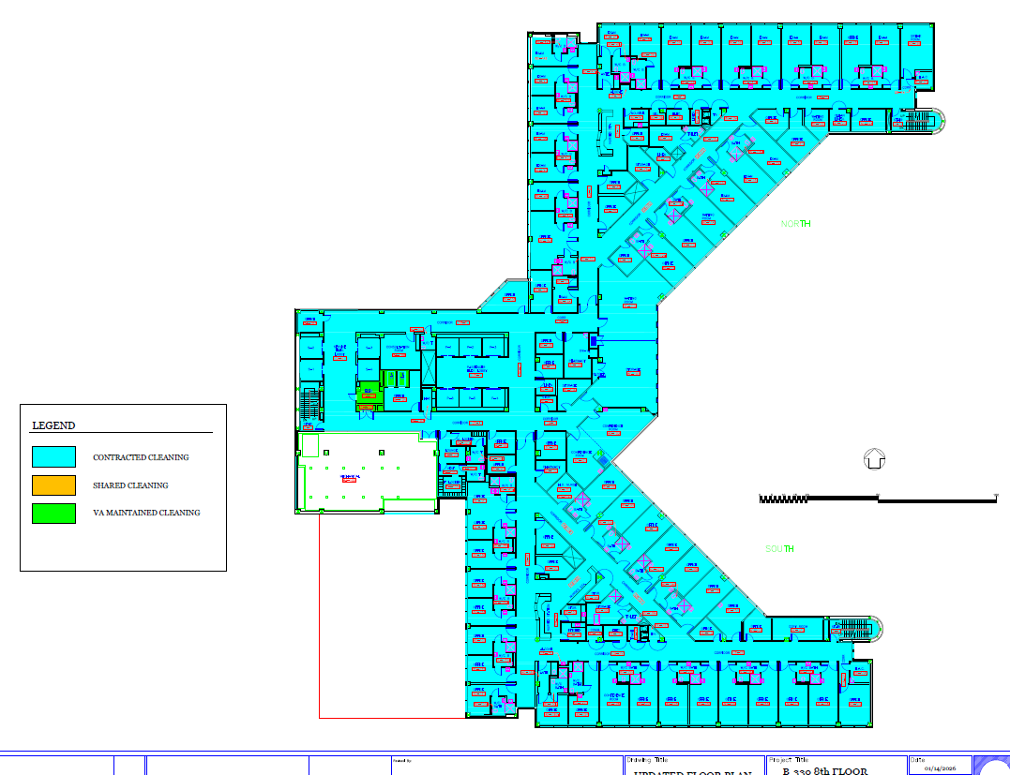
7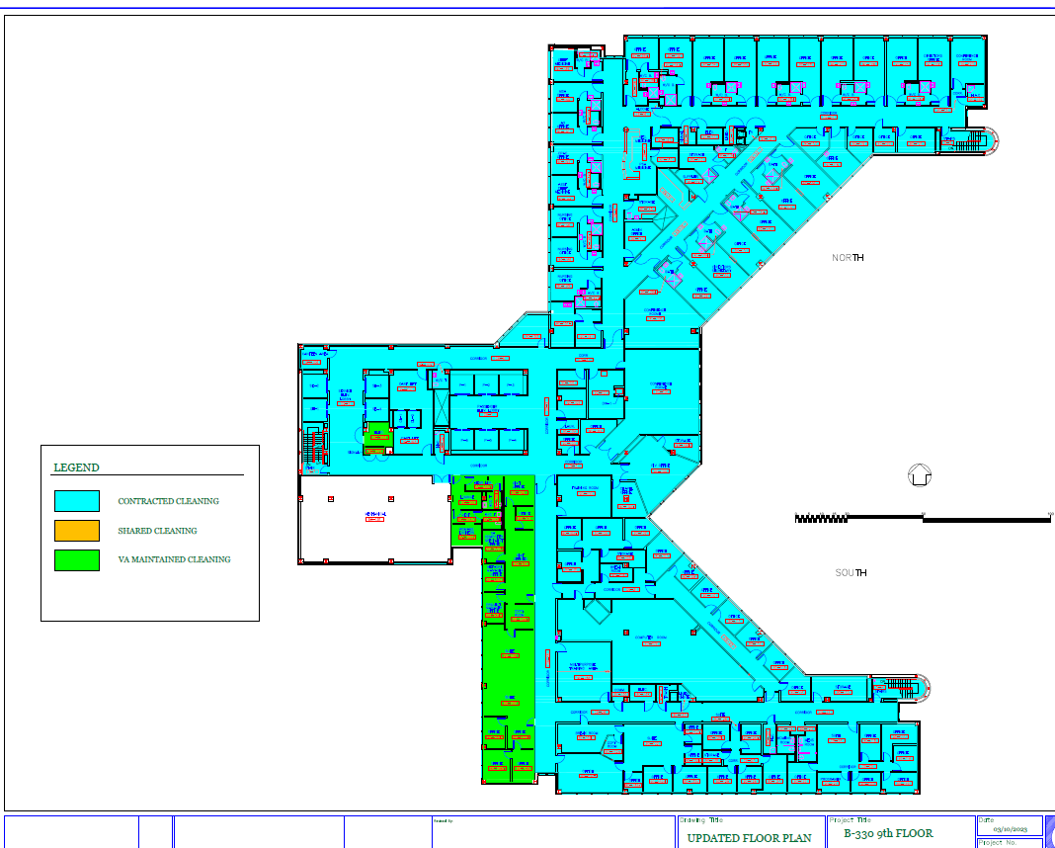

D.5 APPENDIX C: VENDOR ACKNOWLEDGMENT AND CONCURRENCE TABLE
Please complete the following table to indicate your acknowledgment and concurrence with the solicitation terms, conditions, and amendments:

Document | Dated | Concurrence (Yes/No) | Authorized Signature | Date
Original Solicitation
Amendment 1*
Amendment 2*
Amendment 3*
All Terms and Conditions
*Please add rows to the table as you see fit.

By signing the above, the vendor acknowledges receipt of the solicitation and all amendments, and concurs with all terms, conditions, and changes specified therein. Any exceptions or deviations must be clearly stated in the quote.

Note: Failure to acknowledge receipt of all amendments or to indicate concurrence may result in the rejection of the proposal.

Solicitation No: ____36C25026Q0740___________________________________

Company Name: ______________________________________________________

SAM UEI: ____________________________________________________________

Point of Contact: ______________________________________________________

Signature: ____________________________________ Date: ___________________

D.6 APPENDIX D: LIMITATIONS ON SUBCONTRACTING AND COMPLIANCE WORKSHEET

Part 1: Instructions
Please complete this attachment and submit it with your quote response. Failure to submit this attachment by the deadline, or failure to provide sufficient detail for the Government to review your work plan, may result in your quote being considered incomplete and ineligible for award.

This attachment allows the Government to review:
• Who will perform the work
• How much work the prime contractor will perform
• How much work will be subcontracted
• Whether any subcontractor is “similarly situated,” if applicable
If a question does not apply, write “N/A.”

1. Offeror Information
Company Name
SAM UEI
CAGE Code
Solicitation Number | 36C25026Q0740
Solicitation Set Aside | ☒SDVOSB ☐VOSB ☐EDWOSB ☐WOSB ☐HUBZone ☐8(a) ☐SDB ☐Small Business
NAICS Code | 561720

2. Who Will Do the Work?
Provide a brief summary of how you plan to perform the work.
[Provide Answer to #2 here, please add space as necessary]

3. Subcontractor Information by Period of Performance
Complete one row for the base period and each option period. Copy/paste this table as many times as needed for multiple Subcontractors. This information may be edited, changed, or modified as Prime-Sub Relationships change. Any changes shall be submitted to the Contracting Officer within 15 days of any change of relationship.
Period Of Performance | Subcontractor  Name | Subcontractor  SAM UEI | Small Business Status | Is Sub Similarly Situated? | Work To Be Performed | CLINs/Task Area Supported | Estimated Value for This Period
-Example- | Success Enterprises | 7A4839275612 | SDVOSB, HUB | Yes | Disposal of waste | 0001AB, 0002AB | $3,500.00
Base
Option 1
Option 2
Option 3
Option 4

Please include any additional notes here.

4. Total Subcontracting Estimate

Period of Performance | Total Estimated Subcontracted Value ($)
Base
Option 1
Option 2
Option 3
Option 4
Total Value (Full Contract Term)

Explanation of how amounts were calculated: ______________________________________________________________________________________________________________________________________________________________________________________________________________________________________________________________________________________________________________________________

5. Compliance Plan (Detailed Narrative Required)
Offerors must provide a detailed and specific compliance plan. General statements such as “we will ensure we do not pay more than 50% to our subcontractor” are not sufficient and will not be accepted.

Your compliance plan must clearly describe:
• What work the prime will perform and how it provides real value to the Government.
• How the prime will monitor and control subcontractor participation, including the methods, tools, or checkpoints used.
• How the prime will ensure subcontracting remains within required limits, including internal oversight and verification steps.
• How the prime will confirm and maintain subcontractor eligibility, including socioeconomic status and any similarly situated determinations.
• How the prime will document compliance, including what records will be kept and what can be provided to the Government upon request.

To be acceptable, the plan must show:
• The prime contractor will perform meaningful, substantive work, not just administrative tasks.
• The prime contractor will not function as a pass-through and will retain responsibility for critical aspects of performance.
• Compliance will be maintained using consistent, enforceable procedures throughout the entire period of performance.

[Blank space for offeror’s detailed plan, please add to this space as necessary]

6. Certification (Offerors must include Part 1 including Certification as a printed & signed PDF with submission).
By signing below, the offeror certifies that the information in this attachment is true and complete to the best of their knowledge.
• Name: _______________________________
• Title: _________________________________
• Signature: ____________________________
• Date: ________________________________
Part 2: What This Means - Purpose of This Attachment
This document helps the Government understand your performance approach, including how much of the work the prime will perform, how much will be subcontracted, and whether the proposed structure meets the requirements of the set-aside program and applicable subcontracting limitations.

This attachment supports the Government’s evaluation but does not replace any required contract clause or certification.

Addendum: Understanding Limitations on Subcontracting
1. VAAR 852.219-75 (VA SDVOSB/VOSB Set-Asides)
For VA SDVOSB and VOSB set-aside contracts, the prime must perform a required portion of the work. Percentage limits depend on the NAICS code. Work performed by a similarly situated SDVOSB or VOSB does not count against the prime’s subcontracting cap. Material costs do not count as subcontracting.

VA may measure compliance at the end of each base period, option period, or order period.

2. FAR 52.219-14 (All SBA Small-Business Set-Asides)
This clause defines “similarly situated entities” and establishes how subcontracting limits apply. A subcontractor is similarly situated only if it shares the prime's SBA program status and is small under the assigned NAICS.
Examples of SBA Socioeconomic Categories
- Service-Disabled Veteran-Owned Small Business (SDVOSB)
- Veteran-Owned Small Business (VOSB)
- 8(a) Business Development Program
- HUBZone Small Business
- Woman-Owned Small Business (WOSB) / Economically Disadvantaged WOSB (EDWOSB)
- Small Disadvantaged Business
- Small Business (SB)

Similarly Situated Examples
• Prime (Small Business) → Subcontractor (Small Business, same NAICS)
• Prime (SDVOSB) → Subcontractor (SDVOSB)

Not Similarly Situated
• Subcontractor is a large business i.e., WOSB subcontracting to large business if solicitation is WOSB set-aside unless they do pay less than 50% of the cost of the contract to that subcontractor.
• Subcontractor is under a different NAICS
• Second-tier subcontractors

3. This Is Not a “Percentage of the Job” Requirement
Limitations on subcontracting are based on dollar value, not hours, tasks, or workload share.
The prime must ensure payment to non-similarly situated subcontractors stays within the required percentage, regardless of how many tasks those subcontractors perform.

4. How VA Measures Compliance
Compliance may be validated at:
• The end of the base period
• The end of each option period
• The end of each order period
The Government may request documentation at any time. Additionally, the Government may require the contractor to submit documentation within 30 days of the start of an option period, and such documentation will cover the immediately preceding period of performance. If this method is required, it shall be documented in the QASP (Quality Assurance Surveillance Plan) within the Performance Work Statement.

5. Prime Contractor Work Must Provide Actual Value
The prime contractor must perform substantive work that contributes directly to meeting contract requirements and Government objectives.
• Prime contractor work must provide actual value to the Government.
• Work cannot be nominal, minimal, or limited to administrative oversight.
• The prime must not act as a pass-through.
• Real, meaningful contributions must be evident, measurable, and consistent throughout performance.

6. SBA Certification Requirements Table
Set-Aside Program | Requires SBA Certification? | Notes
Service-Disabled Veteran-Owned Small Business (SDVOSB) | Yes | Must be SBA-certified.
Veteran-Owned Small Business (VOSB) | Yes | Required for VA Veterans First.
8(a) Business Development Program | Yes | SBA certification required.
HUBZone Small Business | Yes | Must be HUBZone-certified.
Women-Owned Small Business (WOSB) / EDWOSB | Yes | Must be SBA-certified or certified through an approved third party.
Small Business (SB) | No | Must meet size standard; self-identify in SAM.

7. Small Business Size Standards and SAM.gov Validation
SAM.gov displays whether a proposed subcontractor qualifies as a small business under a specific NAICS code based on SBA size standards, which are determined by either revenue or employee count depending on the industry. The Government will conduct its own due diligence to verify a subcontractor’s size status and confirm any required SBA certifications.

Offerors are responsible for ensuring that each proposed subcontractor qualifies as a small business for the specific NAICS code assigned to their subcontracted work. A company may be a small business under one NAICS code but not a small business under another, depending on the applicable size thresholds.

It is the offeror’s responsibility to review size standards and confirm subcontractor eligibility before submitting a quote. Relying on informal statements such as “they only have 15 employees” or other undocumented assurances does not constitute valid proof of small business status. Prime contractors must verify size status through authoritative means such as SAM.gov, SBA size standards tables, and official business registration information.
Offerors must ensure their subcontractor eligibility determinations are accurate, supportable, and documented at the time of submission.

D.7 APPENDIX E: LIMITATIONS ON SUBCONTRACTING (LOS) REPORTING INSTRUCTIONS
1. Purpose of the Report
This report is used to validate the contractor’s compliance with the Limitations on Subcontracting requirements under FAR 52.219-14 and 15 U.S.C. § 657s. The VA uses this information to ensure that the contractor continues to meet statutory self-performance requirements during each period of performance.

2. Reporting Period
The LOS Compliance Report must cover the immediately preceding period of performance. The report must be submitted within 30 calendar days after the start of each option period, or upon request by the Contracting Officer.

3. Required Report Content
Contractors must report labor cost data only. Do not include materials, supplies, travel, equipment, chemicals, or overhead costs.
Required fields:
- Total Contract Labor Cost (Prime + Subcontractors): ______________________________
- Prime Contractor Labor Cost: ______________________________
- Prime Labor Percentage: ______________________________
- Description of Work Self-Performed: ______________________________
- Subcontractor Labor Cost: ______________________________
- Subcontractor Percentage: ______________________________
(Please copy and paste the four items below to identify all subcontractors.)
- Subcontractor Name: ______________________________
- Subcontractor Business Size (Small/Large): ______________________________
- Subcontractor Socioeconomic Category: ______________________________
- Tasks Performed by Subcontractor(s): ______________________________
Additional required LOS elements:
- Combined Subcontractor Percentage: ______________________________
- LOS Threshold for Contract Type: ______________________________
- Compliance Determination (Yes/No): ______________________________
- Explanation of Deviations (If Any): ______________________________
- Corrective Actions Taken: ______________________________
- Expected Date to Return to Compliance: ______________________________
- Cumulative Prime Labor Percentage: ______________________________
- Cumulative Subcontractor Percentage: ______________________________
- Notes: ______________________________

4. How VA Measures Compliance
VA evaluates LOS compliance based on prime labor versus total labor, subcontractor labor percentages, and consistency with the contractor’s LOS Worksheet submitted at award. Substantial deviations may result in corrective action, withholding of payment, cure notices, or other remedies determined appropriate by the Contracting Officer.

5. Certification
The contractor must certify the accuracy and completeness of the LOS Compliance Report by completing the following fields:
- Authorized Official Name: ______________________________
- Title: ______________________________
- Email: ______________________________
- Phone: ______________________________
- Signature: ______________________________
- Date: ______________________________

D.8 APPENDIX F: INSTRUCTIONS FOR IDENTIFYING AND REPORTING SUBCONTRACTORS

This appendix provides clear instructions to assist contractors in correctly identifying all subcontractors used during the period of performance. These instructions support compliance with FAR 52.219-14 and 15 U.S.C. § 657s (Limitations on Subcontracting) and must be followed when preparing the Limitations on Subcontracting (LOS) Compliance Report required under Appendix D and Appendix E.

1. Purpose
Contractors must identify all subcontractors contributing labor toward contract performance. Accurate identification ensures proper calculation of subcontracted labor percentages and allows the Government to validate compliance with statutory self-performance requirements.

2. When to Provide Subcontractor Information
Subcontractor information must be provided:
- Within 30 calendar days after the start of each option period (as part of the LOS Compliance Report), and
- Any time upon request by the Contracting Officer.

3. Required Identification Items
For each subcontractor used during the reporting period, contractors must provide all four items listed below. These items must be copied and completed exactly as shown when identifying a subcontractor.
(Please copy and paste the four items below to identify each subcontractor):

- Subcontractor Name:

- UEI:

- Business Size (Small/Large):

- Socioeconomic Category (if applicable):
SDVOSB / VOSB / WOSB / HUBZone / 8(a) / Other Small Business / None

Contractors must submit these four items for every subcontractor contributing labor, regardless of dollar amount or frequency of use.

4. Additional Required Details
In addition to the four identification items, the contractor must also provide:
- A description of subcontractor tasks or PWS sections performed
- The subcontractor’s labor cost for the reporting period
- The subcontractor’s percentage of total labor cost
- Any notes or context relevant to subcontractor use
These details help determine how subcontracted labor contributes to overall performance.

5. Accuracy Requirements
Contractors must ensure:
- All subcontractors are reported (even brief or one-time use)
- All fields are completed honestly and fully
- Business size and socioeconomic designations align with SAM.gov records
- Tasks listed match the PWS sections actually completed
- Labor cost reporting is accurate and based on labor only
- No materials, supplies, travel costs, or non-labor amounts are included
Incomplete or inaccurate subcontractor identification may result in:
- Correction requests
- Cure notice issuance
- Payment withholding
- Other actions deemed appropriate by the Contracting Officer

6. Certification Requirement
The subcontractor information provided under Appendix F must correspond to the LOS Certification Statement in Appendix E. The Government may request revised or additional information if discrepancies arise.

See attached document: 26Q0740 - PPQ - Vendor Name.

SECTION E - SOLICITATION PROVISIONS

E.1 52.212-1 INSTRUCTIONS TO OFFERORS—COMMERCIAL PRODUCTS AND COMMERCIAL SERVICES (OCT 2025) (DEVIATION)
(a) Submission of offers. Submit signed and dated offers to the office specified in this solicitation at or before the exact time specified in this solicitation. As a minimum, offers shall include—
(1) The solicitation number;
(2) The name, address, telephone number of the Offeror;
(3) The Offeror’s Unique Entity Identifier (UEI) and, if applicable, Electronic Funds Transfer (EFT) indicator;
(4) Information necessary to evaluate the factors contained in the provision at 52.212-2 or as described in the solicitation;
(5) Responses to provisions that require Offeror completion of information, representations, and certifications (other than those collected via the System for Award Management (SAM)); and
(6) A statement specifying the extent of agreement with all terms, conditions, and provisions included in the solicitation and any solicitation amendments.
(b) Period for acceptance of offers. The Offeror agrees to hold the prices in its offer firm for 60 calendar days from the date specified for receipt of offers, unless another time period is specified in an addendum to the solicitation.
(c) Late submissions, modifications, revisions, and withdrawals of offers.
(1) Offerors are responsible for submitting offers and any modifications or revisions to the Government office designated in the solicitation by the time specified in the solicitation.
(2) Any offer, modification, or revision received after the time specified for receipt of offers is “late” and will not be considered unless it is received before award is made and the Contracting Officer determines that accepting the late offer would not unduly delay the acquisition. However, a late modification of an otherwise successful offer that makes its terms more favorable to the Government will be considered at any time it is received and may be accepted.
(3) If an emergency or unanticipated event interrupts normal Government processes so that offers cannot be received at the Government office designated for receipt of offers by the exact time specified in the solicitation, and urgent Government requirements preclude amendment of the solicitation or other notice of an extension of the closing date, the time specified for receipt of offers will be deemed to be extended to the same time of day specified in the solicitation on the first work day on which normal Government processes resume.
(4) Offerors may withdraw their offers by written notice to the Government received at any time before award.
(d) Contract award (not applicable to Invitation for Bids). The Government intends to evaluate offers and award a contract without discussions with Offerors. Therefore, the Offeror’s initial offer should contain the Offeror’s best terms. However, the Government reserves the right to conduct discussions, if necessary. The Government may reject any or all offers if such action is in the public interest, accept other than the lowest offer, and waive informalities and minor irregularities in offers received.
(e) Debriefings. If a postaward debriefing is given to requesting Offerors, the Government will disclose the following information, if applicable:
(1) The agency’s evaluation of the significant weak or deficient factors in the debriefed Offeror’s offer.
(2) The overall evaluated cost or price and technical rating of the successful Offeror and the debriefed Offeror and past performance information on the debriefed Offeror.
(3) The overall ranking of all Offerors when any ranking was developed by the agency during source selection.
(4) A summary of the rationale for award.
(5) For acquisitions of commercial products, the make and model of the product to be delivered by the successful Offeror.
(6) Reasonable responses to relevant questions posed by the debriefed Offeror as to whether the agency followed source-selection procedures set forth in the solicitation, applicable regulations, and other applicable authorities.
(End of Provision)

E.2 QUOTE PREPARATION INSTRUCTIONS

To ensure timely and equitable evaluation of quotes, offerors must follow the instructions contained herein for quote submissions. Quotes must be complete, self-sufficient, and respond directly to the requirements of this solicitation.

FAILURE TO PROVIDE ANY OF THE INFORMATION REQUESTED IN THIS SECTION MAY RESULT IN YOUR QUOTE BEING EXCLUDED FROM FURTHER CONSIDERATION FOR AWARD.

All quoters shall submit the following as separate documents:
- One PDF or Word-compatible file for each (Administrative, Technical).
- One Completed Price-Cost Schedule PDF for Pricing.
- The offeror has the option to either combine past performance in one PDF or send three individual Past Performance Questionnaires (PPQ) files at their discretion.

The files shall be named utilizing the following convention:
Vendor Firm Name – “Administrative” - 26Q0740

(The vendor will replace “Administrative” with Technical, Price, and Past Performance to match the document type they are submitting.)

If the vendor's name exceeds 15 characters, please utilize best practices for shortening the name so that it is clear and consistent across all submission documents.

Email instructions for submission:
- Subject Lines shall be labeled – “Vendor Firm Name | Quote Response | 26Q0740 | 1 of X “
- *VA has a maximum allowable incoming email size limitation including attachments of thirty (30) megabytes. Offerors submitting responses via email which exceed thirty megabytes shall split their response into multiple email messages to not exceed the maximum allowable email size limitation.
- If more than 1 email is submitted, please indicate 1 of X in the subject line
- *The VA is not responsible for late responses due to undelivered e-mails that exceed thirty megabytes, or responses that are delayed due to scanning attachments for threats.

- ADMINISTRATIVE ITEMS:
  - Cover Page with business name, SAM UEI, Business Address, Point of Contact with Phone, and email information.

  - Vendors must provide a statement concurring with all solicitation Terms and Conditions and must individually acknowledge and concur with every amendment issued. Vendors are responsible for monitoring SAM.gov and ensuring all amendments are reviewed and agreed to, including those released after initial package submission. A template is provided in Appendix C. Failure to individually concur with all solicitation amendments and failure to submit this certification will result in immediate exclusion from award consideration.

  - VAAR 852.219-75, VA Notice of Limitations on Subcontracting – Certificate of Compliance (NOV 2022), must be completed in its entirety, signed, and dated by the quoter. Failure to submit the fully completed, signed, and dated clause will result in exclusion from further consideration

  - Limitations on Subcontracting Compliance Worksheet (Appendix D): Quoters must complete, sign, date and return Part 1 of Appendix D. Only Part 1 is required. All information submitted must be factual, accurate, and supported with appropriate detail. Any incomplete, unsupported, or unsubstantiated information may result in the quote being excluded from award consideration.

  - Vendors must provide a list of all points of contact who will support this requirement, including each individual’s full name, email address, phone number, and role (e.g., Billing, Sales, Transportation).

  - General liability insurance coverage must be provided by the prime contractor and any subcontractor supporting this requirement (if applicable). Coverage must meet or exceed the limits specified in the “Supplemental Insurance Requirements” clause. All insurance documents must be current at the time of submission to be considered for award.

  - The following clauses must be filled in, checked, and submitted with your response to be considered for award:

    - FAR 52.209-7 Information Regarding Responsibility Matters Box (2)(b)
    - FAR 52.229-11 Tax on Certain Foreign Procurements—Notice and Representation – Box (d)(1) and Box (d)(2)

- PRICING ITEMS:
  - Provide your pricing in the price/cost schedule. Pricing shall not be submitted anywhere else in your response.

- TECHNICAL ITEMS:
- Technical Approach: A detailed description of the proposed methodology for meeting all janitorial service requirements, including cleaning procedures, tools, techniques, workflow processes, and a complete list of all equipment the contractor will provide. The vendor must identify all contractor-furnished equipment to be used in daily, weekly, monthly, and periodic cleaning tasks (e.g., vacuums, floor machines, extractors, carts, etc.).

- Project Plan: A comprehensive project management plan outlining timelines, milestones, and key tasks to be completed. The project plan must include:
  - Staffing Ramp-Up Timeline
    - Estimated time required to reach full staffing after award
    - Proposed number of personnel needed to support full operations
    - Identification of staffing levels by shift (not individual names)
  - Shift Staffing Structure
    - Number of supervisors and cleaning staff assigned to each shift
    - Example: Shift 1 – 1 Supervisor / X Cleaning Staff; Shift 2 – 1 Supervisor / X Cleaning Staff
    - Sufficient detail to allow the Government to initiate background investigations once award is made (Individual names are not required at this stage.)
  - Facility-Specific Cleaning Schedule
    - Daily, weekly, monthly, and periodic cleaning tasks per building/location
    - Alignment of staffing numbers to the required frequencies
  - Coordination and Communication Plan
    - How project oversight, schedule updates, and emergent cleaning needs will be communicated with the Government

- Quality Control Plan: A plan detailing inspection procedures, tracking methods, deficiency identification/correction processes, communication with the Government, and methods ensuring compliance with PWS.

- Staffing and Training:
  - Demonstration of availability and qualifications of personnel, including:
    - Contract manager fluent in English.
    - Staff trained in aseptic/medical facility cleaning techniques.
    - Documentation of ongoing training in infection control, handling medical waste, PPE use, chemical safety, and equipment operation.

- PAST PERFORMANCE: (Please submit either)
  - Offerors may submit up to three Past Performance Questionnaires (PPQs) for work performed within the past four years that is similar in size and scope to this requirement. A PPQ form is included with this solicitation. Previously completed PPQs from other federal solicitations may be used in place of new ones, provided they reflect similar size or scope work (including comparable NAICS codes) and are signed and dated by the rating official within the past twelve months.

OR

  - Provide no more than 3 client references for other similarly sized and relevant contracts or requirements that you have met in the past 4 years. Please be sure to include the following information.
    - Entity or organization name
    - Dates of Service
    - Description and short narrative of services rendered
    - POC and contact information (Name, Phone Number, Extension, and email address)
    - Approximate dollar value of contract/requirement
    - Contract number if a Federal Contract

All quotes shall be sent to Josh Kovar Joshua.Kovar@VA.gov via email

QUESTION-AND-ANSWER PERIOD (Q&A PERIOD), the Government will respond to questions submitted by offerors.
- The Q&A will start immediately upon solicitation posting to Contract Opportunities.
- All questions SHALL be submitted no later than 7/31/2026 by 13:30 (1:30 PM EST) via email to Joshua.Kovar@VA.gov.
- Any questions received after this deadline may not be answered. Answers to questions will be provided in the form of a solicitation amendment publicized on Contract Opportunities.
- In order to provide information equally to all interested parties, phone queries will not be entertained.

The Government will conduct a comparative evaluation of quotations in accordance with RFO § 12.203, which allows quotations to be compared directly against one another to determine which provides the best overall value to the Government. Comparative evaluation is a side-by-side assessment of quotations based on the stated evaluation factors. Options will be evaluated at the time of award.

E.3 52.252-1 SOLICITATION PROVISIONS INCORPORATED BY REFERENCE (FEB 1998)
This solicitation incorporates one or more solicitation provisions by reference, with the same force and effect as if they were given in full text. Upon request, the Contracting Officer will make their full text available. The offeror is cautioned that the listed provisions may include blocks that must be completed by the offeror and submitted with its quotation or offer. In lieu of submitting the full text of those provisions, the offeror may identify the provision by paragraph identifier and provide the appropriate information with its quotation or offer. Also, the full text of a solicitation provision may be accessed electronically at this/these address(es):
https://www.acquisition.gov/far-overhaul
https://www.va.gov/oal/library/vaar/

(End of Provision)
FAR Number | Title | Date
52.203-11 | CERTIFICATION AND DISCLOSURE REGARDING PAYMENTS TO INFLUENCE CERTAIN FEDERAL TRANSACTIONS | SEP 2024
52.203-18 | PROHIBITION ON CONTRACTING WITH ENTITIES THAT REQUIRE CERTAIN INTERNAL CONFIDENTIALITY AGREEMENTS OR STATEMENTS—REPRESENTATION | JAN 2017
52.204-7 | SYSTEM FOR AWARD MANAGEMENT—REGISTRATION (DEVIATION) | NOV 2025
52.209-12 | CERTIFICATION REGARDING TAX MATTERS | OCT 2025

E.4 VAAR 852.252-70 SOLICITATION PROVISIONS OR CLAUSES INCORPORATED BY REFERENCE (JAN 2008)
The following provisions or clauses incorporated by reference in this solicitation must be completed by the offeror or prospective contractor and submitted with the quotation or offer. Copies of these provisions or clauses are available on the Internet at the Web sites provided in the provision at FAR 52.252-1, Solicitation Provisions Incorporated by Reference, or the clause at FAR 52.252-2, Clauses Incorporated by Reference. Copies may also be obtained from the contracting officer.
[Contracting officer shall list all FAR and 48 CFR Chapter 8 (VAAR) provisions and clauses incorporated by reference that must be completed by the offeror or prospective contractor and submitted with the quotation or offer.]
(End of Provision)
FAR Number | Title | Date
852.215-72 | NOTICE OF INTENT TO RE-SOLICIT | OCT 2019
852.233-70 | PROTEST CONTENT/ALTERNATIVE DISPUTE RESOLUTION | OCT 2018
852.233-71 | ALTERNATE PROTEST PROCEDURE | OCT 2018
852.233-71 | ALTERNATE PROTEST PROCEDURE (MAY 2010) NOTE | MAY 2010
852.239-75 | INFORMATION AND COMMUNICATION TECHNOLOGY ACCESSIBILITY NOTICE | FEB 2023

E.5 52.209-7 INFORMATION REGARDING RESPONSIBILITY MATTERS (OCT 2018)
(a) Definitions. As used in this provision—
"Administrative proceeding" means a non-judicial process that is adjudicatory in nature in order to make a determination of fault or liability (e.g., Securities and Exchange Commission Administrative Proceedings, Civilian Board of Contract Appeals Proceedings, and Armed Services Board of Contract Appeals Proceedings). This includes administrative proceedings at the Federal and State level but only in connection with performance of a Federal contract or grant. It does not include agency actions such as contract audits, site visits, corrective plans, or inspection of deliverables.
"Federal contracts and grants with total value greater than $10,000,000" means—
(1) The total value of all current, active contracts and grants, including all priced options; and
(2) The total value of all current, active orders including all priced options under indefinite-delivery, indefinite-quantity, 8(a), or requirements contracts (including task and delivery and multiple-award Schedules).
"Principal" means an officer, director, owner, partner, or a person having primary management or supervisory responsibilities within a business entity (e.g., general manager; plant manager; head of a division or business segment; and similar positions).
(b) The offeror [ ] has [ ] does not have current active Federal contracts and grants with total value greater than $10,000,000.
(c) If the offeror checked "has" in paragraph (b) of this provision, the offeror represents, by submission of this offer, that the information it has entered in the Federal Awardee Performance and Integrity Information System (FAPIIS) is current, accurate, and complete as of the date of submission of this offer with regard to the following information:
(1) Whether the offeror, and/or any of its principals, has or has not, within the last five years, in connection with the award to or performance by the offeror of a Federal contract or grant, been the subject of a proceeding, at the Federal or State level that resulted in any of the following dispositions:
(i) In a criminal proceeding, a conviction.
(ii) In a civil proceeding, a finding of fault and liability that results in the payment of a monetary fine, penalty, reimbursement, restitution, or damages of $5,000 or more.
(iii) In an administrative proceeding, a finding of fault and liability that results in—
(A) The payment of a monetary fine or penalty of $5,000 or more; or
(B) The payment of a reimbursement, restitution, or damages in excess of $100,000.
(iv) In a criminal, civil, or administrative proceeding, a disposition of the matter by consent or compromise with an acknowledgment of fault by the Contractor if the proceeding could have led to any of the outcomes specified in paragraphs (c)(1)(i), (c)(1)(ii), or (c)(1)(iii) of this provision.
(2) If the offeror has been involved in the last five years in any of the occurrences listed in (c)(1) of this provision, whether the offeror has provided the requested information with regard to each occurrence.
(d) The offeror shall post the information in paragraphs (c)(1)(i) through (c)(1)(iv) of this provision in FAPIIS as required through maintaining an active registration in the System for Award Management, which can be accessed via https://www.sam.gov (see 52.204-7).
(End of Provision)

E.6 52.229-11 TAX ON CERTAIN FOREIGN PROCUREMENTS—NOTICE AND REPRESENTATION (JUN 2020)
(a) Definitions. As used in this provision—
Foreign person means any person other than a United States person.
Specified Federal procurement payment means any payment made pursuant to a contract with a foreign contracting party that is for goods, manufactured or produced, or services provided in a foreign country that is not a party to an international procurement agreement with the United States. For purposes of the prior sentence, a foreign country does not include an outlying area.
United States person as defined in 26 U.S.C. 7701(a)(30) means—
(1) A citizen or resident of the United States;
(2) A domestic partnership;
(3) A domestic corporation;
(4) Any estate (other than a foreign estate, within the meaning of 26 U.S.C. 701(a)(31)); and
(5) Any trust if—
(i) A court within the United States is able to exercise primary supervision over the administration of the trust; and
(ii) One or more United States persons have the authority to control all substantial decisions of the trust.
(b) Unless exempted, there is a 2 percent tax of the amount of a specified Federal procurement payment on any foreign person receiving such payment. See 26 U.S.C. 5000C and its implementing regulations at 26 CFR 1.5000C-1 through 1.5000C-7.
(c) Exemptions from withholding under this provision are described at 26 CFR 1.5000C-1(d)(5) through (7). The Offeror would claim an exemption from the withholding by using the Department of the Treasury Internal Revenue Service Form W-14, Certificate of Foreign Contracting Party Receiving Federal Procurement Payments, available via the internet at www.irs.gov/w14. Any exemption claimed and self-certified on the IRS Form W-14 is subject to audit by the IRS. Any disputes regarding the imposition and collection of the 26 U.S.C. 5000C tax are adjudicated by the IRS as the 26 U.S.C. 5000C tax is a tax matter, not a contract issue. The IRS Form W-14 is provided to the acquiring agency rather than to the IRS.
(d) For purposes of withholding under 26 U.S.C. 5000C, the Offeror represents that—
(1) It [ ] is [ ] is not a foreign person; and
(2) If the Offeror indicates “is” in paragraph (d)(1) of this provision, then the Offeror represents that—I am claiming on the IRS Form W-14 [ ] a full exemption, or [ ] partial or no exemption [Offeror shall select one] from the excise tax.
(e) If the Offeror represents it is a foreign person in paragraph (d)(1) of this provision, then—
(1) The clause at FAR 52.229-12, Tax on Certain Foreign Procurements, will be included in any resulting contract; and
(2) The Offeror shall submit with its offer the IRS Form W-14. If the IRS Form W-14 is not submitted with the offer, exemptions will not be applied to any resulting contract and the Government will withhold a full 2 percent of each payment.
(f) If the Offeror selects “is” in paragraph (d)(1) and “partial or no exemption” in paragraph (d)(2) of this provision, the Offeror will be subject to withholding in accordance with the clause at FAR 52.229-12, Tax on Certain Foreign Procurements, in any resulting contract.
(g) A taxpayer may, for a fee, seek advice from the Internal Revenue Service (IRS) as to the proper tax treatment of a transaction. This is called a private letter ruling. Also, the IRS may publish a revenue ruling, which is an official interpretation by the IRS of the Internal Revenue Code, related statutes, tax treaties, and regulations. A revenue ruling is the conclusion of the IRS on how the law is applied to a specific set of facts. For questions relating to the interpretation of the IRS regulations go to https://www.irs.gov/help/tax-law-questions.
(End of Provision)

52.233-2 SERVICE OF PROTEST (SEP 2006) (DEVIATION NOV 2025)
(a) Protests, (as defined in FAR 33.102), that are filed directly with an agency, and copies of any protests that are filed with the Government Accountability Office (GAO), must be served on the Contracting Officer identified in the solicitation by obtaining written and dated acknowledgment of receipt from them.
(b) The copy of any protest must be received in the office designated above within one day of filing a protest with the GAO.

(End of provision)

E.7 52.240-90 SECURITY PROHIBITIONS AND EXCLUSIONS REPRESENTATIONS AND CERTIFICATIONS (NOV 2025) (DEVIATION)
(a) Definitions. As used in this provision—
Backhaul, covered article, covered telecommunications equipment or services, critical technology, FASCSA order, Intelligence community, interconnection arrangements, national security system, roaming, sensitive compartmented information, sensitive compartmented information system, source, and substantial or essential component have the meanings provided in the clause 52.240-91, Security Prohibitions and Exclusions.
Business operations means engaging in commerce in any form, including by acquiring, developing, maintaining, owning, selling, possessing, leasing, or operating equipment, facilities, personnel, products, services, personal property, real property, or any other apparatus of business or commerce.
Marginalized populations of Sudan means—
(1) Adversely affected groups in regions authorized to receive assistance under section 8(c) of the Darfur Peace and Accountability Act (Pub. L. 109-344) (50 U.S.C. 1701 note); and
(2) Marginalized areas in Northern Sudan described in section 4(9) of such Act.
Restricted business operations means business operations in Sudan that include power production activities, mineral extraction activities, oil-related activities, or the production of military equipment, as those terms are defined in the Sudan Accountability and Divestment Act of 2007 (Pub. L. 110-174). Restricted business operations do not include business operations that the person (as that term is defined in Section 2 of the Sudan Accountability and Divestment Act of 2007) conducting the business can demonstrate—
(1) Are conducted under contract directly and exclusively with the regional government of southern Sudan;
(2) Are conducted under specific authorization from the Office of Foreign Assets Control in the Department of the Treasury, or are expressly exempted under Federal law from the requirement to be conducted under such authorization;
(3) Consist of providing goods or services to marginalized populations of Sudan;
(4) Consist of providing goods or services to an internationally recognized peacekeeping force or humanitarian organization;
(5) Consist of providing goods or services that are used only to promote health or education; or
(6) Have been voluntarily suspended.
Sensitive technology—
(1) Means hardware, software, telecommunications equipment, or any other technology that is to be used specifically—
(i) To restrict the free flow of unbiased information in Iran; or
(ii) To disrupt, monitor, or otherwise restrict speech of the people of Iran; and
(2) Does not include information or informational materials the export of which the President does not have the authority to regulate or prohibit pursuant to section 203(b)(3) of the International Emergency Economic Powers Act (50 U.S.C. 1702(b)(3)).
(b) Procedures.
(1) Covered telecommunications and video surveillance. The Offeror shall review the list of excluded parties in the System for Award Management (SAM) at https://www.sam.gov for entities excluded from receiving federal awards for “covered telecommunications equipment or services.”
(2) FASCSA Orders.
(i) The Offeror shall search in SAM for the phrase “FASCSA order” for any covered article, or any products or services produced or provided by a source, if there is an applicable FASCSA order described in paragraph (e) of FAR 52.240-91, Security Prohibitions and Exclusions.
(ii) The Offeror shall review the solicitation for any FASCSA orders that are not in SAM but are effective and apply to the solicitation and resultant contract (see FAR 40.204-1(c)(2)).
(iii) FASCSA orders issued after the date of solicitation do not apply unless added by an amendment to the solicitation.
(c) Covered telecommunications equipment or services representations. By submission of its offer, the Offeror represents that, after conducting a reasonable inquiry (that looks at any information in the Offeror’s possession but does not need to include an internal or third-party audit)—
(1) It will not provide covered telecommunications equipment or services to the Government in the performance of any contract, subcontract or other contractual instrument resulting from this solicitation, except as waived by the solicitation, or as disclosed in paragraph (g); and
(2) It does not use covered telecommunications equipment or services, or use any equipment, system, or service that uses covered telecommunications equipment or services, except as waived by the solicitation, or as disclosed in paragraph (g).
(d) FASCSA Representation. By submission of this offer, the offeror represents that it has conducted a reasonable inquiry, and that the offeror does not propose to provide or use in response to this solicitation any covered article, or any products or services produced or provided by a source, if the covered article or the source is prohibited by an applicable FASCSA order in effect on the date the solicitation was issued, except as waived by the solicitation, or as disclosed in paragraph (g). A reasonable inquiry will look at any information in the offeror’s possession but does not need to include an internal or third-party audit.
(e) Sudan certification. By submission of its offer, the offeror certifies, after conducting a reasonable inquiry (that looks at any information in the offeror’s possession but does not need to include an internal or third-party audit), that the offeror does not conduct any restricted business operations in Sudan.
(f) Iran Representation and Certifications.
(1) Except as provided in paragraph (f)(2) of this provision or if a waiver has been granted in accordance with FAR 40.203-3, the offeror, after conducting a reasonable inquiry (that looks at any information in the offeror’s possession but does not need to include an internal or third-party audit), by submission of its offer—
(i) Represents, to the best of its knowledge and belief, that the offeror does not export any sensitive technology to the government of Iran or any entities or individuals owned or controlled by, or acting on behalf or at the direction of, the government of Iran;
(ii) Certifies that the offeror, or any person (as defined at section 15 of the Iran Sanctions Act of 1996, Pub. L. 104-172, 50 U.S.C. 1701 note) owned or controlled by the offeror, does not engage in any activities for which sanctions may be imposed under section 5 of the Act. These sanctioned activities are in the areas of development of the petroleum resources of Iran, production of refined petroleum products in Iran, sale and provision of refined petroleum products to Iran, and contributing to Iran’s ability to acquire or develop certain weapons or technologies; and
(iii) Certifies that the offeror, and any person owned or controlled by the offeror, does not knowingly engage in any transaction that exceeds $15,000 with Iran’s Revolutionary Guard Corps or any of its officials, agents, or affiliates, the property and interests in property of which are blocked pursuant to the International Emergency Economic Powers Act (50 U.S.C. 1701 et seq.) (see OFAC’s Specially Designated Nationals and Blocked Persons List at https://www.treasury.gov/resource-center/sanctions/SDN-List/Pages/default.aspx)
(2) Exception for trade agreements. The representation and certification requirements of paragraph (f)(1) of this provision do not apply if—
(i) This solicitation includes a trade agreements notice or certification (e.g., 52.225-6, Trade Agreements Certificate); and
(ii) The offeror has certified that all the offered products to be supplied are designated country end products or designated country construction material.
(iii) The offeror shall email questions concerning sensitive technology to the Department of State at CISADA106@state.gov.
(g) Disclosure.
(1) If the Offeror is not able to represent compliance with the prohibitions in paragraphs (c) or (d), then the Offeror shall disclose within 72 hours to the contracting office identified in paragraph (g)(2) the following information for each product or service not compliant:
(i) Contract number and order number, if applicable;
(ii) Identification of whether this disclosure relates to paragraph (c) on covered telecommunication equipment or services, or to paragraph (d) on FASCSA orders;
(iii) A description of the products or services that the Contractor identifies or has reason to suspect is prohibited (include brand; model number, such as the original equipment manufacturer (OEM) number, manufacturer part number, or wholesaler number; and item description, as applicable);
(iv) The entity that produced the product or service (include entity name, unique entity identifier, Contractor and Government Entity (CAGE) code, facilities responsible for design, fabrication, assembly, packaging, and test of the product, and whether the entity was the OEM or a distributor (provide manufacturer codes and distributor codes used for the product));
(v) Description of the functionality of the product or service and how that functionality impacts the risk to the product or service;
(vi) An explanation of any factors relevant to determining if the product or service should be permitted by an applicable exception, exemption, or waiver (if the offeror would like the Government to consider a waiver);
(vii) Whether alternative products or services are available that would be compliant with the prohibition;
(viii) If the product or service is related to item maintenance, include the following information on the item being maintained:
(A) Brand;
(B) Model number, OEM number, manufacturer part number, or wholesaler number; and
(C) Item description, as applicable.
(ix) Any readily available information about mitigation actions undertaken or recommended.
(2) If a disclosure is required to be submitted to a contracting office, the offeror shall submit the disclosure as follows:
(i) If a Department of Defense contracting office, the offeror shall submit the disclosure to the website at https://dibnet.dod.mil.
(ii) For all other contracting offices, the Offeror shall submit the disclosure to the Contracting Officer.
(3) If the disclosure provided does not contain any of the information required by paragraph (1), and the Offeror later discovers new information that is required by paragraph (1), then the Offeror shall submit a subsequent disclosure within 72 hours of discovering the new information.
(h) Executive agency review of disclosures. The Contracting Officer will review disclosures provided in paragraph (g) to determine if any applicable waiver may be sought. The Contracting Officer may choose not to pursue a waiver and may instead make an award to an Offeror that does not require a waiver.
(End of Provision)

E.8 52.216-1 TYPE OF CONTRACT (NOV 2025) (DEVIATION)
The Government contemplates award of a Firm Fixed Price contract resulting from this solicitation.

(End of Addendum to 52.212-1)

E.9 52.212-2 EVALUATION—COMMERCIAL PRODUCTS AND COMMERCIAL SERVICES (OCT 2025) (DEVIATION)
(a) Evaluation factors. The Government will award a contract resulting from this solicitation to the responsible Offeror whose offer conforming to the solicitation will be most advantageous to the Government, price and other factors considered. The following factors will be used to evaluate offers:
Comparative Evaluation:
Administrative
Technical
Price
Past Performance
(b) Options (if applicable). The Government will evaluate offers for award purposes by adding the total price for all options to the total price for the basic requirement. The Government may determine that an offer is unacceptable if the option prices are significantly unbalanced. The evaluation of options does not obligate the Government to exercise the option(s).
(c) Notice of award. A written notice of award or acceptance of an offer furnished to the successful Offeror within the time for acceptance specified in the offer, shall result in a binding contract without further action by either party. Before the offer's specified expiration time, the Government may accept an offer (or part of an offer), whether or not there are negotiations after its receipt, unless a written notice of withdrawal is received before award.
(End of Provision)

E.10 EVALUATION APPROACH
The Government will evaluate quotations using the comparative evaluation process permitted under RFO § 12.203. Under this approach, quotations are compared to determine which provides the best benefit to the Government. Comparative evaluation is a side-by-side assessment of quotations based on the stated evaluation factors. The Government may consider a quotation that is not the lowest-priced if it offers additional benefit(s) based on the stated evaluation factors. Quotations may exceed the minimum requirements of the solicitation; however, each quotation must meet all minimum requirements. Alternate quotations are not requested or accepted. Options will be evaluated at the time of award.

1. Administrative Items
Administrative items will be evaluated on a Satisfactory / Unsatisfactory basis. Quotations must include all administrative items listed in the Quote Preparation Instructions, including:
- Concurrence with all solicitation Terms and Conditions
- Individual concurrence with all solicitation amendments
- Completed, signed, and dated VAAR 852.219-75 clause pages
- Completed FAR 52.209-7, and FAR 52.229-11 Clauses
- Completed, signed, and dated Limitations on Subcontracting Worksheet.
- Cover page
- Vendor Points of Contact
- Current liability insurance meeting or exceeding PWS requirements
- Any other administrative documents required in the solicitation

Evaluation Outcome:
- Satisfactory: Vendor provides all required administrative items.
- Unsatisfactory: Vendor fails to provide any required administrative item; the quote may be excluded from further consideration.

2. Technical or Quality
The technical evaluation will assess the extent to which the quotation meets or exceeds the Government’s requirements in accordance with the PWS and the instructions to quoters.

Technical Approach
Requirement:
A detailed description of the proposed methodology for performing janitorial services, including cleaning procedures, tools, techniques, workflow processes, and a complete list of contractor-furnished equipment.

Evaluation:
Assessed for clarity, practicality, and suitability to meet the PWS requirements.

Project Plan
Requirement:
A comprehensive project management plan detailing timelines, milestones, and key tasks. The plan must include:
Staffing Ramp-Up Timeline
- Estimated time to reach full staffing post-award
- Proposed number of personnel required for full operation
- Staffing levels by shift (no individual names required)
Shift Staffing Structure
- Number of supervisors and cleaning staff assigned to each shift
- Example: Shift 1 – 1 Supervisor / X Cleaning Staff; Shift 2 – 1 Supervisor / Y Cleaning Staff
Facility-Specific Cleaning Schedule
- Daily, weekly, monthly, and periodic tasks for each building/location
- Alignment between staffing levels and required cleaning frequencies
Coordination and Communication Plan
- How oversight, scheduling updates, and emergent cleaning requests will be communicated with the Government

Evaluation:
Assessed for feasibility, realism of timelines, clarity of schedules, adequacy of staffing levels, and effectiveness of communication methods.

Quality Control Plan (QCP)
Requirement:
Procedures for performance monitoring, inspections, deficiency identification, corrective action, documentation, and communication with the Government.

Evaluation:
Assessed for effectiveness, completeness, and ability to maintain compliance with the PWS.

Staffing and Training
Requirement:
Demonstration of qualified and trained personnel, including:
- Contract manager fluent in English
- Staff trained in aseptic/medical facility custodial cleaning techniques
- Documentation of ongoing training programs (infection control, medical waste handling, PPE use, chemical safety, equipment operation)

Evaluation:
Assessed for relevance, depth, and adequacy of personnel qualifications and training programs.

3. Price Evaluation
- Requirement: Provide a detailed price proposal outlining costs associated with the provision of the services described.
- Price Evaluation Process: The Government will evaluate the price in the following manner.
- Initial Review: All quotes will be reviewed for compliance with the specified evaluation criteria and calculation methodology. All quotes will be evaluated as a total cost consisting of the base year and all option periods identified in the price-cost schedule.
  - Total Contract Value (TCV): The Government shall evaluate the total price for the basic requirement to find a Total Contract Value (TCV) by adding up all CLINS/SLINS for all periods/years listed in the Price Cost Schedule.
  - Future Value (FV) The Government will evaluate the Future Value (FV) of each quote by applying a 6% discount rate to base and all option-year pricing to determine the best overall long-term value to the Government.

The Government may determine that a quote is unacceptable if the option prices are significantly unbalanced including any/all of the following:

- Excessively Front-loaded or Back-loaded Quotes:
      - Higher prices for initial contract periods or items and significantly lower prices for later periods or items, or vice versa.
      - Example: A quote with a very high price for the base year followed by substantially lower prices for each option year.

- Disproportionate Pricing of CLINs:
      - Prices for some CLINs are disproportionately high or low compared to the overall scope of work or similar items.
      - Example: Per-unit costs for certain supplies are much higher compared to industry standards without clear justification.
- Past Performance:
Past Performance (review of CPARS ratings within last 4 years), and discussions with named POC’s from PPQs or client references identified in the Past Performance section above. The contracting officer will evaluate CPARS past performance that only features PSC: S201 engagements within the last 4 years for this requirement. Past performance shall be assessed as Meets, Does Not Meet, or Neutral (Neutral for vendors who do not have past performance with similar scope and size).

E.11 BASIS FOR AWARD
The Government intends to award a contract resulting from this solicitation to the responsible offeror whose offer conforming to the solicitation will be most advantageous to the Government, considering technical capability, past performance, administrative compliance, and price. The Government reserves the right to award to other than the lowest-priced offer if the technical merit or past performance of the higher-priced offer justifies the additional cost.
The award will be made to the response most advantageous to the Government.
Responses should contain your best terms, conditions.

To facilitate the award process, all quotes must include a statement regarding the terms and conditions herein as follows:
"The terms and conditions in the solicitation are acceptable to be included in the award document without modification, deletion, or addition."
OR
"The terms and conditions in the solicitation are acceptable to be included in the award document with the exception, deletion, or addition of the following:"
Quoters shall list exceptions(s) and rationale for the exception(s), if any.

Submission of your response shall be received not later than 1:30 PM EST on 8/7/2026 at Joshua.kovar@VA.gov.

Only emailed quotes shall be accepted. The quoter shall ensure that the quote is received by the designated contracting person prior to the closing date and time. All quotes, to be considered “on time,” shall be received by the closing date and time of the solicitation. It is the responsibility of the quoter to ensure it was delivered to the Contracting point of contact prior to the closing date and time of the solicitation. For Example: Quoter hits send at 1:59pm and Contracting’s emailed time stamp of received is 2:01pm when the closing time states 2:00pm, will be considered late.

*VA has a maximum allowable incoming email size limitation including attachments of thirty (30) megabytes. Offerors submitting responses via email which exceed thirty megabytes shall split their response into multiple email messages to not exceed the maximum allowable email size limitation.

*The VA is not responsible for late responses due to undelivered e-mails that exceed thirty megabytes, or responses that are delayed due to scanning attachments for threats.

Failure to submit the necessary information may render the Quote unacceptable, in which case it will not be considered for award.

Late submissions shall be treated in accordance with the solicitation provision at FAR 52.212-1(f).

Any questions or concerns regarding this solicitation should be forwarded in writing via e-mail to the Point of Contact listed below.

Point of Contact
Josh Kovar
Contracting Officer
Joshua.Kovar@VA.gov

This is a solicitation for commercial items prepared in accordance with the format in Federal Acquisition Regulation (FAR/RFO) subpart 12.6, “Streamlined Procedures for Evaluation and Solicitation for Commercial Items,” as supplemented with additional information included in this notice. This solicitation is issued as an RFQ. The solicitation document and incorporated provisions and clauses are those in effect through Federal Acquisition Circular 2026-01.

- This solicitation is set aside for SDVOSB (Service-Disabled Veteran Owned Small Businesses)

The associated North American Industrial Classification System (NAICS) code for this procurement is 561720 – Janitorial Services, with a small business size standard of $ 47.0 Million. The FSC/PSC is S201 – Housekeeping – Custodial

Dayton VA Medical Center is requesting Janitorial Services to supplement current staffing.

- All vendors shall provide all requested information in Quote Preparation Instructions section.
- There is a question-and-answer period for this requirement, ending at 1:30 PM EST on 7/31/2026
- There is a non-mandatory Site Visit scheduled for 7/24/2026 1:00-3:00 PM EST

All interested companies shall provide quotations for the following:

See attached document: D.10 - 26Q0740 - PPQ - Vendor Name.

